Федеральное государственное автономное

образовательное учреждение

высшего образования

«СИБИРСКИЙ ФЕДЕРАЛЬНЫЙ УНИВЕРСИТЕТ»

Институт Космических и информационных технологий

институт

Кафедра «Информатика»

кафедра

**ОТЧЕТ О ЛАБОРАТОРНОЙ РАБОТЕ**

Лабораторная работа No 5. Взаимодействие процессов в ОС GNU/Linux

тема

Преподаватель _________ А.С. Кузнецов

подпись, дата инициалы, фамилия

Студент КИ18-17/1б 031831229 _________ В.А. Прекель

номер группы, зачетной книжки подпись, дата инициалы, фамилия

Красноярск 2019

Содержание

Содержание 2

1 Цель работы с постановкой задачи 4

1.1 Цель работы 4

1.2 Задача работы 4

1.3 Описание и пояснение к работе 5

2 Исходные тексты программ (с комментариями в стиле системы doxygen) 6

3 Содержимое скрипта configure 6

4 Тестовые примеры работы программ 110

4.1 Запуск №1 (с помощью loopback; сервер – WSL Ubuntu 18.04, GCC; клиент – Windows 10, MSVC) 110

4.1.1. Сборка с помощью autotools на сервере 110

4.1.2. Сборка с помощью CMake и MSBuild на клиенте 112

4.1.3. Запуск сервера 113

4.1.4. Запуск клиента 114

4.1.5. Результат работы сервера 115

4.2 Запуск №2 (по локальной сети; сервер – Ubuntu 19.10, GCC; клиент – Windows 10, Clang) 115

4.2.1. Сборка на сервере с помощью autotools 115

4.2.2. Сборка на клиенте с помощью CMake и Ninja 116

4.2.3. Запуск сервера 118

4.2.4. Запуск клиента 118

4.2.5. Результат работы сервера 119

4.3 Запуск №3 (по виртуальной сети; сервер – Android (Termix), Clang; клиент – Ubuntu 19.10, Clang) 119

4.3.1. Сборка с помощью CMake и Ninja на клиенте 119

4.3.2. Сборка с помощью autotools на сервере 120

4.3.3. Запуск сервера 124

4.3.4. Запуск клиента 125

4.3.5. Результат работы сервера 125

4.4 Запуск №4 (по глобальной сети; сервер – Ubuntu 16.04, GCC; клиент – Windows 10, MinGW) 126

4.4.1. Сборка на клиенте с помощью CMake и mingw32-make 126

4.4.2. Сборка на сервере с помощью autotools 128

4.4.3. Запуск сервера 129

4.4.4. Запуск клиента 130

4.4.5. Результат работы сервера 130

# Цель работы с постановкой задачи

## Цель работы

Изучение особенностей межпроцессного взаимодействия в ОС GNU/Linux.

## Задача работы

Требуется: разработать две программы: первая реализует серверную часть, вторая — клиентскую часть. Обмен данными между ними организуется посредством механизма Internet-сокетов и протокола TCP либо UDP. Результат выполнения выводится на терминал/консоль. Должен использоваться интерфейс командной строки (CLI). При реализации обязательно использование изученных в лекционном курсе системных вызовов (ОС Linux), предназначенных для работы с сокетами. Программный код, относящийся к пользовательскому интерфейсу, должен быть физически отделен от кода, реализующего межпроцессное взаимодействие, и оба они, в свою очередь, отделены от кода реализации основной логики, например, вычислений. Допускается реализация одной программы в форме Windows-приложения, авторой — в форме Linux-приложения. Далее оговаривается функционал клиентской и серверной частей. Обе части должны быть устойчивы к некорректному пользовательскому вводу. В нечетных вариантах заданий используются потоковые сокеты, в четных — дейтаграммные сокеты.

**Вариант 16.** Клиент отсылает серверу элементы двух квадратных матриц

одинакового размера. Его, а также сами элементы матриц должен вводить пользователь. Сервер принимает две квадратные матрицы, а затем выводит на экран сумму матриц, а также определитель суммарной матрицы.

Используются дейтаграммные сокеты по протоколу UDP.

## Описание и пояснение к работе

Используется система сборки Autotools на Linux и CMake на Windows и Linux. Используется интерфейс командной строки. Для сборки, вывода справки клиента и сервера требуется:

*# linux, autotools, make, gcc*./configure  
make  
./build/Lab_05_Client -h  
./build/Lab_05_Server -h  
  
*# linux, autotools, make, clang*./configure CC=clang  
make  
./build/Lab_05_Client -h  
./build/Lab_05_Server -h  
  
*# linux, cmake, make, gcc*mkdir buildcmake  
cd buildcmake  
cmake ..  
make  
./Lab_05_Client/Lab_05_Client -h  
./Lab_05_Server/Lab_05_Server -h  
  
*# linux, cmake, make, clang*mkdir buildcmake  
cd buildcmake  
cmake -DCMAKE_C_COMPILER=clang ..  
make  
./Lab_05_Client/Lab_05_Client -h  
./Lab_05_Server/Lab_05_Server -h  
  
*# linux, cmake, ninja, clang*mkdir buildcmake  
cd buildcmake  
cmake -G **"Ninja"** -DCMAKE_C_COMPILER=clang ..  
ninja  
./Lab_05_Client/Lab_05_Client -h  
./Lab_05_Server/Lab_05_Server -h  
  
*# windows, cmake, msbuild, msvc*mkdir buildcmake  
cd buildcmake   
cmake -G **"Visual Studio 16 2019"** ..  
msbuild .\ALL_BUILD.vcxproj  
.\Lab_05_Client\Debug\Lab_05_Client.exe -h  
.\Lab_05_Server\Debug\Lab_05_Server.exe -h  
  
*# windows, cmake, mingw32-make, mingw*mkdir buildcmake  
cd buildcmake  
cmake -G **"MinGW Makefiles"** ..  
mingw32-make  
.\Lab_05_Client\Lab_05_Client.exe -h  
.\Lab_05_Server\Lab_05_Server.exe -h  
  
*# windows, cmake, mingw32-make, clang*mkdir buildcmake  
cd buildcmake  
cmake -G **"MinGW Makefiles"** -DCMAKE_C_COMPILER=clang -DCMAKE_CXX_COMPILER=clang++ ..  
mingw32-make  
.\Lab_05_Client\Lab_05_Client.exe -h  
.\Lab_05_Server\Lab_05_Server.exe -h  
  
*# windows, cmake, ninja, clang*mkdir buildcmake  
cd buildcmake  
cmake -G **"Ninja"** -DCMAKE_C_COMPILER=clang -DCMAKE_CXX_COMPILER=clang++ -DCMAKE_RC_COMPILER=llvm-rc ..  
ninja  
.\Lab_05_Client\Lab_05_Client.exe -h  
.\Lab_05_Server\Lab_05_Server.exe -h

# Исходные тексты программ (с комментариями в стиле системы doxygen)

Исходные тексты программ предоставлены в архиве.

# Содержимое скрипта configure

**#! /bin/sh***# Guess values for system-dependent variables and create Makefiles.  
# Generated by GNU Autoconf 2.69 for Lab_05 3.0.  
#  
# Report bugs to <misterptits@yandex.ru>.  
#  
#  
# Copyright (C) 1992-1996, 1998-2012 Free Software Foundation, Inc.  
#  
#  
# This configure script is free software; the Free Software Foundation  
# gives unlimited permission to copy, distribute and modify it.  
## -------------------- ##  
## M4sh Initialization. ##  
## -------------------- ##  
  
# Be more Bourne compatible*DUALCASE=1; export DUALCASE *# for MKS sh***if** test -n **"$**{ZSH_VERSION+set}**" &&** (emulate sh) **>**/dev/null 2>&1; **then** :  
 emulate sh  
 NULLCMD=:  
 *# Pre-4.2 versions of Zsh do word splitting on ${1+"$@"}, which  
 # is contrary to our usage. Disable this feature.* alias -g **'${1+"$@"}'**=**'"$@"'** setopt NO_GLOB_SUBST  
**else  
 case** `(set -o) 2**>**/dev/null` **in** *#(* *posix*) :  
 set -o posix **;;** *#(* *) :  
 **;;  
esac  
fi**as_nl=**'  
'**export as_nl  
*# Printing a long string crashes Solaris 7 /usr/bin/printf.*as_echo=**'\\\\\\\\\\\\\\\\\\\\\\\\\\\\\\\\\\\\\\\\\\\\\\\\\\\\\\\\\\\\\\\\\\\\\\\\\\\\\\\\\\\\\\\\\\\\\\\\\\\\\\\'**as_echo=$as_echo$as_echo$as_echo$as_echo$as_echo  
as_echo=$as_echo$as_echo$as_echo$as_echo$as_echo$as_echo  
*# Prefer a ksh shell builtin over an external printf program on Solaris,  
# but without wasting forks for bash or zsh.***if** test -z **"**$BASH_VERSION$ZSH_VERSION**"** \  
 **&&** (test **"X**`print -r -- $as_echo`**"** = **"X**$as_echo**"**) 2**>**/dev/null; **then** as_echo=**'print -r --'** as_echo_n=**'print -rn --'  
elif** (test **"X**`printf %s $as_echo`**"** = **"X**$as_echo**"**) 2**>**/dev/null; **then** as_echo=**'printf %s\n'** as_echo_n=**'printf %s'  
else  
 if** test **"X**`(/usr/ucb/echo -n -n $as_echo) 2**>**/dev/null`**"** = **"X-n** $as_echo**"**; **then** as_echo_body=**'eval /usr/ucb/echo -n "$1$as_nl"'** as_echo_n=**'/usr/ucb/echo -n'  
 else** as_echo_body=**'eval expr "X$1" : "X\\(.*\\)"'** as_echo_n_body=**'eval  
 arg=$1;  
 case $arg in #(  
 *"$as_nl"*)  
 expr "X$arg" : "X\\(.*\\)$as_nl";  
 arg=`expr "X$arg" : ".*$as_nl\\(.*\\)"`;;  
 esac;  
 expr "X$arg" : "X\\(.*\\)" | tr -d "$as_nl"  
 '** export as_echo_n_body  
 as_echo_n=**'sh -c $as_echo_n_body as_echo'  
 fi** export as_echo_body  
 as_echo=**'sh -c $as_echo_body as_echo'  
fi***# The user is always right.***if** test **"$**{PATH_SEPARATOR+set}**"** != set; **then** PATH_SEPARATOR=:  
 (PATH=**'/bin;/bin'**; FPATH=$PATH; sh -c :) **>**/dev/null 2>&1 **&&** {  
 (PATH=**'/bin:/bin'**; FPATH=$PATH; sh -c :) **>**/dev/null 2>&1 **||** PATH_SEPARATOR=**';'** }  
**fi***# IFS  
# We need space, tab and new line, in precisely that order. Quoting is  
# there to prevent editors from complaining about space-tab.  
# (If _AS_PATH_WALK were called with IFS unset, it would disable word  
# splitting by setting IFS to empty value.)*IFS=**" ""** $as_nl**"***# Find who we are. Look in the path if we contain no directory separator.*as_myself=  
**case** $0 **in** *#((* *[\\/]* ) as_myself=$0 **;;** *) as_save_IFS=$IFS; IFS=$PATH_SEPARATOR  
**for** as_dir in $PATH  
**do** IFS=$as_save_IFS  
 test -z **"**$as_dir**" &&** as_dir=.  
 test -r **"**$as_dir**/**$0**" &&** as_myself=$as_dir/$0 **&&** break  
 **done**IFS=$as_save_IFS  
  
 **;;  
esac***# We did not find ourselves, most probably we were run as `sh COMMAND'  
# in which case we are not to be found in the path.***if** test **"x**$as_myself**"** = x; **then** as_myself=$0  
**fi  
if** test **!** -f **"**$as_myself**"**; **then** $as_echo **"**$as_myself**: error: cannot find myself; rerun with an absolute file name"** >&2  
 exit 1  
**fi***# Unset variables that we do not need and which cause bugs (e.g. in  
# pre-3.0 UWIN ksh). But do not cause bugs in bash 2.01; the "|| exit 1"  
# suppresses any "Segmentation fault" message there. '((' could  
# trigger a bug in pdksh 5.2.14.***for** as_var in BASH_ENV ENV MAIL MAILPATH  
**do** eval test x\${$as_var+set} = xset \  
 && ( (unset $as_var) **||** exit 1) **>**/dev/null 2>&1 **&&** unset $as_var **||** :  
**done**PS1=**'$ '**PS2=**'> '**PS4=**'+ '***# NLS nuisances.*LC_ALL=C  
export LC_ALL  
LANGUAGE=C  
export LANGUAGE  
  
*# CDPATH.*(unset CDPATH) **>**/dev/null 2>&1 **&&** unset CDPATH  
  
*# Use a proper internal environment variable to ensure we don't fall  
 # into an infinite loop, continuously re-executing ourselves.* **if** test x**"$**{_as_can_reexec}**"** != xno **&&** test **"x**$CONFIG_SHELL**"** != x; **then** _as_can_reexec=no; export _as_can_reexec;  
 *# We cannot yet assume a decent shell, so we have to provide a  
# neutralization value for shells without unset; and this also  
# works around shells that cannot unset nonexistent variables.  
# Preserve -v and -x to the replacement shell.*BASH_ENV=/dev/null  
ENV=/dev/null  
(unset BASH_ENV) **>**/dev/null 2>&1 **&&** unset BASH_ENV ENV  
**case** $- **in** *# ((((* *v*x* | *x*v* ) as_opts=-vx **;;** *v* ) as_opts=-v **;;** *x* ) as_opts=-x **;;** * ) as_opts= **;;  
esac**exec $CONFIG_SHELL $as_opts **"**$as_myself**" $**{1+"$@"}  
*# Admittedly, this is quite paranoid, since all the known shells bail  
# out after a failed `exec'.*$as_echo **"**$0**: could not re-execute with** $CONFIG_SHELL**"** >&2  
as_fn_exit 255  
 **fi** *# We don't want this to propagate to other subprocesses.* { _as_can_reexec=; unset _as_can_reexec;}  
**if** test **"x**$CONFIG_SHELL**"** = x; **then** as_bourne_compatible=**"if test -n \"\${ZSH_VERSION+set}\" && (emulate sh) >/dev/null 2>&1; then :  
 emulate sh  
 NULLCMD=:  
 # Pre-4.2 versions of Zsh do word splitting on \${1+\"\$@\"}, which  
 # is contrary to our usage. Disable this feature.  
 alias -g '\${1+\"\$@\"}'='\"\$@\"'  
 setopt NO_GLOB_SUBST  
else  
 case \`(set -o) 2>/dev/null\` in #(  
 *posix*) :  
 set -o posix ;; #(  
 *) :  
 ;;  
esac  
fi  
"** as_required=**"as_fn_return () { (exit \$1); }  
as_fn_success () { as_fn_return 0; }  
as_fn_failure () { as_fn_return 1; }  
as_fn_ret_success () { return 0; }  
as_fn_ret_failure () { return 1; }  
  
exitcode=0  
as_fn_success || { exitcode=1; echo as_fn_success failed.; }  
as_fn_failure && { exitcode=1; echo as_fn_failure succeeded.; }  
as_fn_ret_success || { exitcode=1; echo as_fn_ret_success failed.; }  
as_fn_ret_failure && { exitcode=1; echo as_fn_ret_failure succeeded.; }  
if ( set x; as_fn_ret_success y && test x = \"\$1\" ); then :  
  
else  
 exitcode=1; echo positional parameters were not saved.  
fi  
test x\$exitcode = x0 || exit 1  
test -x / || exit 1"** as_suggested=**" as_lineno_1="**;as_suggested=$as_suggested$LINENO;as_suggested=$as_suggested**" as_lineno_1a=\$LINENO  
 as_lineno_2="**;as_suggested=$as_suggested$LINENO;as_suggested=$as_suggested**" as_lineno_2a=\$LINENO  
 eval 'test \"x\$as_lineno_1'\$as_run'\" != \"x\$as_lineno_2'\$as_run'\" &&  
 test \"x\`expr \$as_lineno_1'\$as_run' + 1\`\" = \"x\$as_lineno_2'\$as_run'\"' || exit 1  
test \$(( 1 + 1 )) = 2 || exit 1"  
 if** (eval **"**$as_required**"**) 2**>**/dev/null; **then** :  
 as_have_required=yes  
**else** as_have_required=no  
**fi  
 if** test x$as_have_required = xyes **&&** (eval **"**$as_suggested**"**) 2**>**/dev/null; **then** :  
  
**else** as_save_IFS=$IFS; IFS=$PATH_SEPARATOR  
as_found=false  
**for** as_dir in /bin$PATH_SEPARATOR/usr/bin$PATH_SEPARATOR$PATH  
**do** IFS=$as_save_IFS  
 test -z **"**$as_dir**" &&** as_dir=.  
 as_found=:  
 **case** $as_dir **in** *#(* /*)  
 **for** as_base in sh bash ksh sh5; **do** *# Try only shells that exist, to save several forks.* as_shell=$as_dir/$as_base  
 **if** { test -f **"**$as_shell**" ||** test -f **"**$as_shell**.exe"**; } **&&** { $as_echo **"**$as_bourne_compatible**""**$as_required**"** | as_run=a **"**$as_shell**"**; } 2**>**/dev/null; **then** :  
 CONFIG_SHELL=$as_shell as_have_required=yes  
 **if** { $as_echo **"**$as_bourne_compatible**""**$as_suggested**"** | as_run=a **"**$as_shell**"**; } 2**>**/dev/null; **then** :  
 break 2  
**fi  
fi  
 done;;  
 esac** as_found=false  
**done**$as_found **||** { **if** { test -f **"**$SHELL**" ||** test -f **"**$SHELL**.exe"**; } **&&** { $as_echo **"**$as_bourne_compatible**""**$as_required**"** | as_run=a **"**$SHELL**"**; } 2**>**/dev/null; **then** :  
 CONFIG_SHELL=$SHELL as_have_required=yes  
**fi**; }  
IFS=$as_save_IFS  
  
  
 **if** test **"x**$CONFIG_SHELL**"** != x; **then** :  
 export CONFIG_SHELL  
 *# We cannot yet assume a decent shell, so we have to provide a  
# neutralization value for shells without unset; and this also  
# works around shells that cannot unset nonexistent variables.  
# Preserve -v and -x to the replacement shell.*BASH_ENV=/dev/null  
ENV=/dev/null  
(unset BASH_ENV) **>**/dev/null 2>&1 **&&** unset BASH_ENV ENV  
**case** $- **in** *# ((((* *v*x* | *x*v* ) as_opts=-vx **;;** *v* ) as_opts=-v **;;** *x* ) as_opts=-x **;;** * ) as_opts= **;;  
esac**exec $CONFIG_SHELL $as_opts **"**$as_myself**" $**{1+"$@"}  
*# Admittedly, this is quite paranoid, since all the known shells bail  
# out after a failed `exec'.*$as_echo **"**$0**: could not re-execute with** $CONFIG_SHELL**"** >&2  
exit 255  
**fi  
  
 if** test x$as_have_required = xno; **then** :  
 $as_echo **"**$0**: This script requires a shell more modern than all"** $as_echo **"**$0**: the shells that I found on your system."  
 if** test x**$**{ZSH_VERSION+set} = xset ; **then** $as_echo **"**$0**: In particular, zsh** $ZSH_VERSION **has bugs and should"** $as_echo **"**$0**: be upgraded to zsh 4.3.4 or later."  
 else** $as_echo **"**$0**: Please tell bug-autoconf@gnu.org and**$0**: misterptits@yandex.ru about your system, including any**$0**: error possibly output before this message. Then install**$0**: a modern shell, or manually run the script under such a**$0**: shell if you do have one."  
 fi** exit 1  
**fi  
fi  
fi**SHELL=**$**{CONFIG_SHELL-/bin/sh}  
export SHELL  
*# Unset more variables known to interfere with behavior of common tools.*CLICOLOR_FORCE= GREP_OPTIONS=  
unset CLICOLOR_FORCE GREP_OPTIONS  
  
*## --------------------- ##  
## M4sh Shell Functions. ##  
## --------------------- ##  
# as_fn_unset VAR  
# ---------------  
# Portably unset VAR.*as_fn_unset ()  
{  
 { eval $1=; unset $1;}  
}  
as_unset=as_fn_unset  
  
*# as_fn_set_status STATUS  
# -----------------------  
# Set $? to STATUS, without forking.*as_fn_set_status ()  
{  
 return $1  
} *# as_fn_set_status  
  
# as_fn_exit STATUS  
# -----------------  
# Exit the shell with STATUS, even in a "trap 0" or "set -e" context.*as_fn_exit ()  
{  
 set +e  
 as_fn_set_status $1  
 exit $1  
} *# as_fn_exit  
  
# as_fn_mkdir_p  
# -------------  
# Create "$as_dir" as a directory, including parents if necessary.*as_fn_mkdir_p ()  
{  
  
 **case** $as_dir **in** *#(* -*) as_dir=./$as_dir**;;  
 esac** test -d **"**$as_dir**" ||** eval $as_mkdir_p **||** {  
 as_dirs=  
 **while** :; **do  
 case** $as_dir **in** *#(* *\'*) as_qdir=`$as_echo **"**$as_dir**"** | sed **"s/'/'\\\\\\\\''/g"**`**;;** *#'(* *) as_qdir=$as_dir**;;  
 esac** as_dirs=**"'**$as_qdir**'** $as_dirs**"** as_dir=`$as_dirname -- **"**$as_dir**" ||**$as_expr X**"**$as_dir**"** : **'X\(.*[^/]\)//*[^/][^/]*/*$'** \| \  
 X**"**$as_dir**"** : **'X\(//\)[^/]'** \| \  
 X**"**$as_dir**"** : **'X\(//\)$'** \| \  
 X**"**$as_dir**"** : **'X\(/\)'** \| . 2**>**/dev/null **||**$as_echo X**"**$as_dir**"** |  
 sed **'/^X\(.*[^/]\)\/\/*[^/][^/]*\/*$/{  
 s//\1/  
 q  
 }  
 /^X\(\/\/\)[^/].*/{  
 s//\1/  
 q  
 }  
 /^X\(\/\/\)$/{  
 s//\1/  
 q  
 }  
 /^X\(\/\).*/{  
 s//\1/  
 q  
 }  
 s/.*/./; q'**`  
 test -d **"**$as_dir**" &&** break  
 **done** test -z **"**$as_dirs**" ||** eval **"mkdir** $as_dirs**"** } **||** test -d **"**$as_dir**" ||** as_fn_error $? **"cannot create directory** $as_dir**"**} *# as_fn_mkdir_p  
  
# as_fn_executable_p FILE  
# -----------------------  
# Test if FILE is an executable regular file.*as_fn_executable_p ()  
{  
 test -f **"**$1**" &&** test -x **"**$1**"**} *# as_fn_executable_p  
# as_fn_append VAR VALUE  
# ----------------------  
# Append the text in VALUE to the end of the definition contained in VAR. Take  
# advantage of any shell optimizations that allow amortized linear growth over  
# repeated appends, instead of the typical quadratic growth present in naive  
# implementations.***if** (eval **"as_var=1; as_var+=2; test x\$as_var = x12"**) 2**>**/dev/null; **then** :  
 eval **'as_fn_append ()  
 {  
 eval $1+=\$2  
 }'  
else** as_fn_append ()  
 {  
 eval $1=\$$1\$2  
 }  
**fi** *# as_fn_append  
  
# as_fn_arith ARG...  
# ------------------  
# Perform arithmetic evaluation on the ARGs, and store the result in the  
# global $as_val. Take advantage of shells that can avoid forks. The arguments  
# must be portable across $(()) and expr.***if** (eval **"test \$(( 1 + 1 )) = 2"**) 2**>**/dev/null; **then** :  
 eval **'as_fn_arith ()  
 {  
 as_val=$(( $* ))  
 }'  
else** as_fn_arith ()  
 {  
 as_val=`expr **"**$@**" ||** test $? -eq 1`  
 }  
**fi** *# as_fn_arith  
  
  
# as_fn_error STATUS ERROR [LINENO LOG_FD]  
# ----------------------------------------  
# Output "`basename $0`: error: ERROR" to stderr. If LINENO and LOG_FD are  
# provided, also output the error to LOG_FD, referencing LINENO. Then exit the  
# script with STATUS, using 1 if that was 0.*as_fn_error ()  
{  
 as_status=$1; test $as_status -eq 0 **&&** as_status=1  
 **if** test **"**$4**"**; **then** as_lineno=**$**{as_lineno-"$3"} as_lineno_stack=as_lineno_stack=$as_lineno_stack  
 $as_echo **"**$as_me**:$**{as_lineno-$LINENO}**: error:** $2**"** >&$4  
 **fi** $as_echo **"**$as_me**: error:** $2**"** >&2  
 as_fn_exit $as_status  
} *# as_fn_error***if** expr a : **'\(a\)' >**/dev/null 2>&1 **&&** test **"X**`expr 00001 : **'.*\(...\)'**`**"** = X001; **then** as_expr=expr  
**else** as_expr=false  
**fi  
  
if** (basename -- /) **>**/dev/null 2>&1 **&&** test **"X**`basename -- / 2>&1`**"** = **"X/"**; **then** as_basename=basename  
**else** as_basename=false  
**fi  
  
if** (as_dir=`dirname -- /` **&&** test **"X**$as_dir**"** = X/) **>**/dev/null 2>&1; **then** as_dirname=dirname  
**else** as_dirname=false  
**fi**as_me=`$as_basename -- **"**$0**" ||**$as_expr X/**"**$0**"** : **'.*/\([^/][^/]*\)/*$'** \| \  
 X**"**$0**"** : **'X\(//\)$'** \| \  
 X**"**$0**"** : **'X\(/\)'** \| . 2**>**/dev/null **||**$as_echo X/**"**$0**"** |  
 sed **'/^.*\/\([^/][^/]*\)\/*$/{  
 s//\1/  
 q  
 }  
 /^X\/\(\/\/\)$/{  
 s//\1/  
 q  
 }  
 /^X\/\(\/\).*/{  
 s//\1/  
 q  
 }  
 s/.*/./; q'**`  
  
*# Avoid depending upon Character Ranges.*as_cr_letters=**'abcdefghijklmnopqrstuvwxyz'**as_cr_LETTERS=**'ABCDEFGHIJKLMNOPQRSTUVWXYZ'**as_cr_Letters=$as_cr_letters$as_cr_LETTERS  
as_cr_digits=**'0123456789'**as_cr_alnum=$as_cr_Letters$as_cr_digits  
  
  
 as_lineno_1=$LINENO as_lineno_1a=$LINENO  
 as_lineno_2=$LINENO as_lineno_2a=$LINENO  
 eval **'test "x$as_lineno_1'**$as_run**'" != "x$as_lineno_2'**$as_run**'" &&  
 test "x`expr $as_lineno_1'**$as_run**' + 1`" = "x$as_lineno_2'**$as_run**'"'** || {  
 *# Blame Lee E. McMahon (1931-1989) for sed's syntax. :-)* sed -n **'  
 p  
 /[$]LINENO/=  
 ' <**$as_myself |  
 sed **'  
 s/[$]LINENO.*/&-/  
 t lineno  
 b  
 :lineno  
 N  
 :loop  
 s/[$]LINENO\([^'**$as_cr_alnum**'_].*\n\)\(.*\)/\2\1\2/  
 t loop  
 s/-\n.*//  
 ' >**$as_me.lineno **&&** chmod +x **"**$as_me**.lineno" ||** { $as_echo **"**$as_me**: error: cannot create** $as_me**.lineno; rerun with a POSIX shell"** >&2; as_fn_exit 1; }  
  
 *# If we had to re-execute with $CONFIG_SHELL, we're ensured to have  
 # already done that, so ensure we don't try to do so again and fall  
 # in an infinite loop. This has already happened in practice.* _as_can_reexec=no; export _as_can_reexec  
 *# Don't try to exec as it changes $[0], causing all sort of problems  
 # (the dirname of $[0] is not the place where we might find the  
 # original and so on. Autoconf is especially sensitive to this).* . **"./**$as_me**.lineno"** *# Exit status is that of the last command.* exit  
}  
  
ECHO_C= ECHO_N= ECHO_T=  
**case** `echo -n x` **in** *#(((((*-n*)  
 **case** `echo **'xy\c'**` **in** *c*) ECHO_T=**' ';;** *# ECHO_T is single tab character.* xy) ECHO_C=**'\c';;** *) echo `echo ksh88 bug on AIX 6.1` **>** /dev/null  
 ECHO_T=**' ';;  
 esac;;**\*)  
 ECHO_N=**'-n';;  
esac**rm -f conf$$ conf$$.exe conf$$.file  
**if** test -d conf$$.dir; **then** rm -f conf$$.dir/conf$$.file  
**else** rm -f conf$$.dir  
 mkdir conf$$.dir 2**>**/dev/null  
**fi  
if** (echo **>**conf$$.file) 2**>**/dev/null; **then  
 if** ln -s conf$$.file conf$$ 2**>**/dev/null; **then** as_ln_s=**'ln -s'** *# ... but there are two gotchas:  
 # 1) On MSYS, both `ln -s file dir' and `ln file dir' fail.  
 # 2) DJGPP < 2.04 has no symlinks; `ln -s' creates a wrapper executable.  
 # In both cases, we have to default to `cp -pR'.* ln -s conf$$.file conf$$.dir 2**>**/dev/null **&&** test **!** -f conf$$.exe **||** as_ln_s=**'cp -pR'  
 elif** ln conf$$.file conf$$ 2**>**/dev/null; **then** as_ln_s=ln  
 **else** as_ln_s=**'cp -pR'  
 fi  
else** as_ln_s=**'cp -pR'  
fi**rm -f conf$$ conf$$.exe conf$$.dir/conf$$.file conf$$.file  
rmdir conf$$.dir 2**>**/dev/null  
  
**if** mkdir -p . 2**>**/dev/null; **then** as_mkdir_p=**'mkdir -p "$as_dir"'  
else** test -d ./-p **&&** rmdir ./-p  
 as_mkdir_p=false  
**fi**as_test_x=**'test -x'**as_executable_p=as_fn_executable_p  
  
*# Sed expression to map a string onto a valid CPP name.*as_tr_cpp=**"eval sed 'y%\***$as_cr_letters**%P**$as_cr_LETTERS**%;s%[^_**$as_cr_alnum**]%_%g'"***# Sed expression to map a string onto a valid variable name.*as_tr_sh=**"eval sed 'y%*+%pp%;s%[^_**$as_cr_alnum**]%_%g'"**test -n **"**$DJDIR**" ||** exec 7<&0 **<**/dev/null  
exec 6>&1  
  
*# Name of the host.  
# hostname on some systems (SVR3.2, old GNU/Linux) returns a bogus exit status,  
# so uname gets run too.*ac_hostname=`(hostname **||** uname -n) 2**>**/dev/null | sed 1q`  
  
*#  
# Initializations.  
#*ac_default_prefix=/usr/local  
ac_clean_files=  
ac_config_libobj_dir=.  
LIBOBJS=  
cross_compiling=no  
subdirs=  
MFLAGS=  
MAKEFLAGS=  
  
*# Identity of this package.*PACKAGE_NAME=**'Lab_05'**PACKAGE_TARNAME=**'lab_05'**PACKAGE_VERSION=**'3.0'**PACKAGE_STRING=**'Lab_05 3.0'**PACKAGE_BUGREPORT=**'misterptits@yandex.ru'**PACKAGE_URL=**''**ac_unique_file=**"Lab_05_Client/main.c"***# Factoring default headers for most tests.*ac_includes_default=**"**\ **#include <stdio.h>  
#ifdef HAVE_SYS_TYPES_H  
# include <sys/types.h>  
#endif  
#ifdef HAVE_SYS_STAT_H  
# include <sys/stat.h>  
#endif  
#ifdef STDC_HEADERS  
# include <stdlib.h>  
# include <stddef.h>  
#else  
# ifdef HAVE_STDLIB_H  
# include <stdlib.h>  
# endif  
#endif  
#ifdef HAVE_STRING_H  
# if !defined STDC_HEADERS && defined HAVE_MEMORY_H  
# include <memory.h>  
# endif  
# include <string.h>  
#endif  
#ifdef HAVE_STRINGS_H  
# include <strings.h>  
#endif  
#ifdef HAVE_INTTYPES_H  
# include <inttypes.h>  
#endif  
#ifdef HAVE_STDINT_H  
# include <stdint.h>  
#endif  
#ifdef HAVE_UNISTD_H  
# include <unistd.h>  
#endif"**ac_subst_vars=**'am__EXEEXT_FALSE  
am__EXEEXT_TRUE  
LTLIBOBJS  
RANLIB  
AM_BACKSLASH  
AM_DEFAULT_VERBOSITY  
AM_DEFAULT_V  
AM_V  
am__fastdepCC_FALSE  
am__fastdepCC_TRUE  
CCDEPMODE  
am__nodep  
AMDEPBACKSLASH  
AMDEP_FALSE  
AMDEP_TRUE  
am__quote  
am__include  
DEPDIR  
am__untar  
am__tar  
AMTAR  
am__leading_dot  
SET_MAKE  
AWK  
mkdir_p  
MKDIR_P  
INSTALL_STRIP_PROGRAM  
STRIP  
install_sh  
MAKEINFO  
AUTOHEADER  
AUTOMAKE  
AUTOCONF  
ACLOCAL  
VERSION  
PACKAGE  
CYGPATH_W  
am__isrc  
INSTALL_DATA  
INSTALL_SCRIPT  
INSTALL_PROGRAM  
LIBOBJS  
EGREP  
GREP  
CPP  
OBJEXT  
EXEEXT  
ac_ct_CC  
CPPFLAGS  
LDFLAGS  
CFLAGS  
CC  
target_alias  
host_alias  
build_alias  
LIBS  
ECHO_T  
ECHO_N  
ECHO_C  
DEFS  
mandir  
localedir  
libdir  
psdir  
pdfdir  
dvidir  
htmldir  
infodir  
docdir  
oldincludedir  
includedir  
runstatedir  
localstatedir  
sharedstatedir  
sysconfdir  
datadir  
datarootdir  
libexecdir  
sbindir  
bindir  
program_transform_name  
prefix  
exec_prefix  
PACKAGE_URL  
PACKAGE_BUGREPORT  
PACKAGE_STRING  
PACKAGE_VERSION  
PACKAGE_TARNAME  
PACKAGE_NAME  
PATH_SEPARATOR  
SHELL'**ac_subst_files=**''**ac_user_opts=**'  
enable_option_checking  
enable_dependency_tracking  
enable_silent_rules  
'** ac_precious_vars=**'build_alias  
host_alias  
target_alias  
CC  
CFLAGS  
LDFLAGS  
LIBS  
CPPFLAGS  
CPP'***# Initialize some variables set by options.*ac_init_help=  
ac_init_version=false  
ac_unrecognized_opts=  
ac_unrecognized_sep=  
*# The variables have the same names as the options, with  
# dashes changed to underlines.*cache_file=/dev/null  
exec_prefix=NONE  
no_create=  
no_recursion=  
prefix=NONE  
program_prefix=NONE  
program_suffix=NONE  
program_transform_name=s,x,x,  
silent=  
site=  
srcdir=  
verbose=  
x_includes=NONE  
x_libraries=NONE  
  
*# Installation directory options.  
# These are left unexpanded so users can "make install exec_prefix=/foo"  
# and all the variables that are supposed to be based on exec_prefix  
# by default will actually change.  
# Use braces instead of parens because sh, perl, etc. also accept them.  
# (The list follows the same order as the GNU Coding Standards.)*bindir=**'${exec_prefix}/bin'**sbindir=**'${exec_prefix}/sbin'**libexecdir=**'${exec_prefix}/libexec'**datarootdir=**'${prefix}/share'**datadir=**'${datarootdir}'**sysconfdir=**'${prefix}/etc'**sharedstatedir=**'${prefix}/com'**localstatedir=**'${prefix}/var'**runstatedir=**'${localstatedir}/run'**includedir=**'${prefix}/include'**oldincludedir=**'/usr/include'**docdir=**'${datarootdir}/doc/${PACKAGE_TARNAME}'**infodir=**'${datarootdir}/info'**htmldir=**'${docdir}'**dvidir=**'${docdir}'**pdfdir=**'${docdir}'**psdir=**'${docdir}'**libdir=**'${exec_prefix}/lib'**localedir=**'${datarootdir}/locale'**mandir=**'${datarootdir}/man'**ac_prev=  
ac_dashdash=  
**for** ac_option  
**do** *# If the previous option needs an argument, assign it.* **if** test -n **"**$ac_prev**"**; **then** eval $ac_prev=\$ac_option  
 ac_prev=  
 continue  
 **fi  
  
 case** $ac_option **in** *=?*) ac_optarg=`expr **"X**$ac_option**"** : **'[^=]*=\(.*\)'**` **;;** *=) ac_optarg= **;;** *) ac_optarg=yes **;;  
 esac** *# Accept the important Cygnus configure options, so we can diagnose typos.* **case** $ac_dashdash$ac_option **in** --)  
 ac_dashdash=yes **;;** -bindir | --bindir | --bindi | --bind | --bin | --bi)  
 ac_prev=bindir **;;** -bindir=* | --bindir=* | --bindi=* | --bind=* | --bin=* | --bi=*)  
 bindir=$ac_optarg **;;** -build | --build | --buil | --bui | --bu)  
 ac_prev=build_alias **;;** -build=* | --build=* | --buil=* | --bui=* | --bu=*)  
 build_alias=$ac_optarg **;;** -cache-file | --cache-file | --cache-fil | --cache-fi \  
 | --cache-f | --cache- | --cache | --cach | --cac | --ca | --c)  
 ac_prev=cache_file **;;** -cache-file=* | --cache-file=* | --cache-fil=* | --cache-fi=* \  
 | --cache-f=* | --cache-=* | --cache=* | --cach=* | --cac=* | --ca=* | --c=*)  
 cache_file=$ac_optarg **;;** --config-cache | -C)  
 cache_file=config.cache **;;** -datadir | --datadir | --datadi | --datad)  
 ac_prev=datadir **;;** -datadir=* | --datadir=* | --datadi=* | --datad=*)  
 datadir=$ac_optarg **;;** -datarootdir | --datarootdir | --datarootdi | --datarootd | --dataroot \  
 | --dataroo | --dataro | --datar)  
 ac_prev=datarootdir **;;** -datarootdir=* | --datarootdir=* | --datarootdi=* | --datarootd=* \  
 | --dataroot=* | --dataroo=* | --dataro=* | --datar=*)  
 datarootdir=$ac_optarg **;;** -disable-* | --disable-*)  
 ac_useropt=`expr **"x**$ac_option**"** : **'x-*disable-\(.*\)'**`  
 *# Reject names that are not valid shell variable names.* expr **"x**$ac_useropt**"** : **".*[^-+._**$as_cr_alnum**]" >**/dev/null **&&** as_fn_error $? **"invalid feature name:** $ac_useropt**"** ac_useropt_orig=$ac_useropt  
 ac_useropt=`$as_echo **"**$ac_useropt**"** | sed **'s/[-+.]/_/g'**`  
 **case** $ac_user_opts **in** \***"  
"**enable_$ac_useropt**"  
"**\*) **;;** *) ac_unrecognized_opts=**"**$ac_unrecognized_opts$ac_unrecognized_sep**--disable-**$ac_useropt_orig**"** ac_unrecognized_sep=**', ';;  
 esac** eval enable_$ac_useropt=no **;;** -docdir | --docdir | --docdi | --doc | --do)  
 ac_prev=docdir **;;** -docdir=* | --docdir=* | --docdi=* | --doc=* | --do=*)  
 docdir=$ac_optarg **;;** -dvidir | --dvidir | --dvidi | --dvid | --dvi | --dv)  
 ac_prev=dvidir **;;** -dvidir=* | --dvidir=* | --dvidi=* | --dvid=* | --dvi=* | --dv=*)  
 dvidir=$ac_optarg **;;** -enable-* | --enable-*)  
 ac_useropt=`expr **"x**$ac_option**"** : **'x-*enable-\([^=]*\)'**`  
 *# Reject names that are not valid shell variable names.* expr **"x**$ac_useropt**"** : **".*[^-+._**$as_cr_alnum**]" >**/dev/null **&&** as_fn_error $? **"invalid feature name:** $ac_useropt**"** ac_useropt_orig=$ac_useropt  
 ac_useropt=`$as_echo **"**$ac_useropt**"** | sed **'s/[-+.]/_/g'**`  
 **case** $ac_user_opts **in** \***"  
"**enable_$ac_useropt**"  
"**\*) **;;** *) ac_unrecognized_opts=**"**$ac_unrecognized_opts$ac_unrecognized_sep**--enable-**$ac_useropt_orig**"** ac_unrecognized_sep=**', ';;  
 esac** eval enable_$ac_useropt=\$ac_optarg **;;** -exec-prefix | --exec_prefix | --exec-prefix | --exec-prefi \  
 | --exec-pref | --exec-pre | --exec-pr | --exec-p | --exec- \  
 | --exec | --exe | --ex)  
 ac_prev=exec_prefix **;;** -exec-prefix=* | --exec_prefix=* | --exec-prefix=* | --exec-prefi=* \  
 | --exec-pref=* | --exec-pre=* | --exec-pr=* | --exec-p=* | --exec-=* \  
 | --exec=* | --exe=* | --ex=*)  
 exec_prefix=$ac_optarg **;;** -gas | --gas | --ga | --g)  
 *# Obsolete; use --with-gas.* with_gas=yes **;;** -help | --help | --hel | --he | -h)  
 ac_init_help=long **;;** -help=r* | --help=r* | --hel=r* | --he=r* | -hr*)  
 ac_init_help=recursive **;;** -help=s* | --help=s* | --hel=s* | --he=s* | -hs*)  
 ac_init_help=short **;;** -host | --host | --hos | --ho)  
 ac_prev=host_alias **;;** -host=* | --host=* | --hos=* | --ho=*)  
 host_alias=$ac_optarg **;;** -htmldir | --htmldir | --htmldi | --htmld | --html | --htm | --ht)  
 ac_prev=htmldir **;;** -htmldir=* | --htmldir=* | --htmldi=* | --htmld=* | --html=* | --htm=* \  
 | --ht=*)  
 htmldir=$ac_optarg **;;** -includedir | --includedir | --includedi | --included | --include \  
 | --includ | --inclu | --incl | --inc)  
 ac_prev=includedir **;;** -includedir=* | --includedir=* | --includedi=* | --included=* | --include=* \  
 | --includ=* | --inclu=* | --incl=* | --inc=*)  
 includedir=$ac_optarg **;;** -infodir | --infodir | --infodi | --infod | --info | --inf)  
 ac_prev=infodir **;;** -infodir=* | --infodir=* | --infodi=* | --infod=* | --info=* | --inf=*)  
 infodir=$ac_optarg **;;** -libdir | --libdir | --libdi | --libd)  
 ac_prev=libdir **;;** -libdir=* | --libdir=* | --libdi=* | --libd=*)  
 libdir=$ac_optarg **;;** -libexecdir | --libexecdir | --libexecdi | --libexecd | --libexec \  
 | --libexe | --libex | --libe)  
 ac_prev=libexecdir **;;** -libexecdir=* | --libexecdir=* | --libexecdi=* | --libexecd=* | --libexec=* \  
 | --libexe=* | --libex=* | --libe=*)  
 libexecdir=$ac_optarg **;;** -localedir | --localedir | --localedi | --localed | --locale)  
 ac_prev=localedir **;;** -localedir=* | --localedir=* | --localedi=* | --localed=* | --locale=*)  
 localedir=$ac_optarg **;;** -localstatedir | --localstatedir | --localstatedi | --localstated \  
 | --localstate | --localstat | --localsta | --localst | --locals)  
 ac_prev=localstatedir **;;** -localstatedir=* | --localstatedir=* | --localstatedi=* | --localstated=* \  
 | --localstate=* | --localstat=* | --localsta=* | --localst=* | --locals=*)  
 localstatedir=$ac_optarg **;;** -mandir | --mandir | --mandi | --mand | --man | --ma | --m)  
 ac_prev=mandir **;;** -mandir=* | --mandir=* | --mandi=* | --mand=* | --man=* | --ma=* | --m=*)  
 mandir=$ac_optarg **;;** -nfp | --nfp | --nf)  
 *# Obsolete; use --without-fp.* with_fp=no **;;** -no-create | --no-create | --no-creat | --no-crea | --no-cre \  
 | --no-cr | --no-c | -n)  
 no_create=yes **;;** -no-recursion | --no-recursion | --no-recursio | --no-recursi \  
 | --no-recurs | --no-recur | --no-recu | --no-rec | --no-re | --no-r)  
 no_recursion=yes **;;** -oldincludedir | --oldincludedir | --oldincludedi | --oldincluded \  
 | --oldinclude | --oldinclud | --oldinclu | --oldincl | --oldinc \  
 | --oldin | --oldi | --old | --ol | --o)  
 ac_prev=oldincludedir **;;** -oldincludedir=* | --oldincludedir=* | --oldincludedi=* | --oldincluded=* \  
 | --oldinclude=* | --oldinclud=* | --oldinclu=* | --oldincl=* | --oldinc=* \  
 | --oldin=* | --oldi=* | --old=* | --ol=* | --o=*)  
 oldincludedir=$ac_optarg **;;** -prefix | --prefix | --prefi | --pref | --pre | --pr | --p)  
 ac_prev=prefix **;;** -prefix=* | --prefix=* | --prefi=* | --pref=* | --pre=* | --pr=* | --p=*)  
 prefix=$ac_optarg **;;** -program-prefix | --program-prefix | --program-prefi | --program-pref \  
 | --program-pre | --program-pr | --program-p)  
 ac_prev=program_prefix **;;** -program-prefix=* | --program-prefix=* | --program-prefi=* \  
 | --program-pref=* | --program-pre=* | --program-pr=* | --program-p=*)  
 program_prefix=$ac_optarg **;;** -program-suffix | --program-suffix | --program-suffi | --program-suff \  
 | --program-suf | --program-su | --program-s)  
 ac_prev=program_suffix **;;** -program-suffix=* | --program-suffix=* | --program-suffi=* \  
 | --program-suff=* | --program-suf=* | --program-su=* | --program-s=*)  
 program_suffix=$ac_optarg **;;** -program-transform-name | --program-transform-name \  
 | --program-transform-nam | --program-transform-na \  
 | --program-transform-n | --program-transform- \  
 | --program-transform | --program-transfor \  
 | --program-transfo | --program-transf \  
 | --program-trans | --program-tran \  
 | --progr-tra | --program-tr | --program-t)  
 ac_prev=program_transform_name **;;** -program-transform-name=* | --program-transform-name=* \  
 | --program-transform-nam=* | --program-transform-na=* \  
 | --program-transform-n=* | --program-transform-=* \  
 | --program-transform=* | --program-transfor=* \  
 | --program-transfo=* | --program-transf=* \  
 | --program-trans=* | --program-tran=* \  
 | --progr-tra=* | --program-tr=* | --program-t=*)  
 program_transform_name=$ac_optarg **;;** -pdfdir | --pdfdir | --pdfdi | --pdfd | --pdf | --pd)  
 ac_prev=pdfdir **;;** -pdfdir=* | --pdfdir=* | --pdfdi=* | --pdfd=* | --pdf=* | --pd=*)  
 pdfdir=$ac_optarg **;;** -psdir | --psdir | --psdi | --psd | --ps)  
 ac_prev=psdir **;;** -psdir=* | --psdir=* | --psdi=* | --psd=* | --ps=*)  
 psdir=$ac_optarg **;;** -q | -quiet | --quiet | --quie | --qui | --qu | --q \  
 | -silent | --silent | --silen | --sile | --sil)  
 silent=yes **;;** -runstatedir | --runstatedir | --runstatedi | --runstated \  
 | --runstate | --runstat | --runsta | --runst | --runs \  
 | --run | --ru | --r)  
 ac_prev=runstatedir **;;** -runstatedir=* | --runstatedir=* | --runstatedi=* | --runstated=* \  
 | --runstate=* | --runstat=* | --runsta=* | --runst=* | --runs=* \  
 | --run=* | --ru=* | --r=*)  
 runstatedir=$ac_optarg **;;** -sbindir | --sbindir | --sbindi | --sbind | --sbin | --sbi | --sb)  
 ac_prev=sbindir **;;** -sbindir=* | --sbindir=* | --sbindi=* | --sbind=* | --sbin=* \  
 | --sbi=* | --sb=*)  
 sbindir=$ac_optarg **;;** -sharedstatedir | --sharedstatedir | --sharedstatedi \  
 | --sharedstated | --sharedstate | --sharedstat | --sharedsta \  
 | --sharedst | --shareds | --shared | --share | --shar \  
 | --sha | --sh)  
 ac_prev=sharedstatedir **;;** -sharedstatedir=* | --sharedstatedir=* | --sharedstatedi=* \  
 | --sharedstated=* | --sharedstate=* | --sharedstat=* | --sharedsta=* \  
 | --sharedst=* | --shareds=* | --shared=* | --share=* | --shar=* \  
 | --sha=* | --sh=*)  
 sharedstatedir=$ac_optarg **;;** -site | --site | --sit)  
 ac_prev=site **;;** -site=* | --site=* | --sit=*)  
 site=$ac_optarg **;;** -srcdir | --srcdir | --srcdi | --srcd | --src | --sr)  
 ac_prev=srcdir **;;** -srcdir=* | --srcdir=* | --srcdi=* | --srcd=* | --src=* | --sr=*)  
 srcdir=$ac_optarg **;;** -sysconfdir | --sysconfdir | --sysconfdi | --sysconfd | --sysconf \  
 | --syscon | --sysco | --sysc | --sys | --sy)  
 ac_prev=sysconfdir **;;** -sysconfdir=* | --sysconfdir=* | --sysconfdi=* | --sysconfd=* | --sysconf=* \  
 | --syscon=* | --sysco=* | --sysc=* | --sys=* | --sy=*)  
 sysconfdir=$ac_optarg **;;** -target | --target | --targe | --targ | --tar | --ta | --t)  
 ac_prev=target_alias **;;** -target=* | --target=* | --targe=* | --targ=* | --tar=* | --ta=* | --t=*)  
 target_alias=$ac_optarg **;;** -v | -verbose | --verbose | --verbos | --verbo | --verb)  
 verbose=yes **;;** -version | --version | --versio | --versi | --vers | -V)  
 ac_init_version=: **;;** -with-* | --with-*)  
 ac_useropt=`expr **"x**$ac_option**"** : **'x-*with-\([^=]*\)'**`  
 *# Reject names that are not valid shell variable names.* expr **"x**$ac_useropt**"** : **".*[^-+._**$as_cr_alnum**]" >**/dev/null **&&** as_fn_error $? **"invalid package name:** $ac_useropt**"** ac_useropt_orig=$ac_useropt  
 ac_useropt=`$as_echo **"**$ac_useropt**"** | sed **'s/[-+.]/_/g'**`  
 **case** $ac_user_opts **in** \***"  
"**with_$ac_useropt**"  
"**\*) **;;** *) ac_unrecognized_opts=**"**$ac_unrecognized_opts$ac_unrecognized_sep**--with-**$ac_useropt_orig**"** ac_unrecognized_sep=**', ';;  
 esac** eval with_$ac_useropt=\$ac_optarg **;;** -without-* | --without-*)  
 ac_useropt=`expr **"x**$ac_option**"** : **'x-*without-\(.*\)'**`  
 *# Reject names that are not valid shell variable names.* expr **"x**$ac_useropt**"** : **".*[^-+._**$as_cr_alnum**]" >**/dev/null **&&** as_fn_error $? **"invalid package name:** $ac_useropt**"** ac_useropt_orig=$ac_useropt  
 ac_useropt=`$as_echo **"**$ac_useropt**"** | sed **'s/[-+.]/_/g'**`  
 **case** $ac_user_opts **in** \***"  
"**with_$ac_useropt**"  
"**\*) **;;** *) ac_unrecognized_opts=**"**$ac_unrecognized_opts$ac_unrecognized_sep**--without-**$ac_useropt_orig**"** ac_unrecognized_sep=**', ';;  
 esac** eval with_$ac_useropt=no **;;** --x)  
 *# Obsolete; use --with-x.* with_x=yes **;;** -x-includes | --x-includes | --x-include | --x-includ | --x-inclu \  
 | --x-incl | --x-inc | --x-in | --x-i)  
 ac_prev=x_includes **;;** -x-includes=* | --x-includes=* | --x-include=* | --x-includ=* | --x-inclu=* \  
 | --x-incl=* | --x-inc=* | --x-in=* | --x-i=*)  
 x_includes=$ac_optarg **;;** -x-libraries | --x-libraries | --x-librarie | --x-librari \  
 | --x-librar | --x-libra | --x-libr | --x-lib | --x-li | --x-l)  
 ac_prev=x_libraries **;;** -x-libraries=* | --x-libraries=* | --x-librarie=* | --x-librari=* \  
 | --x-librar=* | --x-libra=* | --x-libr=* | --x-lib=* | --x-li=* | --x-l=*)  
 x_libraries=$ac_optarg **;;** -*) as_fn_error $? **"unrecognized option: \`**$ac_option**'  
Try \`**$0 **--help' for more information"  
 ;;** *=*)  
 ac_envvar=`expr **"x**$ac_option**"** : **'x\([^=]*\)='**`  
 *# Reject names that are not valid shell variable names.* **case** $ac_envvar **in** *#(* **''** | [0-9]* | *[!_$as_cr_alnum]* )  
 as_fn_error $? **"invalid variable name: \`**$ac_envvar**'" ;;  
 esac** eval $ac_envvar=\$ac_optarg  
 export $ac_envvar **;;** *)  
 *# FIXME: should be removed in autoconf 3.0.* $as_echo **"**$as_me**: WARNING: you should use --build, --host, --target"** >&2  
 expr **"x**$ac_option**"** : **".*[^-._**$as_cr_alnum**]" >**/dev/null **&&** $as_echo **"**$as_me**: WARNING: invalid host type:** $ac_option**"** >&2  
 : **"$**{build_alias=$ac_option} **$**{host_alias=$ac_option} **$**{target_alias=$ac_option}**"  
 ;;  
  
 esac  
done  
  
if** test -n **"**$ac_prev**"**; **then** ac_option=--`echo $ac_prev | sed **'s/_/-/g'**`  
 as_fn_error $? **"missing argument to** $ac_option**"  
fi  
  
if** test -n **"**$ac_unrecognized_opts**"**; **then  
 case** $enable_option_checking **in** no) **;;** fatal) as_fn_error $? **"unrecognized options:** $ac_unrecognized_opts**" ;;** *) $as_echo **"**$as_me**: WARNING: unrecognized options:** $ac_unrecognized_opts**"** >&2 **;;  
 esac  
fi***# Check all directory arguments for consistency.***for** ac_var in exec_prefix prefix bindir sbindir libexecdir datarootdir \  
 datadir sysconfdir sharedstatedir localstatedir includedir \  
 oldincludedir docdir infodir htmldir dvidir pdfdir psdir \  
 libdir localedir mandir runstatedir  
**do** eval ac_val=\$$ac_var  
 *# Remove trailing slashes.* **case** $ac_val **in** */ )  
 ac_val=`expr **"X**$ac_val**"** : **'X\(.*[^/]\)'** \| **"X**$ac_val**"** : **'X\(.*\)'**`  
 eval $ac_var=\$ac_val**;;  
 esac** *# Be sure to have absolute directory names.* **case** $ac_val **in** [\\/**$**]* | ?:[\\/]* ) continue**;;** NONE | **''** ) **case** $ac_var **in** *prefix ) continue**;; esac;;  
 esac** as_fn_error $? **"expected an absolute directory name for --**$ac_var**:** $ac_val**"  
done***# There might be people who depend on the old broken behavior: `$host'  
# used to hold the argument of --host etc.  
# FIXME: To remove some day.*build=$build_alias  
host=$host_alias  
target=$target_alias  
  
*# FIXME: To remove some day.***if** test **"x**$host_alias**"** != x; **then  
 if** test **"x**$build_alias**"** = x; **then** cross_compiling=maybe  
 **elif** test **"x**$build_alias**"** != **"x**$host_alias**"**; **then** cross_compiling=yes  
 **fi  
fi**ac_tool_prefix=  
test -n **"**$host_alias**" &&** ac_tool_prefix=$host_alias-  
  
test **"**$silent**"** = yes **&&** exec 6**>**/dev/null  
  
  
ac_pwd=`pwd` **&&** test -n **"**$ac_pwd**" &&**ac_ls_di=`ls -di .` **&&**ac_pwd_ls_di=`cd **"**$ac_pwd**" &&** ls -di .` **||** as_fn_error $? **"working directory cannot be determined"**test **"X**$ac_ls_di**"** = **"X**$ac_pwd_ls_di**" ||** as_fn_error $? **"pwd does not report name of working directory"***# Find the source files, if location was not specified.***if** test -z **"**$srcdir**"**; **then** ac_srcdir_defaulted=yes  
 *# Try the directory containing this script, then the parent directory.* ac_confdir=`$as_dirname -- **"**$as_myself**" ||**$as_expr X**"**$as_myself**"** : **'X\(.*[^/]\)//*[^/][^/]*/*$'** \| \  
 X**"**$as_myself**"** : **'X\(//\)[^/]'** \| \  
 X**"**$as_myself**"** : **'X\(//\)$'** \| \  
 X**"**$as_myself**"** : **'X\(/\)'** \| . 2**>**/dev/null **||**$as_echo X**"**$as_myself**"** |  
 sed **'/^X\(.*[^/]\)\/\/*[^/][^/]*\/*$/{  
 s//\1/  
 q  
 }  
 /^X\(\/\/\)[^/].*/{  
 s//\1/  
 q  
 }  
 /^X\(\/\/\)$/{  
 s//\1/  
 q  
 }  
 /^X\(\/\).*/{  
 s//\1/  
 q  
 }  
 s/.*/./; q'**`  
 srcdir=$ac_confdir  
 **if** test **!** -r **"**$srcdir**/**$ac_unique_file**"**; **then** srcdir=..  
 **fi  
else** ac_srcdir_defaulted=no  
**fi  
if** test **!** -r **"**$srcdir**/**$ac_unique_file**"**; **then** test **"**$ac_srcdir_defaulted**"** = yes **&&** srcdir=**"**$ac_confdir **or .."** as_fn_error $? **"cannot find sources (**$ac_unique_file**) in** $srcdir**"  
fi**ac_msg=**"sources are in** $srcdir**, but \`cd** $srcdir**' does not work"**ac_abs_confdir=`(  
 cd **"**$srcdir**" &&** test -r **"./**$ac_unique_file**" ||** as_fn_error $? **"**$ac_msg**"** pwd)`  
*# When building in place, set srcdir=.***if** test **"**$ac_abs_confdir**"** = **"**$ac_pwd**"**; **then** srcdir=.  
**fi***# Remove unnecessary trailing slashes from srcdir.  
# Double slashes in file names in object file debugging info  
# mess up M-x gdb in Emacs.***case** $srcdir **in**\*/) srcdir=`expr **"X**$srcdir**"** : **'X\(.*[^/]\)'** \| **"X**$srcdir**"** : **'X\(.*\)'**`**;;  
esac  
for** ac_var in $ac_precious_vars; **do** eval ac_env_**$**{ac_var}_set=\${**$**{ac_var}+set}  
 eval ac_env_**$**{ac_var}_value=\$**$**{ac_var}  
 eval ac_cv_env_**$**{ac_var}_set=\${**$**{ac_var}+set}  
 eval ac_cv_env_**$**{ac_var}_value=\$**$**{ac_var}  
**done***#  
# Report the --help message.  
#***if** test **"**$ac_init_help**"** = **"long"**; **then** *# Omit some internal or obsolete options to make the list less imposing.  
 # This message is too long to be a string in the A/UX 3.1 sh.* cat <<**_ACEOF**\`configure' configures Lab_05 3.0 to adapt to many kinds of systems.  
  
Usage: $0 [OPTION]... [VAR=VALUE]...  
  
To assign environment variables (e.g., CC, CFLAGS...), specify them as  
VAR=VALUE. See below for descriptions of some of the useful variables.  
  
Defaults for the options are specified in brackets.  
  
Configuration:  
 -h, --help display this help and exit  
 --help=short display options specific to this package  
 --help=recursive display the short help of all the included packages  
 -V, --version display version information and exit  
 -q, --quiet, --silent do not print \`checking ...' messages  
 --cache-file=FILE cache test results in FILE [disabled]  
 -C, --config-cache alias for \`--cache-file=config.cache'  
 -n, --no-create do not create output files  
 --srcdir=DIR find the sources in DIR [configure dir or \`..']  
  
Installation directories:  
 --prefix=PREFIX install architecture-independent files in PREFIX  
 [$ac_default_prefix]  
 --exec-prefix=EPREFIX install architecture-dependent files in EPREFIX  
 [PREFIX]  
  
By default, \`make install' will install all the files in  
\`$ac_default_prefix/bin', \`$ac_default_prefix/lib' etc. You can specify  
an installation prefix other than \`$ac_default_prefix' using \`--prefix',  
for instance \`--prefix=\$HOME'.  
  
For better control, use the options below.  
  
Fine tuning of the installation directories:  
 --bindir=DIR user executables [EPREFIX/bin]  
 --sbindir=DIR system admin executables [EPREFIX/sbin]  
 --libexecdir=DIR program executables [EPREFIX/libexec]  
 --sysconfdir=DIR read-only single-machine data [PREFIX/etc]  
 --sharedstatedir=DIR modifiable architecture-independent data [PREFIX/com]  
 --localstatedir=DIR modifiable single-machine data [PREFIX/var]  
 --runstatedir=DIR modifiable per-process data [LOCALSTATEDIR/run]  
 --libdir=DIR object code libraries [EPREFIX/lib]  
 --includedir=DIR C header files [PREFIX/include]  
 --oldincludedir=DIR C header files for non-gcc [/usr/include]  
 --datarootdir=DIR read-only arch.-independent data root [PREFIX/share]  
 --datadir=DIR read-only architecture-independent data [DATAROOTDIR]  
 --infodir=DIR info documentation [DATAROOTDIR/info]  
 --localedir=DIR locale-dependent data [DATAROOTDIR/locale]  
 --mandir=DIR man documentation [DATAROOTDIR/man]  
 --docdir=DIR documentation root [DATAROOTDIR/doc/lab_05]  
 --htmldir=DIR html documentation [DOCDIR]  
 --dvidir=DIR dvi documentation [DOCDIR]  
 --pdfdir=DIR pdf documentation [DOCDIR]  
 --psdir=DIR ps documentation [DOCDIR]  
**_ACEOF** cat <<**\_ACEOF**  
Program names:  
 --program-prefix=PREFIX prepend PREFIX to installed program names  
 --program-suffix=SUFFIX append SUFFIX to installed program names  
 --program-transform-name=PROGRAM run sed PROGRAM on installed program names  
**_ACEOF  
fi  
  
if** test -n **"**$ac_init_help**"**; **then  
 case** $ac_init_help **in** short | recursive ) echo **"Configuration of Lab_05 3.0:";;  
 esac** cat <<**\_ACEOF**  
Optional Features:  
 --disable-option-checking ignore unrecognized --enable/--with options  
 --disable-FEATURE do not include FEATURE (same as --enable-FEATURE=no)  
 --enable-FEATURE[=ARG] include FEATURE [ARG=yes]  
 --enable-dependency-tracking  
 do not reject slow dependency extractors  
 --disable-dependency-tracking  
 speeds up one-time build  
 --enable-silent-rules less verbose build output (undo: "make V=1")  
 --disable-silent-rules verbose build output (undo: "make V=0")  
  
Some influential environment variables:  
 CC C compiler command  
 CFLAGS C compiler flags  
 LDFLAGS linker flags, e.g. -L<lib dir> if you have libraries in a  
 nonstandard directory <lib dir>  
 LIBS libraries to pass to the linker, e.g. -l<library>  
 CPPFLAGS (Objective) C/C++ preprocessor flags, e.g. -I<include dir> if  
 you have headers in a nonstandard directory <include dir>  
 CPP C preprocessor  
  
Use these variables to override the choices made by `configure' or to help  
it to find libraries and programs with nonstandard names/locations.  
  
Report bugs to <misterptits@yandex.ru>.  
**_ACEOF**ac_status=$?  
**fi  
  
if** test **"**$ac_init_help**"** = **"recursive"**; **then** *# If there are subdirs, report their specific --help.* **for** ac_dir in : $ac_subdirs_all; **do** test **"x**$ac_dir**"** = x: **&&** continue  
 test -d **"**$ac_dir**" ||** { cd **"**$srcdir**" &&** ac_pwd=`pwd` **&&** srcdir=. **&&** test -d **"**$ac_dir**"**; } **||** continue  
 ac_builddir=.  
  
**case "**$ac_dir**" in**.) ac_dir_suffix= ac_top_builddir_sub=. ac_top_build_prefix= **;;**\*)  
 ac_dir_suffix=/`$as_echo **"**$ac_dir**"** | sed **'s|^\.[\\/]||'**`  
 *# A ".." for each directory in $ac_dir_suffix.* ac_top_builddir_sub=`$as_echo **"**$ac_dir_suffix**"** | sed **'s|/[^\\/]*|/..|g;s|/||'**`  
 **case** $ac_top_builddir_sub **in  
 ""**) ac_top_builddir_sub=. ac_top_build_prefix= **;;** *) ac_top_build_prefix=$ac_top_builddir_sub/ **;;  
 esac ;;  
esac**ac_abs_top_builddir=$ac_pwd  
ac_abs_builddir=$ac_pwd$ac_dir_suffix  
*# for backward compatibility:*ac_top_builddir=$ac_top_build_prefix  
  
**case** $srcdir **in** .) *# We are building in place.* ac_srcdir=.  
 ac_top_srcdir=$ac_top_builddir_sub  
 ac_abs_top_srcdir=$ac_pwd **;;** [\\/]* | ?:[\\/]* ) *# Absolute name.* ac_srcdir=$srcdir$ac_dir_suffix;  
 ac_top_srcdir=$srcdir  
 ac_abs_top_srcdir=$srcdir **;;** *) *# Relative name.* ac_srcdir=$ac_top_build_prefix$srcdir$ac_dir_suffix  
 ac_top_srcdir=$ac_top_build_prefix$srcdir  
 ac_abs_top_srcdir=$ac_pwd/$srcdir **;;  
esac**ac_abs_srcdir=$ac_abs_top_srcdir$ac_dir_suffix  
  
 cd **"**$ac_dir**" ||** { ac_status=$?; continue; }  
 *# Check for guested configure.* **if** test -f **"**$ac_srcdir**/configure.gnu"**; **then** echo **&&** $SHELL **"**$ac_srcdir**/configure.gnu"** --help=recursive  
 **elif** test -f **"**$ac_srcdir**/configure"**; **then** echo **&&** $SHELL **"**$ac_srcdir**/configure"** --help=recursive  
 **else** $as_echo **"**$as_me**: WARNING: no configuration information is in** $ac_dir**"** >&2  
 **fi ||** ac_status=$?  
 cd **"**$ac_pwd**" ||** { ac_status=$?; break; }  
 **done  
fi**test -n **"**$ac_init_help**" &&** exit $ac_status  
**if** $ac_init_version; **then** cat <<**\_ACEOF**Lab_05 configure 3.0  
generated by GNU Autoconf 2.69  
  
Copyright (C) 2012 Free Software Foundation, Inc.  
This configure script is free software; the Free Software Foundation  
gives unlimited permission to copy, distribute and modify it.  
**_ACEOF** exit  
**fi***## ------------------------ ##  
## Autoconf initialization. ##  
## ------------------------ ##  
  
# ac_fn_c_try_compile LINENO  
# --------------------------  
# Try to compile conftest.$ac_ext, and return whether this succeeded.*ac_fn_c_try_compile ()  
{  
 as_lineno=**$**{as_lineno-"$1"} as_lineno_stack=as_lineno_stack=$as_lineno_stack  
 rm -f conftest.$ac_objext  
 **if** { { ac_try=**"**$ac_compile**"  
case "((**$ac_try**" in** *\"* | *\`* | *\\*) ac_try_echo=\$ac_try**;;** *) ac_try_echo=$ac_try**;;  
esac**eval ac_try_echo=**"\"\$as_me:$**{as_lineno-$LINENO}**:** $ac_try_echo**\""**$as_echo **"**$ac_try_echo**"**; } >&5  
 (eval **"**$ac_compile**"**) 2**>**conftest.err  
 ac_status=$?  
 **if** test -s conftest.err; **then** grep -v **'^ *+'** conftest.err **>**conftest.er1  
 cat conftest.er1 >&5  
 mv -f conftest.er1 conftest.err  
 **fi** $as_echo **"**$as_me**:$**{as_lineno-$LINENO}**: \$? =** $ac_status**"** >&5  
 test $ac_status = 0; } **&&** {  
 test -z **"**$ac_c_werror_flag**" ||** test **!** -s conftest.err  
 } **&&** test -s conftest.$ac_objext; **then** :  
 ac_retval=0  
**else** $as_echo **"**$as_me**: failed program was:"** >&5  
sed **'s/^/| /'** conftest.$ac_ext >&5  
  
 ac_retval=1  
**fi** eval $as_lineno_stack; **$**{as_lineno_stack:+:} unset as_lineno  
 as_fn_set_status $ac_retval  
  
} *# ac_fn_c_try_compile  
  
# ac_fn_c_try_cpp LINENO  
# ----------------------  
# Try to preprocess conftest.$ac_ext, and return whether this succeeded.*ac_fn_c_try_cpp ()  
{  
 as_lineno=**$**{as_lineno-"$1"} as_lineno_stack=as_lineno_stack=$as_lineno_stack  
 **if** { { ac_try=**"**$ac_cpp **conftest.**$ac_ext**"  
case "((**$ac_try**" in** *\"* | *\`* | *\\*) ac_try_echo=\$ac_try**;;** *) ac_try_echo=$ac_try**;;  
esac**eval ac_try_echo=**"\"\$as_me:$**{as_lineno-$LINENO}**:** $ac_try_echo**\""**$as_echo **"**$ac_try_echo**"**; } >&5  
 (eval **"**$ac_cpp **conftest.**$ac_ext**"**) 2**>**conftest.err  
 ac_status=$?  
 **if** test -s conftest.err; **then** grep -v **'^ *+'** conftest.err **>**conftest.er1  
 cat conftest.er1 >&5  
 mv -f conftest.er1 conftest.err  
 **fi** $as_echo **"**$as_me**:$**{as_lineno-$LINENO}**: \$? =** $ac_status**"** >&5  
 test $ac_status = 0; } **>** conftest.i **&&** {  
 test -z **"**$ac_c_preproc_warn_flag$ac_c_werror_flag**" ||** test **!** -s conftest.err  
 }; **then** :  
 ac_retval=0  
**else** $as_echo **"**$as_me**: failed program was:"** >&5  
sed **'s/^/| /'** conftest.$ac_ext >&5  
  
 ac_retval=1  
**fi** eval $as_lineno_stack; **$**{as_lineno_stack:+:} unset as_lineno  
 as_fn_set_status $ac_retval  
  
} *# ac_fn_c_try_cpp  
  
# ac_fn_c_check_header_mongrel LINENO HEADER VAR INCLUDES  
# -------------------------------------------------------  
# Tests whether HEADER exists, giving a warning if it cannot be compiled using  
# the include files in INCLUDES and setting the cache variable VAR  
# accordingly.*ac_fn_c_check_header_mongrel ()  
{  
 as_lineno=**$**{as_lineno-"$1"} as_lineno_stack=as_lineno_stack=$as_lineno_stack  
 **if** eval \${$3+:} false; **then** :  
 { $as_echo **"**$as_me**:$**{as_lineno-$LINENO}**: checking for** $2**"** >&5  
$as_echo_n **"checking for** $2**... "** >&6; }  
**if** eval \${$3+:} false; **then** :  
 $as_echo_n **"(cached) "** >&6  
**fi**eval ac_res=\$$3  
 { $as_echo **"**$as_me**:$**{as_lineno-$LINENO}**: result:** $ac_res**"** >&5  
$as_echo **"**$ac_res**"** >&6; }  
**else** *# Is the header compilable?*{ $as_echo **"**$as_me**:$**{as_lineno-$LINENO}**: checking** $2 **usability"** >&5  
$as_echo_n **"checking** $2 **usability... "** >&6; }  
cat confdefs.h - <<**_ACEOF >**conftest.$ac_ext  
/* end confdefs.h. */  
$4  
#include <$2>  
**_ACEOF  
if** ac_fn_c_try_compile **"**$LINENO**"**; **then** :  
 ac_header_compiler=yes  
**else** ac_header_compiler=no  
**fi**rm -f core conftest.err conftest.$ac_objext conftest.$ac_ext  
{ $as_echo **"**$as_me**:$**{as_lineno-$LINENO}**: result:** $ac_header_compiler**"** >&5  
$as_echo **"**$ac_header_compiler**"** >&6; }  
  
*# Is the header present?*{ $as_echo **"**$as_me**:$**{as_lineno-$LINENO}**: checking** $2 **presence"** >&5  
$as_echo_n **"checking** $2 **presence... "** >&6; }  
cat confdefs.h - <<**_ACEOF >**conftest.$ac_ext  
/* end confdefs.h. */  
#include <$2>  
**_ACEOF  
if** ac_fn_c_try_cpp **"**$LINENO**"**; **then** :  
 ac_header_preproc=yes  
**else** ac_header_preproc=no  
**fi**rm -f conftest.err conftest.i conftest.$ac_ext  
{ $as_echo **"**$as_me**:$**{as_lineno-$LINENO}**: result:** $ac_header_preproc**"** >&5  
$as_echo **"**$ac_header_preproc**"** >&6; }  
  
*# So? What about this header?***case** $ac_header_compiler:$ac_header_preproc:$ac_c_preproc_warn_flag **in** *#((* yes:no: )  
 { $as_echo **"**$as_me**:$**{as_lineno-$LINENO}**: WARNING:** $2**: accepted by the compiler, rejected by the preprocessor!"** >&5  
$as_echo **"**$as_me**: WARNING:** $2**: accepted by the compiler, rejected by the preprocessor!"** >&2;}  
 { $as_echo **"**$as_me**:$**{as_lineno-$LINENO}**: WARNING:** $2**: proceeding with the compiler's result"** >&5  
$as_echo **"**$as_me**: WARNING:** $2**: proceeding with the compiler's result"** >&2;}  
 **;;** no:yes:* )  
 { $as_echo **"**$as_me**:$**{as_lineno-$LINENO}**: WARNING:** $2**: present but cannot be compiled"** >&5  
$as_echo **"**$as_me**: WARNING:** $2**: present but cannot be compiled"** >&2;}  
 { $as_echo **"**$as_me**:$**{as_lineno-$LINENO}**: WARNING:** $2**: check for missing prerequisite headers?"** >&5  
$as_echo **"**$as_me**: WARNING:** $2**: check for missing prerequisite headers?"** >&2;}  
 { $as_echo **"**$as_me**:$**{as_lineno-$LINENO}**: WARNING:** $2**: see the Autoconf documentation"** >&5  
$as_echo **"**$as_me**: WARNING:** $2**: see the Autoconf documentation"** >&2;}  
 { $as_echo **"**$as_me**:$**{as_lineno-$LINENO}**: WARNING:** $2**: section \"Present But Cannot Be Compiled\""** >&5  
$as_echo **"**$as_me**: WARNING:** $2**: section \"Present But Cannot Be Compiled\""** >&2;}  
 { $as_echo **"**$as_me**:$**{as_lineno-$LINENO}**: WARNING:** $2**: proceeding with the compiler's result"** >&5  
$as_echo **"**$as_me**: WARNING:** $2**: proceeding with the compiler's result"** >&2;}  
( $as_echo **"## ------------------------------------ ##  
## Report this to misterptits@yandex.ru ##  
## ------------------------------------ ##"** ) | sed **"s/^/**$as_me**: WARNING: /"** >&2  
 **;;  
esac** { $as_echo **"**$as_me**:$**{as_lineno-$LINENO}**: checking for** $2**"** >&5  
$as_echo_n **"checking for** $2**... "** >&6; }  
**if** eval \${$3+:} false; **then** :  
 $as_echo_n **"(cached) "** >&6  
**else** eval **"**$3**=\$ac_header_compiler"  
fi**eval ac_res=\$$3  
 { $as_echo **"**$as_me**:$**{as_lineno-$LINENO}**: result:** $ac_res**"** >&5  
$as_echo **"**$ac_res**"** >&6; }  
**fi** eval $as_lineno_stack; **$**{as_lineno_stack:+:} unset as_lineno  
  
} *# ac_fn_c_check_header_mongrel  
  
# ac_fn_c_try_run LINENO  
# ----------------------  
# Try to link conftest.$ac_ext, and return whether this succeeded. Assumes  
# that executables *can* be run.*ac_fn_c_try_run ()  
{  
 as_lineno=**$**{as_lineno-"$1"} as_lineno_stack=as_lineno_stack=$as_lineno_stack  
 **if** { { ac_try=**"**$ac_link**"  
case "((**$ac_try**" in** *\"* | *\`* | *\\*) ac_try_echo=\$ac_try**;;** *) ac_try_echo=$ac_try**;;  
esac**eval ac_try_echo=**"\"\$as_me:$**{as_lineno-$LINENO}**:** $ac_try_echo**\""**$as_echo **"**$ac_try_echo**"**; } >&5  
 (eval **"**$ac_link**"**) 2>&5  
 ac_status=$?  
 $as_echo **"**$as_me**:$**{as_lineno-$LINENO}**: \$? =** $ac_status**"** >&5  
 test $ac_status = 0; } **&&** { ac_try=**'./conftest$ac_exeext'** { { **case "((**$ac_try**" in** *\"* | *\`* | *\\*) ac_try_echo=\$ac_try**;;** *) ac_try_echo=$ac_try**;;  
esac**eval ac_try_echo=**"\"\$as_me:$**{as_lineno-$LINENO}**:** $ac_try_echo**\""**$as_echo **"**$ac_try_echo**"**; } >&5  
 (eval **"**$ac_try**"**) 2>&5  
 ac_status=$?  
 $as_echo **"**$as_me**:$**{as_lineno-$LINENO}**: \$? =** $ac_status**"** >&5  
 test $ac_status = 0; }; }; **then** :  
 ac_retval=0  
**else** $as_echo **"**$as_me**: program exited with status** $ac_status**"** >&5  
 $as_echo **"**$as_me**: failed program was:"** >&5  
sed **'s/^/| /'** conftest.$ac_ext >&5  
  
 ac_retval=$ac_status  
**fi** rm -rf conftest.dSYM conftest_ipa8_conftest.oo  
 eval $as_lineno_stack; **$**{as_lineno_stack:+:} unset as_lineno  
 as_fn_set_status $ac_retval  
  
} *# ac_fn_c_try_run  
  
# ac_fn_c_check_header_compile LINENO HEADER VAR INCLUDES  
# -------------------------------------------------------  
# Tests whether HEADER exists and can be compiled using the include files in  
# INCLUDES, setting the cache variable VAR accordingly.*ac_fn_c_check_header_compile ()  
{  
 as_lineno=**$**{as_lineno-"$1"} as_lineno_stack=as_lineno_stack=$as_lineno_stack  
 { $as_echo **"**$as_me**:$**{as_lineno-$LINENO}**: checking for** $2**"** >&5  
$as_echo_n **"checking for** $2**... "** >&6; }  
**if** eval \${$3+:} false; **then** :  
 $as_echo_n **"(cached) "** >&6  
**else** cat confdefs.h - <<**_ACEOF >**conftest.$ac_ext  
/* end confdefs.h. */  
$4  
#include <$2>  
**_ACEOF  
if** ac_fn_c_try_compile **"**$LINENO**"**; **then** :  
 eval **"**$3**=yes"  
else** eval **"**$3**=no"  
fi**rm -f core conftest.err conftest.$ac_objext conftest.$ac_ext  
**fi**eval ac_res=\$$3  
 { $as_echo **"**$as_me**:$**{as_lineno-$LINENO}**: result:** $ac_res**"** >&5  
$as_echo **"**$ac_res**"** >&6; }  
 eval $as_lineno_stack; **$**{as_lineno_stack:+:} unset as_lineno  
  
} *# ac_fn_c_check_header_compile  
  
# ac_fn_c_check_type LINENO TYPE VAR INCLUDES  
# -------------------------------------------  
# Tests whether TYPE exists after having included INCLUDES, setting cache  
# variable VAR accordingly.*ac_fn_c_check_type ()  
{  
 as_lineno=**$**{as_lineno-"$1"} as_lineno_stack=as_lineno_stack=$as_lineno_stack  
 { $as_echo **"**$as_me**:$**{as_lineno-$LINENO}**: checking for** $2**"** >&5  
$as_echo_n **"checking for** $2**... "** >&6; }  
**if** eval \${$3+:} false; **then** :  
 $as_echo_n **"(cached) "** >&6  
**else** eval **"**$3**=no"** cat confdefs.h - <<**_ACEOF >**conftest.$ac_ext  
/* end confdefs.h. */  
$4  
int  
main ()  
{  
if (sizeof ($2))  
 return 0;  
 ;  
 return 0;  
}  
**_ACEOF  
if** ac_fn_c_try_compile **"**$LINENO**"**; **then** :  
 cat confdefs.h - <<**_ACEOF >**conftest.$ac_ext  
/* end confdefs.h. */  
$4  
int  
main ()  
{  
if (sizeof (($2)))  
 return 0;  
 ;  
 return 0;  
}  
**_ACEOF  
if** ac_fn_c_try_compile **"**$LINENO**"**; **then** :  
  
**else** eval **"**$3**=yes"  
fi**rm -f core conftest.err conftest.$ac_objext conftest.$ac_ext  
**fi**rm -f core conftest.err conftest.$ac_objext conftest.$ac_ext  
**fi**eval ac_res=\$$3  
 { $as_echo **"**$as_me**:$**{as_lineno-$LINENO}**: result:** $ac_res**"** >&5  
$as_echo **"**$ac_res**"** >&6; }  
 eval $as_lineno_stack; **$**{as_lineno_stack:+:} unset as_lineno  
  
} *# ac_fn_c_check_type  
  
# ac_fn_c_find_uintX_t LINENO BITS VAR  
# ------------------------------------  
# Finds an unsigned integer type with width BITS, setting cache variable VAR  
# accordingly.*ac_fn_c_find_uintX_t ()  
{  
 as_lineno=**$**{as_lineno-"$1"} as_lineno_stack=as_lineno_stack=$as_lineno_stack  
 { $as_echo **"**$as_me**:$**{as_lineno-$LINENO}**: checking for uint**$2**_t"** >&5  
$as_echo_n **"checking for uint**$2**_t... "** >&6; }  
**if** eval \${$3+:} false; **then** :  
 $as_echo_n **"(cached) "** >&6  
**else** eval **"**$3**=no"** *# Order is important - never check a type that is potentially smaller  
 # than half of the expected target width.* **for** ac_type in uint$2_t **'unsigned int' 'unsigned long int'** \  
 **'unsigned long long int' 'unsigned short int' 'unsigned char'**; **do** cat confdefs.h - <<**_ACEOF >**conftest.$ac_ext  
/* end confdefs.h. */  
$ac_includes_default  
int  
main ()  
{  
static int test_array [1 - 2 * !((($ac_type) -1 >> ($2 / 2 - 1)) >> ($2 / 2 - 1) == 3)];  
test_array [0] = 0;  
return test_array [0];  
  
 ;  
 return 0;  
}  
**_ACEOF  
if** ac_fn_c_try_compile **"**$LINENO**"**; **then** :  
 **case** $ac_type **in** *#(* uint$2_t) :  
 eval **"**$3**=yes" ;;** *#(* *) :  
 eval **"**$3**=\$ac_type" ;;  
esac  
fi**rm -f core conftest.err conftest.$ac_objext conftest.$ac_ext  
 **if** eval test \"x\$**"**$3**"**\" = x**"no"**; **then** :  
  
**else** break  
**fi  
 done  
fi**eval ac_res=\$$3  
 { $as_echo **"**$as_me**:$**{as_lineno-$LINENO}**: result:** $ac_res**"** >&5  
$as_echo **"**$ac_res**"** >&6; }  
 eval $as_lineno_stack; **$**{as_lineno_stack:+:} unset as_lineno  
  
} *# ac_fn_c_find_uintX_t  
  
# ac_fn_c_check_decl LINENO SYMBOL VAR INCLUDES  
# ---------------------------------------------  
# Tests whether SYMBOL is declared in INCLUDES, setting cache variable VAR  
# accordingly.*ac_fn_c_check_decl ()  
{  
 as_lineno=**$**{as_lineno-"$1"} as_lineno_stack=as_lineno_stack=$as_lineno_stack  
 as_decl_name=`echo $2|sed **'s/ *(.*//'**`  
 as_decl_use=`echo $2|sed -e **'s/(/((/'** -e **'s/)/) 0&/'** -e **'s/,/) 0& (/g'**`  
 { $as_echo **"**$as_me**:$**{as_lineno-$LINENO}**: checking whether** $as_decl_name **is declared"** >&5  
$as_echo_n **"checking whether** $as_decl_name **is declared... "** >&6; }  
**if** eval \${$3+:} false; **then** :  
 $as_echo_n **"(cached) "** >&6  
**else** cat confdefs.h - <<**_ACEOF >**conftest.$ac_ext  
/* end confdefs.h. */  
$4  
int  
main ()  
{  
#ifndef $as_decl_name  
#ifdef __cplusplus  
 (void) $as_decl_use;  
#else  
 (void) $as_decl_name;  
#endif  
#endif  
  
 ;  
 return 0;  
}  
**_ACEOF  
if** ac_fn_c_try_compile **"**$LINENO**"**; **then** :  
 eval **"**$3**=yes"  
else** eval **"**$3**=no"  
fi**rm -f core conftest.err conftest.$ac_objext conftest.$ac_ext  
**fi**eval ac_res=\$$3  
 { $as_echo **"**$as_me**:$**{as_lineno-$LINENO}**: result:** $ac_res**"** >&5  
$as_echo **"**$ac_res**"** >&6; }  
 eval $as_lineno_stack; **$**{as_lineno_stack:+:} unset as_lineno  
  
} *# ac_fn_c_check_decl  
  
# ac_fn_c_try_link LINENO  
# -----------------------  
# Try to link conftest.$ac_ext, and return whether this succeeded.*ac_fn_c_try_link ()  
{  
 as_lineno=**$**{as_lineno-"$1"} as_lineno_stack=as_lineno_stack=$as_lineno_stack  
 rm -f conftest.$ac_objext conftest$ac_exeext  
 **if** { { ac_try=**"**$ac_link**"  
case "((**$ac_try**" in** *\"* | *\`* | *\\*) ac_try_echo=\$ac_try**;;** *) ac_try_echo=$ac_try**;;  
esac**eval ac_try_echo=**"\"\$as_me:$**{as_lineno-$LINENO}**:** $ac_try_echo**\""**$as_echo **"**$ac_try_echo**"**; } >&5  
 (eval **"**$ac_link**"**) 2**>**conftest.err  
 ac_status=$?  
 **if** test -s conftest.err; **then** grep -v **'^ *+'** conftest.err **>**conftest.er1  
 cat conftest.er1 >&5  
 mv -f conftest.er1 conftest.err  
 **fi** $as_echo **"**$as_me**:$**{as_lineno-$LINENO}**: \$? =** $ac_status**"** >&5  
 test $ac_status = 0; } **&&** {  
 test -z **"**$ac_c_werror_flag**" ||** test **!** -s conftest.err  
 } **&&** test -s conftest$ac_exeext **&&** {  
 test **"**$cross_compiling**"** = yes **||** test -x conftest$ac_exeext  
 }; **then** :  
 ac_retval=0  
**else** $as_echo **"**$as_me**: failed program was:"** >&5  
sed **'s/^/| /'** conftest.$ac_ext >&5  
  
 ac_retval=1  
**fi** *# Delete the IPA/IPO (Inter Procedural Analysis/Optimization) information  
 # created by the PGI compiler (conftest_ipa8_conftest.oo), as it would  
 # interfere with the next link command; also delete a directory that is  
 # left behind by Apple's compiler. We do this before executing the actions.* rm -rf conftest.dSYM conftest_ipa8_conftest.oo  
 eval $as_lineno_stack; **$**{as_lineno_stack:+:} unset as_lineno  
 as_fn_set_status $ac_retval  
  
} *# ac_fn_c_try_link  
  
# ac_fn_c_check_func LINENO FUNC VAR  
# ----------------------------------  
# Tests whether FUNC exists, setting the cache variable VAR accordingly*ac_fn_c_check_func ()  
{  
 as_lineno=**$**{as_lineno-"$1"} as_lineno_stack=as_lineno_stack=$as_lineno_stack  
 { $as_echo **"**$as_me**:$**{as_lineno-$LINENO}**: checking for** $2**"** >&5  
$as_echo_n **"checking for** $2**... "** >&6; }  
**if** eval \${$3+:} false; **then** :  
 $as_echo_n **"(cached) "** >&6  
**else** cat confdefs.h - <<**_ACEOF >**conftest.$ac_ext  
/* end confdefs.h. */  
/* Define $2 to an innocuous variant, in case <limits.h> declares $2.  
 For example, HP-UX 11i <limits.h> declares gettimeofday. */  
#define $2 innocuous_$2  
  
/* System header to define __stub macros and hopefully few prototypes,  
 which can conflict with char $2 (); below.  
 Prefer <limits.h> to <assert.h> if __STDC__ is defined, since  
 <limits.h> exists even on freestanding compilers. */  
  
#ifdef __STDC__  
# include <limits.h>  
#else  
# include <assert.h>  
#endif  
  
#undef $2  
  
/* Override any GCC internal prototype to avoid an error.  
 Use char because int might match the return type of a GCC  
 builtin and then its argument prototype would still apply. */  
#ifdef __cplusplus  
extern "C"  
#endif  
char $2 ();  
/* The GNU C library defines this for functions which it implements  
 to always fail with ENOSYS. Some functions are actually named  
 something starting with __ and the normal name is an alias. */  
#if defined __stub_$2 || defined __stub___$2  
choke me  
#endif  
  
int  
main ()  
{  
return $2 ();  
 ;  
 return 0;  
}  
**_ACEOF  
if** ac_fn_c_try_link **"**$LINENO**"**; **then** :  
 eval **"**$3**=yes"  
else** eval **"**$3**=no"  
fi**rm -f core conftest.err conftest.$ac_objext \  
 conftest$ac_exeext conftest.$ac_ext  
**fi**eval ac_res=\$$3  
 { $as_echo **"**$as_me**:$**{as_lineno-$LINENO}**: result:** $ac_res**"** >&5  
$as_echo **"**$ac_res**"** >&6; }  
 eval $as_lineno_stack; **$**{as_lineno_stack:+:} unset as_lineno  
  
} *# ac_fn_c_check_func*cat **>**config.log <<**_ACEOF**This file contains any messages produced by compilers while  
running configure, to aid debugging if configure makes a mistake.  
  
It was created by Lab_05 $as_me 3.0, which was  
generated by GNU Autoconf 2.69. Invocation command line was  
  
 $ $0 $@  
  
**_ACEOF**exec 5>>config.log  
{  
cat <<**_ASUNAME**## --------- ##  
## Platform. ##  
## --------- ##  
  
hostname = `(hostname || uname -n) 2>/dev/null | sed 1q`  
uname -m = `(uname -m) 2>/dev/null || echo unknown`  
uname -r = `(uname -r) 2>/dev/null || echo unknown`  
uname -s = `(uname -s) 2>/dev/null || echo unknown`  
uname -v = `(uname -v) 2>/dev/null || echo unknown`  
  
/usr/bin/uname -p = `(/usr/bin/uname -p) 2>/dev/null || echo unknown`  
/bin/uname -X = `(/bin/uname -X) 2>/dev/null || echo unknown`  
  
/bin/arch = `(/bin/arch) 2>/dev/null || echo unknown`  
/usr/bin/arch -k = `(/usr/bin/arch -k) 2>/dev/null || echo unknown`  
/usr/convex/getsysinfo = `(/usr/convex/getsysinfo) 2>/dev/null || echo unknown`  
/usr/bin/hostinfo = `(/usr/bin/hostinfo) 2>/dev/null || echo unknown`  
/bin/machine = `(/bin/machine) 2>/dev/null || echo unknown`  
/usr/bin/oslevel = `(/usr/bin/oslevel) 2>/dev/null || echo unknown`  
/bin/universe = `(/bin/universe) 2>/dev/null || echo unknown`  
  
**_ASUNAME**as_save_IFS=$IFS; IFS=$PATH_SEPARATOR  
**for** as_dir in $PATH  
**do** IFS=$as_save_IFS  
 test -z **"**$as_dir**" &&** as_dir=.  
 $as_echo **"PATH:** $as_dir**"  
 done**IFS=$as_save_IFS  
  
} >&5  
  
cat >&5 <<**_ACEOF**  
  
## ----------- ##  
## Core tests. ##  
## ----------- ##  
  
**_ACEOF***# Keep a trace of the command line.  
# Strip out --no-create and --no-recursion so they do not pile up.  
# Strip out --silent because we don't want to record it for future runs.  
# Also quote any args containing shell meta-characters.  
# Make two passes to allow for proper duplicate-argument suppression.*ac_configure_args=  
ac_configure_args0=  
ac_configure_args1=  
ac_must_keep_next=false  
**for** ac_pass in 1 2  
**do  
 for** ac_arg  
 **do  
 case** $ac_arg **in** -no-create | --no-c* | -n | -no-recursion | --no-r*) continue **;;** -q | -quiet | --quiet | --quie | --qui | --qu | --q \  
 | -silent | --silent | --silen | --sile | --sil)  
 continue **;;** *\'*)  
 ac_arg=`$as_echo **"**$ac_arg**"** | sed **"s/'/'\\\\\\\\''/g"**` **;;  
 esac  
 case** $ac_pass **in** 1) as_fn_append ac_configure_args0 **" '**$ac_arg**'" ;;** 2)  
 as_fn_append ac_configure_args1 **" '**$ac_arg**'"  
 if** test $ac_must_keep_next = true; **then** ac_must_keep_next=false *# Got value, back to normal.* **else  
 case** $ac_arg **in** *=* | --config-cache | -C | -disable-* | --disable-* \  
 | -enable-* | --enable-* | -gas | --g* | -nfp | --nf* \  
 | -q | -quiet | --q* | -silent | --sil* | -v | -verb* \  
 | -with-* | --with-* | -without-* | --without-* | --x)  
 **case "**$ac_configure_args0 **" in  
 "**$ac_configure_args1**"**\***" '**$ac_arg**' "**\* ) continue **;;  
 esac  
 ;;** -* ) ac_must_keep_next=true **;;  
 esac  
 fi** as_fn_append ac_configure_args **" '**$ac_arg**'"  
 ;;  
 esac  
 done  
done**{ ac_configure_args0=; unset ac_configure_args0;}  
{ ac_configure_args1=; unset ac_configure_args1;}  
  
*# When interrupted or exit'd, cleanup temporary files, and complete  
# config.log. We remove comments because anyway the quotes in there  
# would cause problems or look ugly.  
# WARNING: Use '\'' to represent an apostrophe within the trap.  
# WARNING: Do not start the trap code with a newline, due to a FreeBSD 4.0 bug.*trap **'exit_status=$?  
 # Save into config.log some information that might help in debugging.  
 {  
 echo  
  
 $as_echo "## ---------------- ##  
## Cache variables. ##  
## ---------------- ##"  
 echo  
 # The following way of writing the cache mishandles newlines in values,  
(  
 for ac_var in `(set) 2>&1 | sed -n '**\'**'s/^\([a-zA-Z_][a-zA-Z0-9_]*\)=.*/\1/p'**\'**'`; do  
 eval ac_val=\$$ac_var  
 case $ac_val in #(  
 *${as_nl}*)  
 case $ac_var in #(  
 *_cv_*) { $as_echo "$as_me:${as_lineno-$LINENO}: WARNING: cache variable $ac_var contains a newline" >&5  
$as_echo "$as_me: WARNING: cache variable $ac_var contains a newline" >&2;} ;;  
 esac  
 case $ac_var in #(  
 _ | IFS | as_nl) ;; #(  
 BASH_ARGV | BASH_SOURCE) eval $ac_var= ;; #(  
 *) { eval $ac_var=; unset $ac_var;} ;;  
 esac ;;  
 esac  
 done  
 (set) 2>&1 |  
 case $as_nl`(ac_space='**\'**' '**\'**'; set) 2>&1` in #(  
 *${as_nl}ac_space=\ *)  
 sed -n \  
 "s/'**\'**'/'**\'**'\\\\'**\'**''**\'**'/g;  
 s/^\\([_$as_cr_alnum]*_cv_[_$as_cr_alnum]*\\)=\\(.*\\)/\\1='**\'**'\\2'**\'**'/p"  
 ;; #(  
 *)  
 sed -n "/^[_$as_cr_alnum]*_cv_[_$as_cr_alnum]*=/p"  
 ;;  
 esac |  
 sort  
)  
 echo  
  
 $as_echo "## ----------------- ##  
## Output variables. ##  
## ----------------- ##"  
 echo  
 for ac_var in $ac_subst_vars  
 do  
 eval ac_val=\$$ac_var  
 case $ac_val in  
 *\'**\'**'*) ac_val=`$as_echo "$ac_val" | sed "s/'**\'**'/'**\'**'\\\\\\\\'**\'**''**\'**'/g"`;;  
 esac  
 $as_echo "$ac_var='**\'**'$ac_val'**\'**'"  
 done | sort  
 echo  
  
 if test -n "$ac_subst_files"; then  
 $as_echo "## ------------------- ##  
## File substitutions. ##  
## ------------------- ##"  
 echo  
 for ac_var in $ac_subst_files  
 do  
 eval ac_val=\$$ac_var  
 case $ac_val in  
 *\'**\'**'*) ac_val=`$as_echo "$ac_val" | sed "s/'**\'**'/'**\'**'\\\\\\\\'**\'**''**\'**'/g"`;;  
 esac  
 $as_echo "$ac_var='**\'**'$ac_val'**\'**'"  
 done | sort  
 echo  
 fi  
  
 if test -s confdefs.h; then  
 $as_echo "## ----------- ##  
## confdefs.h. ##  
## ----------- ##"  
 echo  
 cat confdefs.h  
 echo  
 fi  
 test "$ac_signal" != 0 &&  
 $as_echo "$as_me: caught signal $ac_signal"  
 $as_echo "$as_me: exit $exit_status"  
 } >&5  
 rm -f core *.core core.conftest.* &&  
 rm -f -r conftest* confdefs* conf$$* $ac_clean_files &&  
 exit $exit_status  
'** 0  
**for** ac_signal in 1 2 13 15; **do** trap **'ac_signal='**$ac_signal**'; as_fn_exit 1'** $ac_signal  
**done**ac_signal=0  
  
*# confdefs.h avoids OS command line length limits that DEFS can exceed.*rm -f -r conftest* confdefs.h  
  
$as_echo **"/* confdefs.h */" >** confdefs.h  
  
*# Predefined preprocessor variables.*cat >>confdefs.h <<**_ACEOF**#define PACKAGE_NAME "$PACKAGE_NAME"  
**_ACEOF**cat >>confdefs.h <<**_ACEOF**#define PACKAGE_TARNAME "$PACKAGE_TARNAME"  
**_ACEOF**cat >>confdefs.h <<**_ACEOF**#define PACKAGE_VERSION "$PACKAGE_VERSION"  
**_ACEOF**cat >>confdefs.h <<**_ACEOF**#define PACKAGE_STRING "$PACKAGE_STRING"  
**_ACEOF**cat >>confdefs.h <<**_ACEOF**#define PACKAGE_BUGREPORT "$PACKAGE_BUGREPORT"  
**_ACEOF**cat >>confdefs.h <<**_ACEOF**#define PACKAGE_URL "$PACKAGE_URL"  
**_ACEOF***# Let the site file select an alternate cache file if it wants to.  
# Prefer an explicitly selected file to automatically selected ones.*ac_site_file1=NONE  
ac_site_file2=NONE  
**if** test -n **"**$CONFIG_SITE**"**; **then** *# We do not want a PATH search for config.site.* **case** $CONFIG_SITE **in** *#((* -*) ac_site_file1=./$CONFIG_SITE**;;** */*) ac_site_file1=$CONFIG_SITE**;;** *) ac_site_file1=./$CONFIG_SITE**;;  
 esac  
elif** test **"x**$prefix**"** != xNONE; **then** ac_site_file1=$prefix/share/config.site  
 ac_site_file2=$prefix/etc/config.site  
**else** ac_site_file1=$ac_default_prefix/share/config.site  
 ac_site_file2=$ac_default_prefix/etc/config.site  
**fi  
for** ac_site_file in **"**$ac_site_file1**" "**$ac_site_file2**"  
do** test **"x**$ac_site_file**"** = xNONE **&&** continue  
 **if** test /dev/null != **"**$ac_site_file**" &&** test -r **"**$ac_site_file**"**; **then** { $as_echo **"**$as_me**:$**{as_lineno-$LINENO}**: loading site script** $ac_site_file**"** >&5  
$as_echo **"**$as_me**: loading site script** $ac_site_file**"** >&6;}  
 sed **'s/^/| /' "**$ac_site_file**"** >&5  
 . **"**$ac_site_file**"** \  
 **||** { { $as_echo **"**$as_me**:$**{as_lineno-$LINENO}**: error: in \`**$ac_pwd**':"** >&5  
$as_echo **"**$as_me**: error: in \`**$ac_pwd**':"** >&2;}  
as_fn_error $? **"failed to load site script** $ac_site_file **See \`config.log' for more details" "**$LINENO**"** 5; }  
 **fi  
done  
  
if** test -r **"**$cache_file**"**; **then** *# Some versions of bash will fail to source /dev/null (special files  
 # actually), so we avoid doing that. DJGPP emulates it as a regular file.* **if** test /dev/null != **"**$cache_file**" &&** test -f **"**$cache_file**"**; **then** { $as_echo **"**$as_me**:$**{as_lineno-$LINENO}**: loading cache** $cache_file**"** >&5  
$as_echo **"**$as_me**: loading cache** $cache_file**"** >&6;}  
 **case** $cache_file **in** [\\/]* | ?:[\\/]* ) . **"**$cache_file**";;** *) . **"./**$cache_file**";;  
 esac  
 fi  
else** { $as_echo **"**$as_me**:$**{as_lineno-$LINENO}**: creating cache** $cache_file**"** >&5  
$as_echo **"**$as_me**: creating cache** $cache_file**"** >&6;}  
 **>**$cache_file  
**fi***# Check that the precious variables saved in the cache have kept the same  
# value.*ac_cache_corrupted=false  
**for** ac_var in $ac_precious_vars; **do** eval ac_old_set=\$ac_cv_env_**$**{ac_var}_set  
 eval ac_new_set=\$ac_env_**$**{ac_var}_set  
 eval ac_old_val=\$ac_cv_env_**$**{ac_var}_value  
 eval ac_new_val=\$ac_env_**$**{ac_var}_value  
 **case** $ac_old_set,$ac_new_set **in** set,)  
 { $as_echo **"**$as_me**:$**{as_lineno-$LINENO}**: error: \`**$ac_var**' was set to \`**$ac_old_val**' in the previous run"** >&5  
$as_echo **"**$as_me**: error: \`**$ac_var**' was set to \`**$ac_old_val**' in the previous run"** >&2;}  
 ac_cache_corrupted=: **;;** ,set)  
 { $as_echo **"**$as_me**:$**{as_lineno-$LINENO}**: error: \`**$ac_var**' was not set in the previous run"** >&5  
$as_echo **"**$as_me**: error: \`**$ac_var**' was not set in the previous run"** >&2;}  
 ac_cache_corrupted=: **;;** ,)**;;** *)  
 **if** test **"x**$ac_old_val**"** != **"x**$ac_new_val**"**; **then** *# differences in whitespace do not lead to failure.* ac_old_val_w=`echo x $ac_old_val`  
 ac_new_val_w=`echo x $ac_new_val`  
 **if** test **"**$ac_old_val_w**"** != **"**$ac_new_val_w**"**; **then** { $as_echo **"**$as_me**:$**{as_lineno-$LINENO}**: error: \`**$ac_var**' has changed since the previous run:"** >&5  
$as_echo **"**$as_me**: error: \`**$ac_var**' has changed since the previous run:"** >&2;}  
 ac_cache_corrupted=:  
 **else** { $as_echo **"**$as_me**:$**{as_lineno-$LINENO}**: warning: ignoring whitespace changes in \`**$ac_var**' since the previous run:"** >&5  
$as_echo **"**$as_me**: warning: ignoring whitespace changes in \`**$ac_var**' since the previous run:"** >&2;}  
 eval $ac_var=\$ac_old_val  
 **fi** { $as_echo **"**$as_me**:$**{as_lineno-$LINENO}**: former value: \`**$ac_old_val**'"** >&5  
$as_echo **"**$as_me**: former value: \`**$ac_old_val**'"** >&2;}  
 { $as_echo **"**$as_me**:$**{as_lineno-$LINENO}**: current value: \`**$ac_new_val**'"** >&5  
$as_echo **"**$as_me**: current value: \`**$ac_new_val**'"** >&2;}  
 **fi;;  
 esac** *# Pass precious variables to config.status.* **if** test **"**$ac_new_set**"** = set; **then  
 case** $ac_new_val **in** *\'*) ac_arg=$ac_var=`$as_echo **"**$ac_new_val**"** | sed **"s/'/'\\\\\\\\''/g"**` **;;** *) ac_arg=$ac_var=$ac_new_val **;;  
 esac  
 case "** $ac_configure_args **" in** \***" '**$ac_arg**' "**\*) **;;** *# Avoid dups. Use of quotes ensures accuracy.* *) as_fn_append ac_configure_args **" '**$ac_arg**'" ;;  
 esac  
 fi  
done  
if** $ac_cache_corrupted; **then** { $as_echo **"**$as_me**:$**{as_lineno-$LINENO}**: error: in \`**$ac_pwd**':"** >&5  
$as_echo **"**$as_me**: error: in \`**$ac_pwd**':"** >&2;}  
 { $as_echo **"**$as_me**:$**{as_lineno-$LINENO}**: error: changes in the environment can compromise the build"** >&5  
$as_echo **"**$as_me**: error: changes in the environment can compromise the build"** >&2;}  
 as_fn_error $? **"run \`make distclean' and/or \`rm** $cache_file**' and start over" "**$LINENO**"** 5  
**fi***## -------------------- ##  
## Main body of script. ##  
## -------------------- ##*ac_ext=c  
ac_cpp=**'$CPP $CPPFLAGS'**ac_compile=**'$CC -c $CFLAGS $CPPFLAGS conftest.$ac_ext >&5'**ac_link=**'$CC -o conftest$ac_exeext $CFLAGS $CPPFLAGS $LDFLAGS conftest.$ac_ext $LIBS >&5'**ac_compiler_gnu=$ac_cv_c_compiler_gnu  
  
  
  
  
*# Checks for programs.*ac_ext=c  
ac_cpp=**'$CPP $CPPFLAGS'**ac_compile=**'$CC -c $CFLAGS $CPPFLAGS conftest.$ac_ext >&5'**ac_link=**'$CC -o conftest$ac_exeext $CFLAGS $CPPFLAGS $LDFLAGS conftest.$ac_ext $LIBS >&5'**ac_compiler_gnu=$ac_cv_c_compiler_gnu  
**if** test -n **"**$ac_tool_prefix**"**; **then** *# Extract the first word of "${ac_tool_prefix}gcc", so it can be a program name with args.*set dummy **$**{ac_tool_prefix}gcc; ac_word=$2  
{ $as_echo **"**$as_me**:$**{as_lineno-$LINENO}**: checking for** $ac_word**"** >&5  
$as_echo_n **"checking for** $ac_word**... "** >&6; }  
**if $**{ac_cv_prog_CC+:} false; **then** :  
 $as_echo_n **"(cached) "** >&6  
**else  
 if** test -n **"**$CC**"**; **then** ac_cv_prog_CC=**"**$CC**"** *# Let the user override the test.***else**as_save_IFS=$IFS; IFS=$PATH_SEPARATOR  
**for** as_dir in $PATH  
**do** IFS=$as_save_IFS  
 test -z **"**$as_dir**" &&** as_dir=.  
 **for** ac_exec_ext in **''** $ac_executable_extensions; **do  
 if** as_fn_executable_p **"**$as_dir**/**$ac_word$ac_exec_ext**"**; **then** ac_cv_prog_CC=**"$**{ac_tool_prefix}**gcc"** $as_echo **"**$as_me**:$**{as_lineno-$LINENO}**: found** $as_dir**/**$ac_word$ac_exec_ext**"** >&5  
 break 2  
 **fi  
done  
 done**IFS=$as_save_IFS  
  
**fi  
fi**CC=$ac_cv_prog_CC  
**if** test -n **"**$CC**"**; **then** { $as_echo **"**$as_me**:$**{as_lineno-$LINENO}**: result:** $CC**"** >&5  
$as_echo **"**$CC**"** >&6; }  
**else** { $as_echo **"**$as_me**:$**{as_lineno-$LINENO}**: result: no"** >&5  
$as_echo **"no"** >&6; }  
**fi  
  
  
fi  
if** test -z **"**$ac_cv_prog_CC**"**; **then** ac_ct_CC=$CC  
 *# Extract the first word of "gcc", so it can be a program name with args.*set dummy gcc; ac_word=$2  
{ $as_echo **"**$as_me**:$**{as_lineno-$LINENO}**: checking for** $ac_word**"** >&5  
$as_echo_n **"checking for** $ac_word**... "** >&6; }  
**if $**{ac_cv_prog_ac_ct_CC+:} false; **then** :  
 $as_echo_n **"(cached) "** >&6  
**else  
 if** test -n **"**$ac_ct_CC**"**; **then** ac_cv_prog_ac_ct_CC=**"**$ac_ct_CC**"** *# Let the user override the test.***else**as_save_IFS=$IFS; IFS=$PATH_SEPARATOR  
**for** as_dir in $PATH  
**do** IFS=$as_save_IFS  
 test -z **"**$as_dir**" &&** as_dir=.  
 **for** ac_exec_ext in **''** $ac_executable_extensions; **do  
 if** as_fn_executable_p **"**$as_dir**/**$ac_word$ac_exec_ext**"**; **then** ac_cv_prog_ac_ct_CC=**"gcc"** $as_echo **"**$as_me**:$**{as_lineno-$LINENO}**: found** $as_dir**/**$ac_word$ac_exec_ext**"** >&5  
 break 2  
 **fi  
done  
 done**IFS=$as_save_IFS  
  
**fi  
fi**ac_ct_CC=$ac_cv_prog_ac_ct_CC  
**if** test -n **"**$ac_ct_CC**"**; **then** { $as_echo **"**$as_me**:$**{as_lineno-$LINENO}**: result:** $ac_ct_CC**"** >&5  
$as_echo **"**$ac_ct_CC**"** >&6; }  
**else** { $as_echo **"**$as_me**:$**{as_lineno-$LINENO}**: result: no"** >&5  
$as_echo **"no"** >&6; }  
**fi  
  
 if** test **"x**$ac_ct_CC**"** = x; **then** CC=**""  
 else  
 case** $cross_compiling:$ac_tool_warned **in**yes:)  
{ $as_echo **"**$as_me**:$**{as_lineno-$LINENO}**: WARNING: using cross tools not prefixed with host triplet"** >&5  
$as_echo **"**$as_me**: WARNING: using cross tools not prefixed with host triplet"** >&2;}  
ac_tool_warned=yes **;;  
esac** CC=$ac_ct_CC  
 **fi  
else** CC=**"**$ac_cv_prog_CC**"  
fi  
  
if** test -z **"**$CC**"**; **then  
 if** test -n **"**$ac_tool_prefix**"**; **then** *# Extract the first word of "${ac_tool_prefix}cc", so it can be a program name with args.*set dummy **$**{ac_tool_prefix}cc; ac_word=$2  
{ $as_echo **"**$as_me**:$**{as_lineno-$LINENO}**: checking for** $ac_word**"** >&5  
$as_echo_n **"checking for** $ac_word**... "** >&6; }  
**if $**{ac_cv_prog_CC+:} false; **then** :  
 $as_echo_n **"(cached) "** >&6  
**else  
 if** test -n **"**$CC**"**; **then** ac_cv_prog_CC=**"**$CC**"** *# Let the user override the test.***else**as_save_IFS=$IFS; IFS=$PATH_SEPARATOR  
**for** as_dir in $PATH  
**do** IFS=$as_save_IFS  
 test -z **"**$as_dir**" &&** as_dir=.  
 **for** ac_exec_ext in **''** $ac_executable_extensions; **do  
 if** as_fn_executable_p **"**$as_dir**/**$ac_word$ac_exec_ext**"**; **then** ac_cv_prog_CC=**"$**{ac_tool_prefix}**cc"** $as_echo **"**$as_me**:$**{as_lineno-$LINENO}**: found** $as_dir**/**$ac_word$ac_exec_ext**"** >&5  
 break 2  
 **fi  
done  
 done**IFS=$as_save_IFS  
  
**fi  
fi**CC=$ac_cv_prog_CC  
**if** test -n **"**$CC**"**; **then** { $as_echo **"**$as_me**:$**{as_lineno-$LINENO}**: result:** $CC**"** >&5  
$as_echo **"**$CC**"** >&6; }  
**else** { $as_echo **"**$as_me**:$**{as_lineno-$LINENO}**: result: no"** >&5  
$as_echo **"no"** >&6; }  
**fi  
  
  
 fi  
fi  
if** test -z **"**$CC**"**; **then** *# Extract the first word of "cc", so it can be a program name with args.*set dummy cc; ac_word=$2  
{ $as_echo **"**$as_me**:$**{as_lineno-$LINENO}**: checking for** $ac_word**"** >&5  
$as_echo_n **"checking for** $ac_word**... "** >&6; }  
**if $**{ac_cv_prog_CC+:} false; **then** :  
 $as_echo_n **"(cached) "** >&6  
**else  
 if** test -n **"**$CC**"**; **then** ac_cv_prog_CC=**"**$CC**"** *# Let the user override the test.***else** ac_prog_rejected=no  
as_save_IFS=$IFS; IFS=$PATH_SEPARATOR  
**for** as_dir in $PATH  
**do** IFS=$as_save_IFS  
 test -z **"**$as_dir**" &&** as_dir=.  
 **for** ac_exec_ext in **''** $ac_executable_extensions; **do  
 if** as_fn_executable_p **"**$as_dir**/**$ac_word$ac_exec_ext**"**; **then  
 if** test **"**$as_dir**/**$ac_word$ac_exec_ext**"** = **"/usr/ucb/cc"**; **then** ac_prog_rejected=yes  
 continue  
 **fi** ac_cv_prog_CC=**"cc"** $as_echo **"**$as_me**:$**{as_lineno-$LINENO}**: found** $as_dir**/**$ac_word$ac_exec_ext**"** >&5  
 break 2  
 **fi  
done  
 done**IFS=$as_save_IFS  
  
**if** test $ac_prog_rejected = yes; **then** *# We found a bogon in the path, so make sure we never use it.* set dummy $ac_cv_prog_CC  
 shift  
 **if** test $# != 0; **then** *# We chose a different compiler from the bogus one.  
 # However, it has the same basename, so the bogon will be chosen  
 # first if we set CC to just the basename; use the full file name.* shift  
 ac_cv_prog_CC=**"**$as_dir**/**$ac_word**$**{1+' '}$@**"  
 fi  
fi  
fi  
fi**CC=$ac_cv_prog_CC  
**if** test -n **"**$CC**"**; **then** { $as_echo **"**$as_me**:$**{as_lineno-$LINENO}**: result:** $CC**"** >&5  
$as_echo **"**$CC**"** >&6; }  
**else** { $as_echo **"**$as_me**:$**{as_lineno-$LINENO}**: result: no"** >&5  
$as_echo **"no"** >&6; }  
**fi  
  
  
fi  
if** test -z **"**$CC**"**; **then  
 if** test -n **"**$ac_tool_prefix**"**; **then  
 for** ac_prog in cl.exe  
 **do** *# Extract the first word of "$ac_tool_prefix$ac_prog", so it can be a program name with args.*set dummy $ac_tool_prefix$ac_prog; ac_word=$2  
{ $as_echo **"**$as_me**:$**{as_lineno-$LINENO}**: checking for** $ac_word**"** >&5  
$as_echo_n **"checking for** $ac_word**... "** >&6; }  
**if $**{ac_cv_prog_CC+:} false; **then** :  
 $as_echo_n **"(cached) "** >&6  
**else  
 if** test -n **"**$CC**"**; **then** ac_cv_prog_CC=**"**$CC**"** *# Let the user override the test.***else**as_save_IFS=$IFS; IFS=$PATH_SEPARATOR  
**for** as_dir in $PATH  
**do** IFS=$as_save_IFS  
 test -z **"**$as_dir**" &&** as_dir=.  
 **for** ac_exec_ext in **''** $ac_executable_extensions; **do  
 if** as_fn_executable_p **"**$as_dir**/**$ac_word$ac_exec_ext**"**; **then** ac_cv_prog_CC=**"**$ac_tool_prefix$ac_prog**"** $as_echo **"**$as_me**:$**{as_lineno-$LINENO}**: found** $as_dir**/**$ac_word$ac_exec_ext**"** >&5  
 break 2  
 **fi  
done  
 done**IFS=$as_save_IFS  
  
**fi  
fi**CC=$ac_cv_prog_CC  
**if** test -n **"**$CC**"**; **then** { $as_echo **"**$as_me**:$**{as_lineno-$LINENO}**: result:** $CC**"** >&5  
$as_echo **"**$CC**"** >&6; }  
**else** { $as_echo **"**$as_me**:$**{as_lineno-$LINENO}**: result: no"** >&5  
$as_echo **"no"** >&6; }  
**fi** test -n **"**$CC**" &&** break  
 **done  
fi  
if** test -z **"**$CC**"**; **then** ac_ct_CC=$CC  
 **for** ac_prog in cl.exe  
**do** *# Extract the first word of "$ac_prog", so it can be a program name with args.*set dummy $ac_prog; ac_word=$2  
{ $as_echo **"**$as_me**:$**{as_lineno-$LINENO}**: checking for** $ac_word**"** >&5  
$as_echo_n **"checking for** $ac_word**... "** >&6; }  
**if $**{ac_cv_prog_ac_ct_CC+:} false; **then** :  
 $as_echo_n **"(cached) "** >&6  
**else  
 if** test -n **"**$ac_ct_CC**"**; **then** ac_cv_prog_ac_ct_CC=**"**$ac_ct_CC**"** *# Let the user override the test.***else**as_save_IFS=$IFS; IFS=$PATH_SEPARATOR  
**for** as_dir in $PATH  
**do** IFS=$as_save_IFS  
 test -z **"**$as_dir**" &&** as_dir=.  
 **for** ac_exec_ext in **''** $ac_executable_extensions; **do  
 if** as_fn_executable_p **"**$as_dir**/**$ac_word$ac_exec_ext**"**; **then** ac_cv_prog_ac_ct_CC=**"**$ac_prog**"** $as_echo **"**$as_me**:$**{as_lineno-$LINENO}**: found** $as_dir**/**$ac_word$ac_exec_ext**"** >&5  
 break 2  
 **fi  
done  
 done**IFS=$as_save_IFS  
  
**fi  
fi**ac_ct_CC=$ac_cv_prog_ac_ct_CC  
**if** test -n **"**$ac_ct_CC**"**; **then** { $as_echo **"**$as_me**:$**{as_lineno-$LINENO}**: result:** $ac_ct_CC**"** >&5  
$as_echo **"**$ac_ct_CC**"** >&6; }  
**else** { $as_echo **"**$as_me**:$**{as_lineno-$LINENO}**: result: no"** >&5  
$as_echo **"no"** >&6; }  
**fi** test -n **"**$ac_ct_CC**" &&** break  
**done  
  
 if** test **"x**$ac_ct_CC**"** = x; **then** CC=**""  
 else  
 case** $cross_compiling:$ac_tool_warned **in**yes:)  
{ $as_echo **"**$as_me**:$**{as_lineno-$LINENO}**: WARNING: using cross tools not prefixed with host triplet"** >&5  
$as_echo **"**$as_me**: WARNING: using cross tools not prefixed with host triplet"** >&2;}  
ac_tool_warned=yes **;;  
esac** CC=$ac_ct_CC  
 **fi  
fi  
  
fi**test -z **"**$CC**" &&** { { $as_echo **"**$as_me**:$**{as_lineno-$LINENO}**: error: in \`**$ac_pwd**':"** >&5  
$as_echo **"**$as_me**: error: in \`**$ac_pwd**':"** >&2;}  
as_fn_error $? **"no acceptable C compiler found in \$PATH  
See \`config.log' for more details" "**$LINENO**"** 5; }  
  
*# Provide some information about the compiler.*$as_echo **"**$as_me**:$**{as_lineno-$LINENO}**: checking for C compiler version"** >&5  
set X $ac_compile  
ac_compiler=$2  
**for** ac_option in --version -v -V -qversion; **do** { { ac_try=**"**$ac_compiler $ac_option **>&5"  
case "((**$ac_try**" in** *\"* | *\`* | *\\*) ac_try_echo=\$ac_try**;;** *) ac_try_echo=$ac_try**;;  
esac**eval ac_try_echo=**"\"\$as_me:$**{as_lineno-$LINENO}**:** $ac_try_echo**\""**$as_echo **"**$ac_try_echo**"**; } >&5  
 (eval **"**$ac_compiler $ac_option **>&5"**) 2**>**conftest.err  
 ac_status=$?  
 **if** test -s conftest.err; **then** sed **'10a\  
... rest of stderr output deleted ...  
 10q'** conftest.err **>**conftest.er1  
 cat conftest.er1 >&5  
 **fi** rm -f conftest.er1 conftest.err  
 $as_echo **"**$as_me**:$**{as_lineno-$LINENO}**: \$? =** $ac_status**"** >&5  
 test $ac_status = 0; }  
**done**cat confdefs.h - <<**_ACEOF >**conftest.$ac_ext  
/* end confdefs.h. */  
  
int  
main ()  
{  
  
 ;  
 return 0;  
}  
**_ACEOF**ac_clean_files_save=$ac_clean_files  
ac_clean_files=**"**$ac_clean_files **a.out a.out.dSYM a.exe b.out"***# Try to create an executable without -o first, disregard a.out.  
# It will help us diagnose broken compilers, and finding out an intuition  
# of exeext.*{ $as_echo **"**$as_me**:$**{as_lineno-$LINENO}**: checking whether the C compiler works"** >&5  
$as_echo_n **"checking whether the C compiler works... "** >&6; }  
ac_link_default=`$as_echo **"**$ac_link**"** | sed **'s/ -o *conftest[^ ]*//'**`  
  
*# The possible output files:*ac_files=**"a.out conftest.exe conftest a.exe a_out.exe b.out conftest.*"**ac_rmfiles=  
**for** ac_file in $ac_files  
**do  
 case** $ac_file **in** *.$ac_ext | *.xcoff | *.tds | *.d | *.pdb | *.xSYM | *.bb | *.bbg | *.map | *.inf | *.dSYM | *.o | *.obj ) **;;** * ) ac_rmfiles=**"**$ac_rmfiles $ac_file**";;  
 esac  
done**rm -f $ac_rmfiles  
  
**if** { { ac_try=**"**$ac_link_default**"  
case "((**$ac_try**" in** *\"* | *\`* | *\\*) ac_try_echo=\$ac_try**;;** *) ac_try_echo=$ac_try**;;  
esac**eval ac_try_echo=**"\"\$as_me:$**{as_lineno-$LINENO}**:** $ac_try_echo**\""**$as_echo **"**$ac_try_echo**"**; } >&5  
 (eval **"**$ac_link_default**"**) 2>&5  
 ac_status=$?  
 $as_echo **"**$as_me**:$**{as_lineno-$LINENO}**: \$? =** $ac_status**"** >&5  
 test $ac_status = 0; }; **then** :  
 *# Autoconf-2.13 could set the ac_cv_exeext variable to `no'.  
# So ignore a value of `no', otherwise this would lead to `EXEEXT = no'  
# in a Makefile. We should not override ac_cv_exeext if it was cached,  
# so that the user can short-circuit this test for compilers unknown to  
# Autoconf.***for** ac_file in $ac_files **''  
do** test -f **"**$ac_file**" ||** continue  
 **case** $ac_file **in** *.$ac_ext | *.xcoff | *.tds | *.d | *.pdb | *.xSYM | *.bb | *.bbg | *.map | *.inf | *.dSYM | *.o | *.obj )  
 **;;** [ab].out )  
 *# We found the default executable, but exeext='' is most  
 # certainly right.* break**;;** *.* )  
 **if** test **"$**{ac_cv_exeext+set}**"** = set **&&** test **"**$ac_cv_exeext**"** != no;  
 **then** :; **else** ac_cv_exeext=`expr **"**$ac_file**"** : **'[^.]*\(\..*\)'**`  
 **fi** *# We set ac_cv_exeext here because the later test for it is not  
 # safe: cross compilers may not add the suffix if given an `-o'  
 # argument, so we may need to know it at that point already.  
 # Even if this section looks crufty: it has the advantage of  
 # actually working.* break**;;** * )  
 break**;;  
 esac  
done**test **"**$ac_cv_exeext**"** = no **&&** ac_cv_exeext=  
  
**else** ac_file=**''  
fi  
if** test -z **"**$ac_file**"**; **then** :  
 { $as_echo **"**$as_me**:$**{as_lineno-$LINENO}**: result: no"** >&5  
$as_echo **"no"** >&6; }  
$as_echo **"**$as_me**: failed program was:"** >&5  
sed **'s/^/| /'** conftest.$ac_ext >&5  
  
{ { $as_echo **"**$as_me**:$**{as_lineno-$LINENO}**: error: in \`**$ac_pwd**':"** >&5  
$as_echo **"**$as_me**: error: in \`**$ac_pwd**':"** >&2;}  
as_fn_error 77 **"C compiler cannot create executables  
See \`config.log' for more details" "**$LINENO**"** 5; }  
**else** { $as_echo **"**$as_me**:$**{as_lineno-$LINENO}**: result: yes"** >&5  
$as_echo **"yes"** >&6; }  
**fi**{ $as_echo **"**$as_me**:$**{as_lineno-$LINENO}**: checking for C compiler default output file name"** >&5  
$as_echo_n **"checking for C compiler default output file name... "** >&6; }  
{ $as_echo **"**$as_me**:$**{as_lineno-$LINENO}**: result:** $ac_file**"** >&5  
$as_echo **"**$ac_file**"** >&6; }  
ac_exeext=$ac_cv_exeext  
  
rm -f -r a.out a.out.dSYM a.exe conftest$ac_cv_exeext b.out  
ac_clean_files=$ac_clean_files_save  
{ $as_echo **"**$as_me**:$**{as_lineno-$LINENO}**: checking for suffix of executables"** >&5  
$as_echo_n **"checking for suffix of executables... "** >&6; }  
**if** { { ac_try=**"**$ac_link**"  
case "((**$ac_try**" in** *\"* | *\`* | *\\*) ac_try_echo=\$ac_try**;;** *) ac_try_echo=$ac_try**;;  
esac**eval ac_try_echo=**"\"\$as_me:$**{as_lineno-$LINENO}**:** $ac_try_echo**\""**$as_echo **"**$ac_try_echo**"**; } >&5  
 (eval **"**$ac_link**"**) 2>&5  
 ac_status=$?  
 $as_echo **"**$as_me**:$**{as_lineno-$LINENO}**: \$? =** $ac_status**"** >&5  
 test $ac_status = 0; }; **then** :  
 *# If both `conftest.exe' and `conftest' are `present' (well, observable)  
# catch `conftest.exe'. For instance with Cygwin, `ls conftest' will  
# work properly (i.e., refer to `conftest.exe'), while it won't with  
# `rm'.***for** ac_file in conftest.exe conftest conftest.*; **do** test -f **"**$ac_file**" ||** continue  
 **case** $ac_file **in** *.$ac_ext | *.xcoff | *.tds | *.d | *.pdb | *.xSYM | *.bb | *.bbg | *.map | *.inf | *.dSYM | *.o | *.obj ) **;;** *.* ) ac_cv_exeext=`expr **"**$ac_file**"** : **'[^.]*\(\..*\)'**`  
 break**;;** * ) break**;;  
 esac  
done  
else** { { $as_echo **"**$as_me**:$**{as_lineno-$LINENO}**: error: in \`**$ac_pwd**':"** >&5  
$as_echo **"**$as_me**: error: in \`**$ac_pwd**':"** >&2;}  
as_fn_error $? **"cannot compute suffix of executables: cannot compile and link  
See \`config.log' for more details" "**$LINENO**"** 5; }  
**fi**rm -f conftest conftest$ac_cv_exeext  
{ $as_echo **"**$as_me**:$**{as_lineno-$LINENO}**: result:** $ac_cv_exeext**"** >&5  
$as_echo **"**$ac_cv_exeext**"** >&6; }  
  
rm -f conftest.$ac_ext  
EXEEXT=$ac_cv_exeext  
ac_exeext=$EXEEXT  
cat confdefs.h - <<**_ACEOF >**conftest.$ac_ext  
/* end confdefs.h. */  
#include <stdio.h>  
int  
main ()  
{  
FILE *f = fopen ("conftest.out", "w");  
 return ferror (f) || fclose (f) != 0;  
  
 ;  
 return 0;  
}  
**_ACEOF**ac_clean_files=**"**$ac_clean_files **conftest.out"***# Check that the compiler produces executables we can run. If not, either  
# the compiler is broken, or we cross compile.*{ $as_echo **"**$as_me**:$**{as_lineno-$LINENO}**: checking whether we are cross compiling"** >&5  
$as_echo_n **"checking whether we are cross compiling... "** >&6; }  
**if** test **"**$cross_compiling**"** != yes; **then** { { ac_try=**"**$ac_link**"  
case "((**$ac_try**" in** *\"* | *\`* | *\\*) ac_try_echo=\$ac_try**;;** *) ac_try_echo=$ac_try**;;  
esac**eval ac_try_echo=**"\"\$as_me:$**{as_lineno-$LINENO}**:** $ac_try_echo**\""**$as_echo **"**$ac_try_echo**"**; } >&5  
 (eval **"**$ac_link**"**) 2>&5  
 ac_status=$?  
 $as_echo **"**$as_me**:$**{as_lineno-$LINENO}**: \$? =** $ac_status**"** >&5  
 test $ac_status = 0; }  
 **if** { ac_try=**'./conftest$ac_cv_exeext'** { { **case "((**$ac_try**" in** *\"* | *\`* | *\\*) ac_try_echo=\$ac_try**;;** *) ac_try_echo=$ac_try**;;  
esac**eval ac_try_echo=**"\"\$as_me:$**{as_lineno-$LINENO}**:** $ac_try_echo**\""**$as_echo **"**$ac_try_echo**"**; } >&5  
 (eval **"**$ac_try**"**) 2>&5  
 ac_status=$?  
 $as_echo **"**$as_me**:$**{as_lineno-$LINENO}**: \$? =** $ac_status**"** >&5  
 test $ac_status = 0; }; }; **then** cross_compiling=no  
 **else  
 if** test **"**$cross_compiling**"** = maybe; **then** cross_compiling=yes  
 **else** { { $as_echo **"**$as_me**:$**{as_lineno-$LINENO}**: error: in \`**$ac_pwd**':"** >&5  
$as_echo **"**$as_me**: error: in \`**$ac_pwd**':"** >&2;}  
as_fn_error $? **"cannot run C compiled programs.  
If you meant to cross compile, use \`--host'.  
See \`config.log' for more details" "**$LINENO**"** 5; }  
 **fi  
 fi  
fi**{ $as_echo **"**$as_me**:$**{as_lineno-$LINENO}**: result:** $cross_compiling**"** >&5  
$as_echo **"**$cross_compiling**"** >&6; }  
  
rm -f conftest.$ac_ext conftest$ac_cv_exeext conftest.out  
ac_clean_files=$ac_clean_files_save  
{ $as_echo **"**$as_me**:$**{as_lineno-$LINENO}**: checking for suffix of object files"** >&5  
$as_echo_n **"checking for suffix of object files... "** >&6; }  
**if $**{ac_cv_objext+:} false; **then** :  
 $as_echo_n **"(cached) "** >&6  
**else** cat confdefs.h - <<**_ACEOF >**conftest.$ac_ext  
/* end confdefs.h. */  
  
int  
main ()  
{  
  
 ;  
 return 0;  
}  
**_ACEOF**rm -f conftest.o conftest.obj  
**if** { { ac_try=**"**$ac_compile**"  
case "((**$ac_try**" in** *\"* | *\`* | *\\*) ac_try_echo=\$ac_try**;;** *) ac_try_echo=$ac_try**;;  
esac**eval ac_try_echo=**"\"\$as_me:$**{as_lineno-$LINENO}**:** $ac_try_echo**\""**$as_echo **"**$ac_try_echo**"**; } >&5  
 (eval **"**$ac_compile**"**) 2>&5  
 ac_status=$?  
 $as_echo **"**$as_me**:$**{as_lineno-$LINENO}**: \$? =** $ac_status**"** >&5  
 test $ac_status = 0; }; **then** :  
 **for** ac_file in conftest.o conftest.obj conftest.*; **do** test -f **"**$ac_file**" ||** continue;  
 **case** $ac_file **in** *.$ac_ext | *.xcoff | *.tds | *.d | *.pdb | *.xSYM | *.bb | *.bbg | *.map | *.inf | *.dSYM ) **;;** *) ac_cv_objext=`expr **"**$ac_file**"** : **'.*\.\(.*\)'**`  
 break**;;  
 esac  
done  
else** $as_echo **"**$as_me**: failed program was:"** >&5  
sed **'s/^/| /'** conftest.$ac_ext >&5  
  
{ { $as_echo **"**$as_me**:$**{as_lineno-$LINENO}**: error: in \`**$ac_pwd**':"** >&5  
$as_echo **"**$as_me**: error: in \`**$ac_pwd**':"** >&2;}  
as_fn_error $? **"cannot compute suffix of object files: cannot compile  
See \`config.log' for more details" "**$LINENO**"** 5; }  
**fi**rm -f conftest.$ac_cv_objext conftest.$ac_ext  
**fi**{ $as_echo **"**$as_me**:$**{as_lineno-$LINENO}**: result:** $ac_cv_objext**"** >&5  
$as_echo **"**$ac_cv_objext**"** >&6; }  
OBJEXT=$ac_cv_objext  
ac_objext=$OBJEXT  
{ $as_echo **"**$as_me**:$**{as_lineno-$LINENO}**: checking whether we are using the GNU C compiler"** >&5  
$as_echo_n **"checking whether we are using the GNU C compiler... "** >&6; }  
**if $**{ac_cv_c_compiler_gnu+:} false; **then** :  
 $as_echo_n **"(cached) "** >&6  
**else** cat confdefs.h - <<**_ACEOF >**conftest.$ac_ext  
/* end confdefs.h. */  
  
int  
main ()  
{  
#ifndef __GNUC__  
 choke me  
#endif  
  
 ;  
 return 0;  
}  
**_ACEOF  
if** ac_fn_c_try_compile **"**$LINENO**"**; **then** :  
 ac_compiler_gnu=yes  
**else** ac_compiler_gnu=no  
**fi**rm -f core conftest.err conftest.$ac_objext conftest.$ac_ext  
ac_cv_c_compiler_gnu=$ac_compiler_gnu  
  
**fi**{ $as_echo **"**$as_me**:$**{as_lineno-$LINENO}**: result:** $ac_cv_c_compiler_gnu**"** >&5  
$as_echo **"**$ac_cv_c_compiler_gnu**"** >&6; }  
**if** test $ac_compiler_gnu = yes; **then** GCC=yes  
**else** GCC=  
**fi**ac_test_CFLAGS=**$**{CFLAGS+set}  
ac_save_CFLAGS=$CFLAGS  
{ $as_echo **"**$as_me**:$**{as_lineno-$LINENO}**: checking whether** $CC **accepts -g"** >&5  
$as_echo_n **"checking whether** $CC **accepts -g... "** >&6; }  
**if $**{ac_cv_prog_cc_g+:} false; **then** :  
 $as_echo_n **"(cached) "** >&6  
**else** ac_save_c_werror_flag=$ac_c_werror_flag  
 ac_c_werror_flag=yes  
 ac_cv_prog_cc_g=no  
 CFLAGS=**"-g"** cat confdefs.h - <<**_ACEOF >**conftest.$ac_ext  
/* end confdefs.h. */  
  
int  
main ()  
{  
  
 ;  
 return 0;  
}  
**_ACEOF  
if** ac_fn_c_try_compile **"**$LINENO**"**; **then** :  
 ac_cv_prog_cc_g=yes  
**else** CFLAGS=**""** cat confdefs.h - <<**_ACEOF >**conftest.$ac_ext  
/* end confdefs.h. */  
  
int  
main ()  
{  
  
 ;  
 return 0;  
}  
**_ACEOF  
if** ac_fn_c_try_compile **"**$LINENO**"**; **then** :  
  
**else** ac_c_werror_flag=$ac_save_c_werror_flag  
 CFLAGS=**"-g"** cat confdefs.h - <<**_ACEOF >**conftest.$ac_ext  
/* end confdefs.h. */  
  
int  
main ()  
{  
  
 ;  
 return 0;  
}  
**_ACEOF  
if** ac_fn_c_try_compile **"**$LINENO**"**; **then** :  
 ac_cv_prog_cc_g=yes  
**fi**rm -f core conftest.err conftest.$ac_objext conftest.$ac_ext  
**fi**rm -f core conftest.err conftest.$ac_objext conftest.$ac_ext  
**fi**rm -f core conftest.err conftest.$ac_objext conftest.$ac_ext  
 ac_c_werror_flag=$ac_save_c_werror_flag  
**fi**{ $as_echo **"**$as_me**:$**{as_lineno-$LINENO}**: result:** $ac_cv_prog_cc_g**"** >&5  
$as_echo **"**$ac_cv_prog_cc_g**"** >&6; }  
**if** test **"**$ac_test_CFLAGS**"** = set; **then** CFLAGS=$ac_save_CFLAGS  
**elif** test $ac_cv_prog_cc_g = yes; **then  
 if** test **"**$GCC**"** = yes; **then** CFLAGS=**"-g -O2"  
 else** CFLAGS=**"-g"  
 fi  
else  
 if** test **"**$GCC**"** = yes; **then** CFLAGS=**"-O2"  
 else** CFLAGS=  
 **fi  
fi**{ $as_echo **"**$as_me**:$**{as_lineno-$LINENO}**: checking for** $CC **option to accept ISO C89"** >&5  
$as_echo_n **"checking for** $CC **option to accept ISO C89... "** >&6; }  
**if $**{ac_cv_prog_cc_c89+:} false; **then** :  
 $as_echo_n **"(cached) "** >&6  
**else** ac_cv_prog_cc_c89=no  
ac_save_CC=$CC  
cat confdefs.h - <<**_ACEOF >**conftest.$ac_ext  
/* end confdefs.h. */  
#include <stdarg.h>  
#include <stdio.h>  
struct stat;  
/* Most of the following tests are stolen from RCS 5.7's src/conf.sh. */  
struct buf { int x; };  
FILE * (*rcsopen) (struct buf *, struct stat *, int);  
static char *e (p, i)  
 char **p;  
 int i;  
{  
 return p[i];  
}  
static char *f (char * (*g) (char **, int), char **p, ...)  
{  
 char *s;  
 va_list v;  
 va_start (v,p);  
 s = g (p, va_arg (v,int));  
 va_end (v);  
 return s;  
}  
  
/* OSF 4.0 Compaq cc is some sort of almost-ANSI by default. It has  
 function prototypes and stuff, but not '\xHH' hex character constants.  
 These don't provoke an error unfortunately, instead are silently treated  
 as 'x'. The following induces an error, until -std is added to get  
 proper ANSI mode. Curiously '\x00'!='x' always comes out true, for an  
 array size at least. It's necessary to write '\x00'==0 to get something  
 that's true only with -std. */  
int osf4_cc_array ['\x00' == 0 ? 1 : -1];  
  
/* IBM C 6 for AIX is almost-ANSI by default, but it replaces macro parameters  
 inside strings and character constants. */  
#define FOO(x) 'x'  
int xlc6_cc_array[FOO(a) == 'x' ? 1 : -1];  
  
int test (int i, double x);  
struct s1 {int (*f) (int a);};  
struct s2 {int (*f) (double a);};  
int pairnames (int, char **, FILE *(*)(struct buf *, struct stat *, int), int, int);  
int argc;  
char **argv;  
int  
main ()  
{  
return f (e, argv, 0) != argv[0] || f (e, argv, 1) != argv[1];  
 ;  
 return 0;  
}  
**_ACEOF  
for** ac_arg in **''** -qlanglvl=extc89 -qlanglvl=ansi -std \  
 -Ae **"-Aa -D_HPUX_SOURCE" "-Xc -D__EXTENSIONS__"  
do** CC=**"**$ac_save_CC $ac_arg**"  
 if** ac_fn_c_try_compile **"**$LINENO**"**; **then** :  
 ac_cv_prog_cc_c89=$ac_arg  
**fi**rm -f core conftest.err conftest.$ac_objext  
 test **"x**$ac_cv_prog_cc_c89**"** != **"xno" &&** break  
**done**rm -f conftest.$ac_ext  
CC=$ac_save_CC  
  
**fi***# AC_CACHE_VAL***case "x**$ac_cv_prog_cc_c89**" in** x)  
 { $as_echo **"**$as_me**:$**{as_lineno-$LINENO}**: result: none needed"** >&5  
$as_echo **"none needed"** >&6; } **;;** xno)  
 { $as_echo **"**$as_me**:$**{as_lineno-$LINENO}**: result: unsupported"** >&5  
$as_echo **"unsupported"** >&6; } **;;** *)  
 CC=**"**$CC $ac_cv_prog_cc_c89**"** { $as_echo **"**$as_me**:$**{as_lineno-$LINENO}**: result:** $ac_cv_prog_cc_c89**"** >&5  
$as_echo **"**$ac_cv_prog_cc_c89**"** >&6; } **;;  
esac  
if** test **"x**$ac_cv_prog_cc_c89**"** != xno; **then** :  
  
**fi**ac_ext=c  
ac_cpp=**'$CPP $CPPFLAGS'**ac_compile=**'$CC -c $CFLAGS $CPPFLAGS conftest.$ac_ext >&5'**ac_link=**'$CC -o conftest$ac_exeext $CFLAGS $CPPFLAGS $LDFLAGS conftest.$ac_ext $LIBS >&5'**ac_compiler_gnu=$ac_cv_c_compiler_gnu  
  
ac_aux_dir=  
**for** ac_dir in **"**$srcdir**" "**$srcdir**/.." "**$srcdir**/../.."**; **do  
 if** test -f **"**$ac_dir**/install-sh"**; **then** ac_aux_dir=$ac_dir  
 ac_install_sh=**"**$ac_aux_dir**/install-sh -c"** break  
 **elif** test -f **"**$ac_dir**/install.sh"**; **then** ac_aux_dir=$ac_dir  
 ac_install_sh=**"**$ac_aux_dir**/install.sh -c"** break  
 **elif** test -f **"**$ac_dir**/shtool"**; **then** ac_aux_dir=$ac_dir  
 ac_install_sh=**"**$ac_aux_dir**/shtool install -c"** break  
 **fi  
done  
if** test -z **"**$ac_aux_dir**"**; **then** as_fn_error $? **"cannot find install-sh, install.sh, or shtool in \"**$srcdir**\" \"**$srcdir**/..\" \"**$srcdir**/../..\"" "**$LINENO**"** 5  
**fi***# These three variables are undocumented and unsupported,  
# and are intended to be withdrawn in a future Autoconf release.  
# They can cause serious problems if a builder's source tree is in a directory  
# whose full name contains unusual characters.*ac_config_guess=**"**$SHELL $ac_aux_dir**/config.guess"** *# Please don't use this var.*ac_config_sub=**"**$SHELL $ac_aux_dir**/config.sub"** *# Please don't use this var.*ac_configure=**"**$SHELL $ac_aux_dir**/configure"** *# Please don't use this var.  
  
  
# Expand $ac_aux_dir to an absolute path.*am_aux_dir=`cd **"**$ac_aux_dir**" &&** pwd`  
  
ac_ext=c  
ac_cpp=**'$CPP $CPPFLAGS'**ac_compile=**'$CC -c $CFLAGS $CPPFLAGS conftest.$ac_ext >&5'**ac_link=**'$CC -o conftest$ac_exeext $CFLAGS $CPPFLAGS $LDFLAGS conftest.$ac_ext $LIBS >&5'**ac_compiler_gnu=$ac_cv_c_compiler_gnu  
{ $as_echo **"**$as_me**:$**{as_lineno-$LINENO}**: checking whether** $CC **understands -c and -o together"** >&5  
$as_echo_n **"checking whether** $CC **understands -c and -o together... "** >&6; }  
**if $**{am_cv_prog_cc_c_o+:} false; **then** :  
 $as_echo_n **"(cached) "** >&6  
**else** cat confdefs.h - <<**_ACEOF >**conftest.$ac_ext  
/* end confdefs.h. */  
  
int  
main ()  
{  
  
 ;  
 return 0;  
}  
**_ACEOF** *# Make sure it works both with $CC and with simple cc.  
 # Following AC_PROG_CC_C_O, we do the test twice because some  
 # compilers refuse to overwrite an existing .o file with -o,  
 # though they will create one.* am_cv_prog_cc_c_o=yes  
 **for** am_i in 1 2; **do  
 if** { echo **"**$as_me**:**$LINENO**:** $CC **-c conftest.**$ac_ext **-o conftest2.**$ac_objext**"** >&5  
 ($CC -c conftest.$ac_ext -o conftest2.$ac_objext) >&5 2>&5  
 ac_status=$?  
 echo **"**$as_me**:**$LINENO**: \$? =** $ac_status**"** >&5  
 (exit $ac_status); } \  
 **&&** test -f conftest2.$ac_objext; **then** : OK  
 **else** am_cv_prog_cc_c_o=no  
 break  
 **fi  
 done** rm -f core conftest*  
 unset am_i  
**fi**{ $as_echo **"**$as_me**:$**{as_lineno-$LINENO}**: result:** $am_cv_prog_cc_c_o**"** >&5  
$as_echo **"**$am_cv_prog_cc_c_o**"** >&6; }  
**if** test **"**$am_cv_prog_cc_c_o**"** != yes; **then** *# Losing compiler, so override with the script.  
 # FIXME: It is wrong to rewrite CC.  
 # But if we don't then we get into trouble of one sort or another.  
 # A longer-term fix would be to have automake use am__CC in this case,  
 # and then we could set am__CC="\$(top_srcdir)/compile \$(CC)"* CC=**"**$am_aux_dir**/compile** $CC**"  
fi**ac_ext=c  
ac_cpp=**'$CPP $CPPFLAGS'**ac_compile=**'$CC -c $CFLAGS $CPPFLAGS conftest.$ac_ext >&5'**ac_link=**'$CC -o conftest$ac_exeext $CFLAGS $CPPFLAGS $LDFLAGS conftest.$ac_ext $LIBS >&5'**ac_compiler_gnu=$ac_cv_c_compiler_gnu  
  
  
  
*# Checks for libraries.  
  
# Checks for header files.*ac_ext=c  
ac_cpp=**'$CPP $CPPFLAGS'**ac_compile=**'$CC -c $CFLAGS $CPPFLAGS conftest.$ac_ext >&5'**ac_link=**'$CC -o conftest$ac_exeext $CFLAGS $CPPFLAGS $LDFLAGS conftest.$ac_ext $LIBS >&5'**ac_compiler_gnu=$ac_cv_c_compiler_gnu  
{ $as_echo **"**$as_me**:$**{as_lineno-$LINENO}**: checking how to run the C preprocessor"** >&5  
$as_echo_n **"checking how to run the C preprocessor... "** >&6; }  
*# On Suns, sometimes $CPP names a directory.***if** test -n **"**$CPP**" &&** test -d **"**$CPP**"**; **then** CPP=  
**fi  
if** test -z **"**$CPP**"**; **then  
 if $**{ac_cv_prog_CPP+:} false; **then** :  
 $as_echo_n **"(cached) "** >&6  
**else** *# Double quotes because CPP needs to be expanded* **for** CPP in **"**$CC **-E" "**$CC **-E -traditional-cpp" "/lib/cpp"  
 do** ac_preproc_ok=false  
**for** ac_c_preproc_warn_flag in **''** yes  
**do** *# Use a header file that comes with gcc, so configuring glibc  
 # with a fresh cross-compiler works.  
 # Prefer <limits.h> to <assert.h> if __STDC__ is defined, since  
 # <limits.h> exists even on freestanding compilers.  
 # On the NeXT, cc -E runs the code through the compiler's parser,  
 # not just through cpp. "Syntax error" is here to catch this case.* cat confdefs.h - <<**_ACEOF >**conftest.$ac_ext  
/* end confdefs.h. */  
#ifdef __STDC__  
# include <limits.h>  
#else  
# include <assert.h>  
#endif  
 Syntax error  
**_ACEOF  
if** ac_fn_c_try_cpp **"**$LINENO**"**; **then** :  
  
**else** *# Broken: fails on valid input.*continue  
**fi**rm -f conftest.err conftest.i conftest.$ac_ext  
  
 *# OK, works on sane cases. Now check whether nonexistent headers  
 # can be detected and how.* cat confdefs.h - <<**_ACEOF >**conftest.$ac_ext  
/* end confdefs.h. */  
#include <ac_nonexistent.h>  
**_ACEOF  
if** ac_fn_c_try_cpp **"**$LINENO**"**; **then** :  
 *# Broken: success on invalid input.*continue  
**else** *# Passes both tests.*ac_preproc_ok=:  
break  
**fi**rm -f conftest.err conftest.i conftest.$ac_ext  
  
**done***# Because of `break', _AC_PREPROC_IFELSE's cleaning code was skipped.*rm -f conftest.i conftest.err conftest.$ac_ext  
**if** $ac_preproc_ok; **then** :  
 break  
**fi  
  
 done** ac_cv_prog_CPP=$CPP  
  
**fi** CPP=$ac_cv_prog_CPP  
**else** ac_cv_prog_CPP=$CPP  
**fi**{ $as_echo **"**$as_me**:$**{as_lineno-$LINENO}**: result:** $CPP**"** >&5  
$as_echo **"**$CPP**"** >&6; }  
ac_preproc_ok=false  
**for** ac_c_preproc_warn_flag in **''** yes  
**do** *# Use a header file that comes with gcc, so configuring glibc  
 # with a fresh cross-compiler works.  
 # Prefer <limits.h> to <assert.h> if __STDC__ is defined, since  
 # <limits.h> exists even on freestanding compilers.  
 # On the NeXT, cc -E runs the code through the compiler's parser,  
 # not just through cpp. "Syntax error" is here to catch this case.* cat confdefs.h - <<**_ACEOF >**conftest.$ac_ext  
/* end confdefs.h. */  
#ifdef __STDC__  
# include <limits.h>  
#else  
# include <assert.h>  
#endif  
 Syntax error  
**_ACEOF  
if** ac_fn_c_try_cpp **"**$LINENO**"**; **then** :  
  
**else** *# Broken: fails on valid input.*continue  
**fi**rm -f conftest.err conftest.i conftest.$ac_ext  
  
 *# OK, works on sane cases. Now check whether nonexistent headers  
 # can be detected and how.* cat confdefs.h - <<**_ACEOF >**conftest.$ac_ext  
/* end confdefs.h. */  
#include <ac_nonexistent.h>  
**_ACEOF  
if** ac_fn_c_try_cpp **"**$LINENO**"**; **then** :  
 *# Broken: success on invalid input.*continue  
**else** *# Passes both tests.*ac_preproc_ok=:  
break  
**fi**rm -f conftest.err conftest.i conftest.$ac_ext  
  
**done***# Because of `break', _AC_PREPROC_IFELSE's cleaning code was skipped.*rm -f conftest.i conftest.err conftest.$ac_ext  
**if** $ac_preproc_ok; **then** :  
  
**else** { { $as_echo **"**$as_me**:$**{as_lineno-$LINENO}**: error: in \`**$ac_pwd**':"** >&5  
$as_echo **"**$as_me**: error: in \`**$ac_pwd**':"** >&2;}  
as_fn_error $? **"C preprocessor \"**$CPP**\" fails sanity check  
See \`config.log' for more details" "**$LINENO**"** 5; }  
**fi**ac_ext=c  
ac_cpp=**'$CPP $CPPFLAGS'**ac_compile=**'$CC -c $CFLAGS $CPPFLAGS conftest.$ac_ext >&5'**ac_link=**'$CC -o conftest$ac_exeext $CFLAGS $CPPFLAGS $LDFLAGS conftest.$ac_ext $LIBS >&5'**ac_compiler_gnu=$ac_cv_c_compiler_gnu  
  
  
{ $as_echo **"**$as_me**:$**{as_lineno-$LINENO}**: checking for grep that handles long lines and -e"** >&5  
$as_echo_n **"checking for grep that handles long lines and -e... "** >&6; }  
**if $**{ac_cv_path_GREP+:} false; **then** :  
 $as_echo_n **"(cached) "** >&6  
**else  
 if** test -z **"**$GREP**"**; **then** ac_path_GREP_found=false  
 *# Loop through the user's path and test for each of PROGNAME-LIST* as_save_IFS=$IFS; IFS=$PATH_SEPARATOR  
**for** as_dir in $PATH$PATH_SEPARATOR/usr/xpg4/bin  
**do** IFS=$as_save_IFS  
 test -z **"**$as_dir**" &&** as_dir=.  
 **for** ac_prog in grep ggrep; **do  
 for** ac_exec_ext in **''** $ac_executable_extensions; **do** ac_path_GREP=**"**$as_dir**/**$ac_prog$ac_exec_ext**"** as_fn_executable_p **"**$ac_path_GREP**" ||** continue  
*# Check for GNU ac_path_GREP and select it if it is found.  
 # Check for GNU $ac_path_GREP***case** `**"**$ac_path_GREP**"** --version 2>&1` **in**\*GNU*)  
 ac_cv_path_GREP=**"**$ac_path_GREP**"** ac_path_GREP_found=:**;;**\*)  
 ac_count=0  
 $as_echo_n 0123456789 **>"conftest.in"  
 while** :  
 **do** cat **"conftest.in" "conftest.in" >"conftest.tmp"** mv **"conftest.tmp" "conftest.in"** cp **"conftest.in" "conftest.nl"** $as_echo **'GREP'** >> **"conftest.nl"  
 "**$ac_path_GREP**"** -e **'GREP$'** -e **'-(cannot match)-' < "conftest.nl" >"conftest.out"** 2**>**/dev/null **||** break  
 diff **"conftest.out" "conftest.nl" >**/dev/null 2>&1 **||** break  
 as_fn_arith $ac_count + 1 **&&** ac_count=$as_val  
 **if** test $ac_count -gt **$**{ac_path_GREP_max-0}; **then** *# Best one so far, save it but keep looking for a better one* ac_cv_path_GREP=**"**$ac_path_GREP**"** ac_path_GREP_max=$ac_count  
 **fi** *# 10*(2^10) chars as input seems more than enough* test $ac_count -gt 10 **&&** break  
 **done** rm -f conftest.in conftest.tmp conftest.nl conftest.out**;;  
esac** $ac_path_GREP_found **&&** break 3  
 **done  
 done  
 done**IFS=$as_save_IFS  
 **if** test -z **"**$ac_cv_path_GREP**"**; **then** as_fn_error $? **"no acceptable grep could be found in** $PATH$PATH_SEPARATOR**/usr/xpg4/bin" "**$LINENO**"** 5  
 **fi  
else** ac_cv_path_GREP=$GREP  
**fi  
  
fi**{ $as_echo **"**$as_me**:$**{as_lineno-$LINENO}**: result:** $ac_cv_path_GREP**"** >&5  
$as_echo **"**$ac_cv_path_GREP**"** >&6; }  
 GREP=**"**$ac_cv_path_GREP**"**{ $as_echo **"**$as_me**:$**{as_lineno-$LINENO}**: checking for egrep"** >&5  
$as_echo_n **"checking for egrep... "** >&6; }  
**if $**{ac_cv_path_EGREP+:} false; **then** :  
 $as_echo_n **"(cached) "** >&6  
**else  
 if** echo a | $GREP -E **'(a|b)' >**/dev/null 2>&1  
 **then** ac_cv_path_EGREP=**"**$GREP **-E"  
 else  
 if** test -z **"**$EGREP**"**; **then** ac_path_EGREP_found=false  
 *# Loop through the user's path and test for each of PROGNAME-LIST* as_save_IFS=$IFS; IFS=$PATH_SEPARATOR  
**for** as_dir in $PATH$PATH_SEPARATOR/usr/xpg4/bin  
**do** IFS=$as_save_IFS  
 test -z **"**$as_dir**" &&** as_dir=.  
 **for** ac_prog in egrep; **do  
 for** ac_exec_ext in **''** $ac_executable_extensions; **do** ac_path_EGREP=**"**$as_dir**/**$ac_prog$ac_exec_ext**"** as_fn_executable_p **"**$ac_path_EGREP**" ||** continue  
*# Check for GNU ac_path_EGREP and select it if it is found.  
 # Check for GNU $ac_path_EGREP***case** `**"**$ac_path_EGREP**"** --version 2>&1` **in**\*GNU*)  
 ac_cv_path_EGREP=**"**$ac_path_EGREP**"** ac_path_EGREP_found=:**;;**\*)  
 ac_count=0  
 $as_echo_n 0123456789 **>"conftest.in"  
 while** :  
 **do** cat **"conftest.in" "conftest.in" >"conftest.tmp"** mv **"conftest.tmp" "conftest.in"** cp **"conftest.in" "conftest.nl"** $as_echo **'EGREP'** >> **"conftest.nl"  
 "**$ac_path_EGREP**" 'EGREP$' < "conftest.nl" >"conftest.out"** 2**>**/dev/null **||** break  
 diff **"conftest.out" "conftest.nl" >**/dev/null 2>&1 **||** break  
 as_fn_arith $ac_count + 1 **&&** ac_count=$as_val  
 **if** test $ac_count -gt **$**{ac_path_EGREP_max-0}; **then** *# Best one so far, save it but keep looking for a better one* ac_cv_path_EGREP=**"**$ac_path_EGREP**"** ac_path_EGREP_max=$ac_count  
 **fi** *# 10*(2^10) chars as input seems more than enough* test $ac_count -gt 10 **&&** break  
 **done** rm -f conftest.in conftest.tmp conftest.nl conftest.out**;;  
esac** $ac_path_EGREP_found **&&** break 3  
 **done  
 done  
 done**IFS=$as_save_IFS  
 **if** test -z **"**$ac_cv_path_EGREP**"**; **then** as_fn_error $? **"no acceptable egrep could be found in** $PATH$PATH_SEPARATOR**/usr/xpg4/bin" "**$LINENO**"** 5  
 **fi  
else** ac_cv_path_EGREP=$EGREP  
**fi  
  
 fi  
fi**{ $as_echo **"**$as_me**:$**{as_lineno-$LINENO}**: result:** $ac_cv_path_EGREP**"** >&5  
$as_echo **"**$ac_cv_path_EGREP**"** >&6; }  
 EGREP=**"**$ac_cv_path_EGREP**"**{ $as_echo **"**$as_me**:$**{as_lineno-$LINENO}**: checking for ANSI C header files"** >&5  
$as_echo_n **"checking for ANSI C header files... "** >&6; }  
**if $**{ac_cv_header_stdc+:} false; **then** :  
 $as_echo_n **"(cached) "** >&6  
**else** cat confdefs.h - <<**_ACEOF >**conftest.$ac_ext  
/* end confdefs.h. */  
#include <stdlib.h>  
#include <stdarg.h>  
#include <string.h>  
#include <float.h>  
  
int  
main ()  
{  
  
 ;  
 return 0;  
}  
**_ACEOF  
if** ac_fn_c_try_compile **"**$LINENO**"**; **then** :  
 ac_cv_header_stdc=yes  
**else** ac_cv_header_stdc=no  
**fi**rm -f core conftest.err conftest.$ac_objext conftest.$ac_ext  
  
**if** test $ac_cv_header_stdc = yes; **then** *# SunOS 4.x string.h does not declare mem*, contrary to ANSI.* cat confdefs.h - <<**_ACEOF >**conftest.$ac_ext  
/* end confdefs.h. */  
#include <string.h>  
  
**_ACEOF  
if** (eval **"**$ac_cpp **conftest.**$ac_ext**"**) 2>&5 |  
 $EGREP **"memchr" >**/dev/null 2>&1; **then** :  
  
**else** ac_cv_header_stdc=no  
**fi**rm -f conftest*  
  
**fi  
  
if** test $ac_cv_header_stdc = yes; **then** *# ISC 2.0.2 stdlib.h does not declare free, contrary to ANSI.* cat confdefs.h - <<**_ACEOF >**conftest.$ac_ext  
/* end confdefs.h. */  
#include <stdlib.h>  
  
**_ACEOF  
if** (eval **"**$ac_cpp **conftest.**$ac_ext**"**) 2>&5 |  
 $EGREP **"free" >**/dev/null 2>&1; **then** :  
  
**else** ac_cv_header_stdc=no  
**fi**rm -f conftest*  
  
**fi  
  
if** test $ac_cv_header_stdc = yes; **then** *# /bin/cc in Irix-4.0.5 gets non-ANSI ctype macros unless using -ansi.* **if** test **"**$cross_compiling**"** = yes; **then** :  
 :  
**else** cat confdefs.h - <<**_ACEOF >**conftest.$ac_ext  
/* end confdefs.h. */  
#include <ctype.h>  
#include <stdlib.h>  
#if ((' ' & 0x0FF) == 0x020)  
# define ISLOWER(c) ('a' <= (c) && (c) <= 'z')  
# define TOUPPER(c) (ISLOWER(c) ? 'A' + ((c) - 'a') : (c))  
#else  
# define ISLOWER(c) \  
 (('a' <= (c) && (c) <= 'i') \  
 || ('j' <= (c) && (c) <= 'r') \  
 || ('s' <= (c) && (c) <= 'z'))  
# define TOUPPER(c) (ISLOWER(c) ? ((c) | 0x40) : (c))  
#endif  
  
#define XOR(e, f) (((e) && !(f)) || (!(e) && (f)))  
int  
main ()  
{  
 int i;  
 for (i = 0; i < 256; i++)  
 if (XOR (islower (i), ISLOWER (i))  
 || toupper (i) != TOUPPER (i))  
 return 2;  
 return 0;  
}  
**_ACEOF  
if** ac_fn_c_try_run **"**$LINENO**"**; **then** :  
  
**else** ac_cv_header_stdc=no  
**fi**rm -f core *.core core.conftest.* gmon.out bb.out conftest$ac_exeext \  
 conftest.$ac_objext conftest.beam conftest.$ac_ext  
**fi  
  
fi  
fi**{ $as_echo **"**$as_me**:$**{as_lineno-$LINENO}**: result:** $ac_cv_header_stdc**"** >&5  
$as_echo **"**$ac_cv_header_stdc**"** >&6; }  
**if** test $ac_cv_header_stdc = yes; **then**$as_echo **"#define STDC_HEADERS 1"** >>confdefs.h  
  
**fi***# On IRIX 5.3, sys/types and inttypes.h are conflicting.***for** ac_header in sys/types.h sys/stat.h stdlib.h string.h memory.h strings.h \  
 inttypes.h stdint.h unistd.h  
**do** :  
 as_ac_Header=`$as_echo **"ac_cv_header_**$ac_header**"** | $as_tr_sh`  
ac_fn_c_check_header_compile **"**$LINENO**" "**$ac_header**" "**$as_ac_Header**" "**$ac_includes_default  
**"  
if** eval test \"x\$**"**$as_ac_Header**"**\" = x**"yes"**; **then** :  
 cat >>confdefs.h <<**_ACEOF**#define `$as_echo "HAVE_$ac_header" | $as_tr_cpp` 1  
**_ACEOF  
  
fi  
  
done  
  
  
for** ac_header in arpa/inet.h fcntl.h limits.h malloc.h netinet/in.h stddef.h stdint.h stdlib.h string.h sys/socket.h unistd.h  
**do** :  
 as_ac_Header=`$as_echo **"ac_cv_header_**$ac_header**"** | $as_tr_sh`  
ac_fn_c_check_header_mongrel **"**$LINENO**" "**$ac_header**" "**$as_ac_Header**" "**$ac_includes_default**"  
if** eval test \"x\$**"**$as_ac_Header**"**\" = x**"yes"**; **then** :  
 cat >>confdefs.h <<**_ACEOF**#define `$as_echo "HAVE_$ac_header" | $as_tr_cpp` 1  
**_ACEOF  
  
fi  
  
done***# Checks for typedefs, structures, and compiler characteristics.*{ $as_echo **"**$as_me**:$**{as_lineno-$LINENO}**: checking for stdbool.h that conforms to C99"** >&5  
$as_echo_n **"checking for stdbool.h that conforms to C99... "** >&6; }  
**if $**{ac_cv_header_stdbool_h+:} false; **then** :  
 $as_echo_n **"(cached) "** >&6  
**else** cat confdefs.h - <<**_ACEOF >**conftest.$ac_ext  
/* end confdefs.h. */  
  
 #include <stdbool.h>  
 #ifndef bool  
 "error: bool is not defined"  
 #endif  
 #ifndef false  
 "error: false is not defined"  
 #endif  
 #if false  
 "error: false is not 0"  
 #endif  
 #ifndef true  
 "error: true is not defined"  
 #endif  
 #if true != 1  
 "error: true is not 1"  
 #endif  
 #ifndef __bool_true_false_are_defined  
 "error: __bool_true_false_are_defined is not defined"  
 #endif  
  
 struct s { _Bool s: 1; _Bool t; } s;  
  
 char a[true == 1 ? 1 : -1];  
 char b[false == 0 ? 1 : -1];  
 char c[__bool_true_false_are_defined == 1 ? 1 : -1];  
 char d[(bool) 0.5 == true ? 1 : -1];  
 /* See body of main program for 'e'. */  
 char f[(_Bool) 0.0 == false ? 1 : -1];  
 char g[true];  
 char h[sizeof (_Bool)];  
 char i[sizeof s.t];  
 enum { j = false, k = true, l = false * true, m = true * 256 };  
 /* The following fails for  
 HP aC++/ANSI C B3910B A.05.55 [Dec 04 2003]. */  
 _Bool n[m];  
 char o[sizeof n == m * sizeof n[0] ? 1 : -1];  
 char p[-1 - (_Bool) 0 < 0 && -1 - (bool) 0 < 0 ? 1 : -1];  
 /* Catch a bug in an HP-UX C compiler. See  
 http://gcc.gnu.org/ml/gcc-patches/2003-12/msg02303.html  
 http://lists.gnu.org/archive/html/bug-coreutils/2005-11/msg00161.html  
 */  
 _Bool q = true;  
 _Bool *pq = &q;  
  
int  
main ()  
{  
  
 bool e = &s;  
 *pq |= q;  
 *pq |= ! q;  
 /* Refer to every declared value, to avoid compiler optimizations. */  
 return (!a + !b + !c + !d + !e + !f + !g + !h + !i + !!j + !k + !!l  
 + !m + !n + !o + !p + !q + !pq);  
  
 ;  
 return 0;  
}  
**_ACEOF  
if** ac_fn_c_try_compile **"**$LINENO**"**; **then** :  
 ac_cv_header_stdbool_h=yes  
**else** ac_cv_header_stdbool_h=no  
**fi**rm -f core conftest.err conftest.$ac_objext conftest.$ac_ext  
**fi**{ $as_echo **"**$as_me**:$**{as_lineno-$LINENO}**: result:** $ac_cv_header_stdbool_h**"** >&5  
$as_echo **"**$ac_cv_header_stdbool_h**"** >&6; }  
 ac_fn_c_check_type **"**$LINENO**" "_Bool" "ac_cv_type__Bool" "**$ac_includes_default**"  
if** test **"x**$ac_cv_type__Bool**"** = xyes; **then** :  
  
cat >>confdefs.h <<**_ACEOF**#define HAVE__BOOL 1  
**_ACEOF  
  
  
fi**ac_fn_c_check_type **"**$LINENO**" "size_t" "ac_cv_type_size_t" "**$ac_includes_default**"  
if** test **"x**$ac_cv_type_size_t**"** = xyes; **then** :  
  
**else**cat >>confdefs.h <<**_ACEOF**#define size_t unsigned int  
**_ACEOF  
  
fi**ac_fn_c_find_uintX_t **"**$LINENO**" "16" "ac_cv_c_uint16_t"  
case** $ac_cv_c_uint16_t **in** *#(* no|yes) **;;** *#(* *)  
  
  
cat >>confdefs.h <<**_ACEOF**#define uint16_t $ac_cv_c_uint16_t  
**_ACEOF  
;;  
 esac**ac_fn_c_find_uintX_t **"**$LINENO**" "32" "ac_cv_c_uint32_t"  
case** $ac_cv_c_uint32_t **in** *#(* no|yes) **;;** *#(* *)  
  
$as_echo **"#define _UINT32_T 1"** >>confdefs.h  
  
  
cat >>confdefs.h <<**_ACEOF**#define uint32_t $ac_cv_c_uint32_t  
**_ACEOF  
;;  
 esac***# Checks for library functions.***for** ac_header in stdlib.h  
**do** :  
 ac_fn_c_check_header_mongrel **"**$LINENO**" "stdlib.h" "ac_cv_header_stdlib_h" "**$ac_includes_default**"  
if** test **"x**$ac_cv_header_stdlib_h**"** = xyes; **then** :  
 cat >>confdefs.h <<**_ACEOF**#define HAVE_STDLIB_H 1  
**_ACEOF  
  
fi  
  
done**{ $as_echo **"**$as_me**:$**{as_lineno-$LINENO}**: checking for GNU libc compatible malloc"** >&5  
$as_echo_n **"checking for GNU libc compatible malloc... "** >&6; }  
**if $**{ac_cv_func_malloc_0_nonnull+:} false; **then** :  
 $as_echo_n **"(cached) "** >&6  
**else  
 if** test **"**$cross_compiling**"** = yes; **then** :  
 ac_cv_func_malloc_0_nonnull=no  
**else** cat confdefs.h - <<**_ACEOF >**conftest.$ac_ext  
/* end confdefs.h. */  
#if defined STDC_HEADERS || defined HAVE_STDLIB_H  
# include <stdlib.h>  
#else  
char *malloc ();  
#endif  
  
int  
main ()  
{  
return ! malloc (0);  
 ;  
 return 0;  
}  
**_ACEOF  
if** ac_fn_c_try_run **"**$LINENO**"**; **then** :  
 ac_cv_func_malloc_0_nonnull=yes  
**else** ac_cv_func_malloc_0_nonnull=no  
**fi**rm -f core *.core core.conftest.* gmon.out bb.out conftest$ac_exeext \  
 conftest.$ac_objext conftest.beam conftest.$ac_ext  
**fi  
  
fi**{ $as_echo **"**$as_me**:$**{as_lineno-$LINENO}**: result:** $ac_cv_func_malloc_0_nonnull**"** >&5  
$as_echo **"**$ac_cv_func_malloc_0_nonnull**"** >&6; }  
**if** test $ac_cv_func_malloc_0_nonnull = yes; **then** :  
  
$as_echo **"#define HAVE_MALLOC 1"** >>confdefs.h  
  
**else** $as_echo **"#define HAVE_MALLOC 0"** >>confdefs.h  
  
 **case "** $LIBOBJS **" in** \***" malloc.**$ac_objext **"**\* ) **;;** *) LIBOBJS=**"**$LIBOBJS **malloc.**$ac_objext**"  
 ;;  
esac**$as_echo **"#define malloc rpl_malloc"** >>confdefs.h  
  
**fi  
  
  
for** ac_header in stdlib.h  
**do** :  
 ac_fn_c_check_header_mongrel **"**$LINENO**" "stdlib.h" "ac_cv_header_stdlib_h" "**$ac_includes_default**"  
if** test **"x**$ac_cv_header_stdlib_h**"** = xyes; **then** :  
 cat >>confdefs.h <<**_ACEOF**#define HAVE_STDLIB_H 1  
**_ACEOF  
  
fi  
  
done**{ $as_echo **"**$as_me**:$**{as_lineno-$LINENO}**: checking for GNU libc compatible realloc"** >&5  
$as_echo_n **"checking for GNU libc compatible realloc... "** >&6; }  
**if $**{ac_cv_func_realloc_0_nonnull+:} false; **then** :  
 $as_echo_n **"(cached) "** >&6  
**else  
 if** test **"**$cross_compiling**"** = yes; **then** :  
 ac_cv_func_realloc_0_nonnull=no  
**else** cat confdefs.h - <<**_ACEOF >**conftest.$ac_ext  
/* end confdefs.h. */  
#if defined STDC_HEADERS || defined HAVE_STDLIB_H  
# include <stdlib.h>  
#else  
char *realloc ();  
#endif  
  
int  
main ()  
{  
return ! realloc (0, 0);  
 ;  
 return 0;  
}  
**_ACEOF  
if** ac_fn_c_try_run **"**$LINENO**"**; **then** :  
 ac_cv_func_realloc_0_nonnull=yes  
**else** ac_cv_func_realloc_0_nonnull=no  
**fi**rm -f core *.core core.conftest.* gmon.out bb.out conftest$ac_exeext \  
 conftest.$ac_objext conftest.beam conftest.$ac_ext  
**fi  
  
fi**{ $as_echo **"**$as_me**:$**{as_lineno-$LINENO}**: result:** $ac_cv_func_realloc_0_nonnull**"** >&5  
$as_echo **"**$ac_cv_func_realloc_0_nonnull**"** >&6; }  
**if** test $ac_cv_func_realloc_0_nonnull = yes; **then** :  
  
$as_echo **"#define HAVE_REALLOC 1"** >>confdefs.h  
  
**else** $as_echo **"#define HAVE_REALLOC 0"** >>confdefs.h  
  
 **case "** $LIBOBJS **" in** \***" realloc.**$ac_objext **"**\* ) **;;** *) LIBOBJS=**"**$LIBOBJS **realloc.**$ac_objext**"  
 ;;  
esac**$as_echo **"#define realloc rpl_realloc"** >>confdefs.h  
  
**fi**ac_fn_c_check_decl **"**$LINENO**" "strerror_r" "ac_cv_have_decl_strerror_r" "**$ac_includes_default**"  
if** test **"x**$ac_cv_have_decl_strerror_r**"** = xyes; **then** :  
 ac_have_decl=1  
**else** ac_have_decl=0  
**fi**cat >>confdefs.h <<**_ACEOF**#define HAVE_DECL_STRERROR_R $ac_have_decl  
**_ACEOF  
  
for** ac_func in strerror_r  
**do** :  
 ac_fn_c_check_func **"**$LINENO**" "strerror_r" "ac_cv_func_strerror_r"  
if** test **"x**$ac_cv_func_strerror_r**"** = xyes; **then** :  
 cat >>confdefs.h <<**_ACEOF**#define HAVE_STRERROR_R 1  
**_ACEOF  
  
fi  
done**{ $as_echo **"**$as_me**:$**{as_lineno-$LINENO}**: checking whether strerror_r returns char *"** >&5  
$as_echo_n **"checking whether strerror_r returns char *... "** >&6; }  
**if $**{ac_cv_func_strerror_r_char_p+:} false; **then** :  
 $as_echo_n **"(cached) "** >&6  
**else** ac_cv_func_strerror_r_char_p=no  
 **if** test $ac_cv_have_decl_strerror_r = yes; **then** cat confdefs.h - <<**_ACEOF >**conftest.$ac_ext  
/* end confdefs.h. */  
$ac_includes_default  
int  
main ()  
{  
  
 char buf[100];  
 char x = *strerror_r (0, buf, sizeof buf);  
 char *p = strerror_r (0, buf, sizeof buf);  
 return !p || x;  
  
 ;  
 return 0;  
}  
**_ACEOF  
if** ac_fn_c_try_compile **"**$LINENO**"**; **then** :  
 ac_cv_func_strerror_r_char_p=yes  
**fi**rm -f core conftest.err conftest.$ac_objext conftest.$ac_ext  
 **else** *# strerror_r is not declared. Choose between  
 # systems that have relatively inaccessible declarations for the  
 # function. BeOS and DEC UNIX 4.0 fall in this category, but the  
 # former has a strerror_r that returns char*, while the latter  
 # has a strerror_r that returns `int'.  
 # This test should segfault on the DEC system.* **if** test **"**$cross_compiling**"** = yes; **then** :  
 :  
**else** cat confdefs.h - <<**_ACEOF >**conftest.$ac_ext  
/* end confdefs.h. */  
$ac_includes_default  
 extern char *strerror_r ();  
int  
main ()  
{  
char buf[100];  
 char x = *strerror_r (0, buf, sizeof buf);  
 return ! isalpha (x);  
 ;  
 return 0;  
}  
**_ACEOF  
if** ac_fn_c_try_run **"**$LINENO**"**; **then** :  
 ac_cv_func_strerror_r_char_p=yes  
**fi**rm -f core *.core core.conftest.* gmon.out bb.out conftest$ac_exeext \  
 conftest.$ac_objext conftest.beam conftest.$ac_ext  
**fi  
  
 fi  
  
fi**{ $as_echo **"**$as_me**:$**{as_lineno-$LINENO}**: result:** $ac_cv_func_strerror_r_char_p**"** >&5  
$as_echo **"**$ac_cv_func_strerror_r_char_p**"** >&6; }  
**if** test $ac_cv_func_strerror_r_char_p = yes; **then**$as_echo **"#define STRERROR_R_CHAR_P 1"** >>confdefs.h  
  
**fi  
  
for** ac_func in socket strchr  
**do** :  
 as_ac_var=`$as_echo **"ac_cv_func_**$ac_func**"** | $as_tr_sh`  
ac_fn_c_check_func **"**$LINENO**" "**$ac_func**" "**$as_ac_var**"  
if** eval test \"x\$**"**$as_ac_var**"**\" = x**"yes"**; **then** :  
 cat >>confdefs.h <<**_ACEOF**#define `$as_echo "HAVE_$ac_func" | $as_tr_cpp` 1  
**_ACEOF  
  
fi  
done**am__api_version=**'1.15'***# Find a good install program. We prefer a C program (faster),  
# so one script is as good as another. But avoid the broken or  
# incompatible versions:  
# SysV /etc/install, /usr/sbin/install  
# SunOS /usr/etc/install  
# IRIX /sbin/install  
# AIX /bin/install  
# AmigaOS /C/install, which installs bootblocks on floppy discs  
# AIX 4 /usr/bin/installbsd, which doesn't work without a -g flag  
# AFS /usr/afsws/bin/install, which mishandles nonexistent args  
# SVR4 /usr/ucb/install, which tries to use the nonexistent group "staff"  
# OS/2's system install, which has a completely different semantic  
# ./install, which can be erroneously created by make from ./install.sh.  
# Reject install programs that cannot install multiple files.*{ $as_echo **"**$as_me**:$**{as_lineno-$LINENO}**: checking for a BSD-compatible install"** >&5  
$as_echo_n **"checking for a BSD-compatible install... "** >&6; }  
**if** test -z **"**$INSTALL**"**; **then  
if $**{ac_cv_path_install+:} false; **then** :  
 $as_echo_n **"(cached) "** >&6  
**else** as_save_IFS=$IFS; IFS=$PATH_SEPARATOR  
**for** as_dir in $PATH  
**do** IFS=$as_save_IFS  
 test -z **"**$as_dir**" &&** as_dir=.  
 *# Account for people who put trailing slashes in PATH elements.***case** $as_dir/ **in** *#((* ./ | .// | /[cC]/* | \  
 /etc/* | /usr/sbin/* | /usr/etc/* | /sbin/* | /usr/afsws/bin/* | \  
 ?:[\\/]os2[\\/]install[\\/]* | ?:[\\/]OS2[\\/]INSTALL[\\/]* | \  
 /usr/ucb/* ) **;;** *)  
 *# OSF1 and SCO ODT 3.0 have their own names for install.  
 # Don't use installbsd from OSF since it installs stuff as root  
 # by default.* **for** ac_prog in ginstall scoinst install; **do  
 for** ac_exec_ext in **''** $ac_executable_extensions; **do  
 if** as_fn_executable_p **"**$as_dir**/**$ac_prog$ac_exec_ext**"**; **then  
 if** test $ac_prog = install **&&** grep dspmsg **"**$as_dir**/**$ac_prog$ac_exec_ext**" >**/dev/null 2>&1; **then** *# AIX install. It has an incompatible calling convention.* :  
 **elif** test $ac_prog = install **&&** grep pwplus **"**$as_dir**/**$ac_prog$ac_exec_ext**" >**/dev/null 2>&1; **then** *# program-specific install script used by HP pwplus--don't use.* :  
 **else** rm -rf conftest.one conftest.two conftest.dir  
 echo one **>** conftest.one  
 echo two **>** conftest.two  
 mkdir conftest.dir  
 **if "**$as_dir**/**$ac_prog$ac_exec_ext**"** -c conftest.one conftest.two **"**`pwd`**/conftest.dir" &&** test -s conftest.one **&&** test -s conftest.two **&&** test -s conftest.dir/conftest.one **&&** test -s conftest.dir/conftest.two  
 **then** ac_cv_path_install=**"**$as_dir**/**$ac_prog$ac_exec_ext **-c"** break 3  
 **fi  
 fi  
 fi  
 done  
 done  
 ;;  
esac  
  
 done**IFS=$as_save_IFS  
  
rm -rf conftest.one conftest.two conftest.dir  
  
**fi  
 if** test **"$**{ac_cv_path_install+set}**"** = set; **then** INSTALL=$ac_cv_path_install  
 **else** *# As a last resort, use the slow shell script. Don't cache a  
 # value for INSTALL within a source directory, because that will  
 # break other packages using the cache if that directory is  
 # removed, or if the value is a relative name.* INSTALL=$ac_install_sh  
 **fi  
fi**{ $as_echo **"**$as_me**:$**{as_lineno-$LINENO}**: result:** $INSTALL**"** >&5  
$as_echo **"**$INSTALL**"** >&6; }  
  
*# Use test -z because SunOS4 sh mishandles braces in ${var-val}.  
# It thinks the first close brace ends the variable substitution.*test -z **"**$INSTALL_PROGRAM**" &&** INSTALL_PROGRAM=**'${INSTALL}'**test -z **"**$INSTALL_SCRIPT**" &&** INSTALL_SCRIPT=**'${INSTALL}'**test -z **"**$INSTALL_DATA**" &&** INSTALL_DATA=**'${INSTALL} -m 644'**{ $as_echo **"**$as_me**:$**{as_lineno-$LINENO}**: checking whether build environment is sane"** >&5  
$as_echo_n **"checking whether build environment is sane... "** >&6; }  
*# Reject unsafe characters in $srcdir or the absolute working directory  
# name. Accept space and tab only in the latter.*am_lf=**'  
'  
case** `pwd` **in** *[\\\"\#\$\&\'\`$am_lf]*)  
 as_fn_error $? **"unsafe absolute working directory name" "**$LINENO**"** 5**;;  
esac  
case** $srcdir **in** *[\\\"\#\$\&\'\`$am_lf\ \ ]*)  
 as_fn_error $? **"unsafe srcdir value: '**$srcdir**'" "**$LINENO**"** 5**;;  
esac***# Do 'set' in a subshell so we don't clobber the current shell's  
# arguments. Must try -L first in case configure is actually a  
# symlink; some systems play weird games with the mod time of symlinks  
# (eg FreeBSD returns the mod time of the symlink's containing  
# directory).***if** (  
 am_has_slept=no  
 **for** am_try in 1 2; **do** echo **"timestamp, slept:** $am_has_slept**" >** conftest.file  
 set X `ls -Lt **"**$srcdir**/configure"** conftest.file 2**>** /dev/null`  
 **if** test **"**$\***"** = **"X"**; **then** *# -L didn't work.* set X `ls -t **"**$srcdir**/configure"** conftest.file`  
 **fi  
 if** test **"**$\***"** != **"X** $srcdir**/configure conftest.file"** \  
 **&&** test **"**$\***"** != **"X conftest.file** $srcdir**/configure"**; **then** *# If neither matched, then we have a broken ls. This can happen  
 # if, for instance, CONFIG_SHELL is bash and it inherits a  
 # broken ls alias from the environment. This has actually  
 # happened. Such a system could not be considered "sane".* as_fn_error $? **"ls -t appears to fail. Make sure there is not a broken  
 alias in your environment" "**$LINENO**"** 5  
 **fi  
 if** test **"**$2**"** = conftest.file **||** test $am_try -eq 2; **then** break  
 **fi** *# Just in case.* sleep 1  
 am_has_slept=yes  
 **done** test **"**$2**"** = conftest.file  
 )  
**then** *# Ok.* :  
**else** as_fn_error $? **"newly created file is older than distributed files!  
Check your system clock" "**$LINENO**"** 5  
**fi**{ $as_echo **"**$as_me**:$**{as_lineno-$LINENO}**: result: yes"** >&5  
$as_echo **"yes"** >&6; }  
*# If we didn't sleep, we still need to ensure time stamps of config.status and  
# generated files are strictly newer.*am_sleep_pid=  
**if** grep **'slept: no'** conftest.file **>**/dev/null 2>&1; **then** ( sleep 1 ) &  
 am_sleep_pid=$!  
**fi**rm -f conftest.file  
  
test **"**$program_prefix**"** != NONE **&&** program_transform_name=**"s&^&**$program_prefix**&;**$program_transform_name**"***# Use a double $ so make ignores it.*test **"**$program_suffix**"** != NONE **&&** program_transform_name=**"s&\$&**$program_suffix**&;**$program_transform_name**"***# Double any \ or $.  
# By default was `s,x,x', remove it if useless.*ac_script=**'s/[\\$]/&&/g;s/;s,x,x,$//'**program_transform_name=`$as_echo **"**$program_transform_name**"** | sed **"**$ac_script**"**`  
  
**if** test x**"$**{MISSING+set}**"** != xset; **then  
 case** $am_aux_dir **in** *\ * | *\ *)  
 MISSING=**"\${SHELL} \"**$am_aux_dir**/missing\"" ;;** *)  
 MISSING=**"\${SHELL}** $am_aux_dir**/missing" ;;  
 esac  
fi***# Use eval to expand $SHELL***if** eval **"**$MISSING **--is-lightweight"**; **then** am_missing_run=**"**$MISSING **"  
else** am_missing_run=  
 { $as_echo **"**$as_me**:$**{as_lineno-$LINENO}**: WARNING: 'missing' script is too old or missing"** >&5  
$as_echo **"**$as_me**: WARNING: 'missing' script is too old or missing"** >&2;}  
**fi  
  
if** test x**"$**{install_sh+set}**"** != xset; **then  
 case** $am_aux_dir **in** *\ * | *\ *)  
 install_sh=**"\${SHELL} '**$am_aux_dir**/install-sh'" ;;** *)  
 install_sh=**"\${SHELL}** $am_aux_dir**/install-sh"  
 esac  
fi***# Installed binaries are usually stripped using 'strip' when the user  
# run "make install-strip". However 'strip' might not be the right  
# tool to use in cross-compilation environments, therefore Automake  
# will honor the 'STRIP' environment variable to overrule this program.***if** test **"**$cross_compiling**"** != no; **then  
 if** test -n **"**$ac_tool_prefix**"**; **then** *# Extract the first word of "${ac_tool_prefix}strip", so it can be a program name with args.*set dummy **$**{ac_tool_prefix}strip; ac_word=$2  
{ $as_echo **"**$as_me**:$**{as_lineno-$LINENO}**: checking for** $ac_word**"** >&5  
$as_echo_n **"checking for** $ac_word**... "** >&6; }  
**if $**{ac_cv_prog_STRIP+:} false; **then** :  
 $as_echo_n **"(cached) "** >&6  
**else  
 if** test -n **"**$STRIP**"**; **then** ac_cv_prog_STRIP=**"**$STRIP**"** *# Let the user override the test.***else**as_save_IFS=$IFS; IFS=$PATH_SEPARATOR  
**for** as_dir in $PATH  
**do** IFS=$as_save_IFS  
 test -z **"**$as_dir**" &&** as_dir=.  
 **for** ac_exec_ext in **''** $ac_executable_extensions; **do  
 if** as_fn_executable_p **"**$as_dir**/**$ac_word$ac_exec_ext**"**; **then** ac_cv_prog_STRIP=**"$**{ac_tool_prefix}**strip"** $as_echo **"**$as_me**:$**{as_lineno-$LINENO}**: found** $as_dir**/**$ac_word$ac_exec_ext**"** >&5  
 break 2  
 **fi  
done  
 done**IFS=$as_save_IFS  
  
**fi  
fi**STRIP=$ac_cv_prog_STRIP  
**if** test -n **"**$STRIP**"**; **then** { $as_echo **"**$as_me**:$**{as_lineno-$LINENO}**: result:** $STRIP**"** >&5  
$as_echo **"**$STRIP**"** >&6; }  
**else** { $as_echo **"**$as_me**:$**{as_lineno-$LINENO}**: result: no"** >&5  
$as_echo **"no"** >&6; }  
**fi  
  
  
fi  
if** test -z **"**$ac_cv_prog_STRIP**"**; **then** ac_ct_STRIP=$STRIP  
 *# Extract the first word of "strip", so it can be a program name with args.*set dummy strip; ac_word=$2  
{ $as_echo **"**$as_me**:$**{as_lineno-$LINENO}**: checking for** $ac_word**"** >&5  
$as_echo_n **"checking for** $ac_word**... "** >&6; }  
**if $**{ac_cv_prog_ac_ct_STRIP+:} false; **then** :  
 $as_echo_n **"(cached) "** >&6  
**else  
 if** test -n **"**$ac_ct_STRIP**"**; **then** ac_cv_prog_ac_ct_STRIP=**"**$ac_ct_STRIP**"** *# Let the user override the test.***else**as_save_IFS=$IFS; IFS=$PATH_SEPARATOR  
**for** as_dir in $PATH  
**do** IFS=$as_save_IFS  
 test -z **"**$as_dir**" &&** as_dir=.  
 **for** ac_exec_ext in **''** $ac_executable_extensions; **do  
 if** as_fn_executable_p **"**$as_dir**/**$ac_word$ac_exec_ext**"**; **then** ac_cv_prog_ac_ct_STRIP=**"strip"** $as_echo **"**$as_me**:$**{as_lineno-$LINENO}**: found** $as_dir**/**$ac_word$ac_exec_ext**"** >&5  
 break 2  
 **fi  
done  
 done**IFS=$as_save_IFS  
  
**fi  
fi**ac_ct_STRIP=$ac_cv_prog_ac_ct_STRIP  
**if** test -n **"**$ac_ct_STRIP**"**; **then** { $as_echo **"**$as_me**:$**{as_lineno-$LINENO}**: result:** $ac_ct_STRIP**"** >&5  
$as_echo **"**$ac_ct_STRIP**"** >&6; }  
**else** { $as_echo **"**$as_me**:$**{as_lineno-$LINENO}**: result: no"** >&5  
$as_echo **"no"** >&6; }  
**fi  
  
 if** test **"x**$ac_ct_STRIP**"** = x; **then** STRIP=**":"  
 else  
 case** $cross_compiling:$ac_tool_warned **in**yes:)  
{ $as_echo **"**$as_me**:$**{as_lineno-$LINENO}**: WARNING: using cross tools not prefixed with host triplet"** >&5  
$as_echo **"**$as_me**: WARNING: using cross tools not prefixed with host triplet"** >&2;}  
ac_tool_warned=yes **;;  
esac** STRIP=$ac_ct_STRIP  
 **fi  
else** STRIP=**"**$ac_cv_prog_STRIP**"  
fi  
  
fi**INSTALL_STRIP_PROGRAM=**"\$(install_sh) -c -s"**{ $as_echo **"**$as_me**:$**{as_lineno-$LINENO}**: checking for a thread-safe mkdir -p"** >&5  
$as_echo_n **"checking for a thread-safe mkdir -p... "** >&6; }  
**if** test -z **"**$MKDIR_P**"**; **then  
 if $**{ac_cv_path_mkdir+:} false; **then** :  
 $as_echo_n **"(cached) "** >&6  
**else** as_save_IFS=$IFS; IFS=$PATH_SEPARATOR  
**for** as_dir in $PATH$PATH_SEPARATOR/opt/sfw/bin  
**do** IFS=$as_save_IFS  
 test -z **"**$as_dir**" &&** as_dir=.  
 **for** ac_prog in mkdir gmkdir; **do  
 for** ac_exec_ext in **''** $ac_executable_extensions; **do** as_fn_executable_p **"**$as_dir**/**$ac_prog$ac_exec_ext**" ||** continue  
 **case** `**"**$as_dir**/**$ac_prog$ac_exec_ext**"** --version 2>&1` **in** *#(* **'mkdir (GNU coreutils) '**\* | \  
 **'mkdir (coreutils) '**\* | \  
 **'mkdir (fileutils) '**4.1*)  
 ac_cv_path_mkdir=$as_dir/$ac_prog$ac_exec_ext  
 break 3**;;  
 esac  
 done  
 done  
 done**IFS=$as_save_IFS  
  
**fi** test -d ./--version **&&** rmdir ./--version  
 **if** test **"$**{ac_cv_path_mkdir+set}**"** = set; **then** MKDIR_P=**"**$ac_cv_path_mkdir **-p"  
 else** *# As a last resort, use the slow shell script. Don't cache a  
 # value for MKDIR_P within a source directory, because that will  
 # break other packages using the cache if that directory is  
 # removed, or if the value is a relative name.* MKDIR_P=**"**$ac_install_sh **-d"  
 fi  
fi**{ $as_echo **"**$as_me**:$**{as_lineno-$LINENO}**: result:** $MKDIR_P**"** >&5  
$as_echo **"**$MKDIR_P**"** >&6; }  
  
**for** ac_prog in gawk mawk nawk awk  
**do** *# Extract the first word of "$ac_prog", so it can be a program name with args.*set dummy $ac_prog; ac_word=$2  
{ $as_echo **"**$as_me**:$**{as_lineno-$LINENO}**: checking for** $ac_word**"** >&5  
$as_echo_n **"checking for** $ac_word**... "** >&6; }  
**if $**{ac_cv_prog_AWK+:} false; **then** :  
 $as_echo_n **"(cached) "** >&6  
**else  
 if** test -n **"**$AWK**"**; **then** ac_cv_prog_AWK=**"**$AWK**"** *# Let the user override the test.***else**as_save_IFS=$IFS; IFS=$PATH_SEPARATOR  
**for** as_dir in $PATH  
**do** IFS=$as_save_IFS  
 test -z **"**$as_dir**" &&** as_dir=.  
 **for** ac_exec_ext in **''** $ac_executable_extensions; **do  
 if** as_fn_executable_p **"**$as_dir**/**$ac_word$ac_exec_ext**"**; **then** ac_cv_prog_AWK=**"**$ac_prog**"** $as_echo **"**$as_me**:$**{as_lineno-$LINENO}**: found** $as_dir**/**$ac_word$ac_exec_ext**"** >&5  
 break 2  
 **fi  
done  
 done**IFS=$as_save_IFS  
  
**fi  
fi**AWK=$ac_cv_prog_AWK  
**if** test -n **"**$AWK**"**; **then** { $as_echo **"**$as_me**:$**{as_lineno-$LINENO}**: result:** $AWK**"** >&5  
$as_echo **"**$AWK**"** >&6; }  
**else** { $as_echo **"**$as_me**:$**{as_lineno-$LINENO}**: result: no"** >&5  
$as_echo **"no"** >&6; }  
**fi** test -n **"**$AWK**" &&** break  
**done**{ $as_echo **"**$as_me**:$**{as_lineno-$LINENO}**: checking whether $**{MAKE-make} **sets \$(MAKE)"** >&5  
$as_echo_n **"checking whether $**{MAKE-make} **sets \$(MAKE)... "** >&6; }  
set x **$**{MAKE-make}  
ac_make=`$as_echo **"**$2**"** | sed **'s/+/p/g; s/[^a-zA-Z0-9_]/_/g'**`  
**if** eval \${ac_cv_prog_make_**$**{ac_make}_set+:} false; **then** :  
 $as_echo_n **"(cached) "** >&6  
**else** cat **>**conftest.make <<**\_ACEOF**SHELL = /bin/sh  
all:  
 @echo '@@@%%%=$(MAKE)=@@@%%%'  
**_ACEOF***# GNU make sometimes prints "make[1]: Entering ...", which would confuse us.***case** `**$**{MAKE-make} -f conftest.make 2**>**/dev/null` **in** *@@@%%%=?*=@@@%%%*)  
 eval ac_cv_prog_make_**$**{ac_make}_set=yes**;;** *)  
 eval ac_cv_prog_make_**$**{ac_make}_set=no**;;  
esac**rm -f conftest.make  
**fi  
if** eval test \$ac_cv_prog_make_**$**{ac_make}_set = yes; **then** { $as_echo **"**$as_me**:$**{as_lineno-$LINENO}**: result: yes"** >&5  
$as_echo **"yes"** >&6; }  
 SET_MAKE=  
**else** { $as_echo **"**$as_me**:$**{as_lineno-$LINENO}**: result: no"** >&5  
$as_echo **"no"** >&6; }  
 SET_MAKE=**"MAKE=$**{MAKE-make}**"  
fi**rm -rf .tst 2**>**/dev/null  
mkdir .tst 2**>**/dev/null  
**if** test -d .tst; **then** am__leading_dot=.  
**else** am__leading_dot=_  
**fi**rmdir .tst 2**>**/dev/null  
  
DEPDIR=**"$**{am__leading_dot}**deps"**ac_config_commands=**"**$ac_config_commands **depfiles"**am_make=**$**{MAKE-make}  
cat **>** confinc << **'END'**am__doit:  
 @echo this is the am__doit target  
.PHONY: am__doit  
**END***# If we don't find an include directive, just comment out the code.*{ $as_echo **"**$as_me**:$**{as_lineno-$LINENO}**: checking for style of include used by** $am_make**"** >&5  
$as_echo_n **"checking for style of include used by** $am_make**... "** >&6; }  
am__include=**"#"**am__quote=  
_am_result=none  
*# First try GNU make style include.*echo **"include confinc" >** confmf  
*# Ignore all kinds of additional output from 'make'.***case** `$am_make -s -f confmf 2**>** /dev/null` **in** *#(*\*the\ am__doit\ target*)  
 am__include=include  
 am__quote=  
 _am_result=GNU  
 **;;  
esac***# Now try BSD make style include.***if** test **"**$am__include**"** = **"#"**; **then** echo **'.include "confinc"' >** confmf  
 **case** `$am_make -s -f confmf 2**>** /dev/null` **in** *#(* *the\ am__doit\ target*)  
 am__include=.include  
 am__quote=**"\""** _am_result=BSD  
 **;;  
 esac  
fi**{ $as_echo **"**$as_me**:$**{as_lineno-$LINENO}**: result:** $_am_result**"** >&5  
$as_echo **"**$_am_result**"** >&6; }  
rm -f confinc confmf  
  
*# Check whether --enable-dependency-tracking was given.***if** test **"$**{enable_dependency_tracking+set}**"** = set; **then** :  
 enableval=$enable_dependency_tracking;  
**fi  
  
if** test **"x**$enable_dependency_tracking**"** != xno; **then** am_depcomp=**"**$ac_aux_dir**/depcomp"** AMDEPBACKSLASH=**'\'** am__nodep=**'_no'  
fi  
 if** test **"x**$enable_dependency_tracking**"** != xno; **then** AMDEP_TRUE=  
 AMDEP_FALSE=**'#'  
else** AMDEP_TRUE=**'#'** AMDEP_FALSE=  
**fi***# Check whether --enable-silent-rules was given.***if** test **"$**{enable_silent_rules+set}**"** = set; **then** :  
 enableval=$enable_silent_rules;  
**fi  
  
case** $enable_silent_rules **in** *# (((* yes) AM_DEFAULT_VERBOSITY=0**;;** no) AM_DEFAULT_VERBOSITY=1**;;** *) AM_DEFAULT_VERBOSITY=1**;;  
esac**am_make=**$**{MAKE-make}  
{ $as_echo **"**$as_me**:$**{as_lineno-$LINENO}**: checking whether** $am_make **supports nested variables"** >&5  
$as_echo_n **"checking whether** $am_make **supports nested variables... "** >&6; }  
**if $**{am_cv_make_support_nested_variables+:} false; **then** :  
 $as_echo_n **"(cached) "** >&6  
**else  
 if** $as_echo **'TRUE=$(BAR$(V))  
BAR0=false  
BAR1=true  
V=1  
am__doit:  
 @$(TRUE)  
.PHONY: am__doit'** | $am_make -f - **>**/dev/null 2>&1; **then** am_cv_make_support_nested_variables=yes  
**else** am_cv_make_support_nested_variables=no  
**fi  
fi**{ $as_echo **"**$as_me**:$**{as_lineno-$LINENO}**: result:** $am_cv_make_support_nested_variables**"** >&5  
$as_echo **"**$am_cv_make_support_nested_variables**"** >&6; }  
**if** test $am_cv_make_support_nested_variables = yes; **then** AM_V=**'$(V)'** AM_DEFAULT_V=**'$(AM_DEFAULT_VERBOSITY)'  
else** AM_V=$AM_DEFAULT_VERBOSITY  
 AM_DEFAULT_V=$AM_DEFAULT_VERBOSITY  
**fi**AM_BACKSLASH=**'\'  
  
if** test **"**`cd $srcdir **&&** pwd`**"** != **"**`pwd`**"**; **then** *# Use -I$(srcdir) only when $(srcdir) != ., so that make's output  
 # is not polluted with repeated "-I."* am__isrc=**' -I$(srcdir)'** *# test to see if srcdir already configured* **if** test -f $srcdir/config.status; **then** as_fn_error $? **"source directory already configured; run \"make distclean\" there first" "**$LINENO**"** 5  
 **fi  
fi***# test whether we have cygpath***if** test -z **"**$CYGPATH_W**"**; **then  
 if** (cygpath --version) **>**/dev/null 2**>**/dev/null; **then** CYGPATH_W=**'cygpath -w'  
 else** CYGPATH_W=echo  
 **fi  
fi***# Define the identity of the package.* PACKAGE=**'lab_05'** VERSION=**'3.0'**cat >>confdefs.h <<**_ACEOF**#define PACKAGE "$PACKAGE"  
**_ACEOF**cat >>confdefs.h <<**_ACEOF**#define VERSION "$VERSION"  
**_ACEOF***# Some tools Automake needs.*ACLOCAL=**$**{ACLOCAL-"**$**{am_missing_run}aclocal-**$**{am__api_version}"}  
  
  
AUTOCONF=**$**{AUTOCONF-"**$**{am_missing_run}autoconf"}  
  
  
AUTOMAKE=**$**{AUTOMAKE-"**$**{am_missing_run}automake-**$**{am__api_version}"}  
  
  
AUTOHEADER=**$**{AUTOHEADER-"**$**{am_missing_run}autoheader"}  
  
  
MAKEINFO=**$**{MAKEINFO-"**$**{am_missing_run}makeinfo"}  
  
*# For better backward compatibility. To be removed once Automake 1.9.x  
# dies out for good. For more background, see:  
# <http://lists.gnu.org/archive/html/automake/2012-07/msg00001.html>  
# <http://lists.gnu.org/archive/html/automake/2012-07/msg00014.html>*mkdir_p=**'$(MKDIR_P)'***# We need awk for the "check" target (and possibly the TAP driver). The  
# system "awk" is bad on some platforms.  
# Always define AMTAR for backward compatibility. Yes, it's still used  
# in the wild :-( We should find a proper way to deprecate it ...*AMTAR=**'$${TAR-tar}'***# We'll loop over all known methods to create a tar archive until one works.*_am_tools=**'gnutar pax cpio none'**am__tar=**'$${TAR-tar} chof - "$$tardir"'** am__untar=**'$${TAR-tar} xf -'**depcc=**"**$CC**"** am_compiler_list=  
  
{ $as_echo **"**$as_me**:$**{as_lineno-$LINENO}**: checking dependency style of** $depcc**"** >&5  
$as_echo_n **"checking dependency style of** $depcc**... "** >&6; }  
**if $**{am_cv_CC_dependencies_compiler_type+:} false; **then** :  
 $as_echo_n **"(cached) "** >&6  
**else  
 if** test -z **"**$AMDEP_TRUE**" &&** test -f **"**$am_depcomp**"**; **then** *# We make a subdir and do the tests there. Otherwise we can end up  
 # making bogus files that we don't know about and never remove. For  
 # instance it was reported that on HP-UX the gcc test will end up  
 # making a dummy file named 'D' -- because '-MD' means "put the output  
 # in D".* rm -rf conftest.dir  
 mkdir conftest.dir  
 *# Copy depcomp to subdir because otherwise we won't find it if we're  
 # using a relative directory.* cp **"**$am_depcomp**"** conftest.dir  
 cd conftest.dir  
 *# We will build objects and dependencies in a subdirectory because  
 # it helps to detect inapplicable dependency modes. For instance  
 # both Tru64's cc and ICC support -MD to output dependencies as a  
 # side effect of compilation, but ICC will put the dependencies in  
 # the current directory while Tru64 will put them in the object  
 # directory.* mkdir sub  
  
 am_cv_CC_dependencies_compiler_type=none  
 **if** test **"**$am_compiler_list**"** = **""**; **then** am_compiler_list=`sed -n **'s/^#*\([a-zA-Z0-9]*\))$/\1/p' <** ./depcomp`  
 **fi** am__universal=false  
 **case "** $depcc **" in** *#(* *\ -arch\ *\ -arch\ *) am__universal=true **;;  
 esac  
  
 for** depmode in $am_compiler_list; **do** *# Setup a source with many dependencies, because some compilers  
 # like to wrap large dependency lists on column 80 (with \), and  
 # we should not choose a depcomp mode which is confused by this.  
 #  
 # We need to recreate these files for each test, as the compiler may  
 # overwrite some of them when testing with obscure command lines.  
 # This happens at least with the AIX C compiler.* : **>** sub/conftest.c  
 **for** i in 1 2 3 4 5 6; **do** echo **'#include "conftst'**$i**'.h"'** >> sub/conftest.c  
 *# Using ": > sub/conftst$i.h" creates only sub/conftst1.h with  
 # Solaris 10 /bin/sh.* echo **'/* dummy */' >** sub/conftst$i.h  
 **done** echo **"$**{am__include} **$**{am__quote}**sub/conftest.Po$**{am__quote}**" >** confmf  
  
 *# We check with '-c' and '-o' for the sake of the "dashmstdout"  
 # mode. It turns out that the SunPro C++ compiler does not properly  
 # handle '-M -o', and we need to detect this. Also, some Intel  
 # versions had trouble with output in subdirs.* am__obj=sub/conftest.**$**{OBJEXT-o}  
 am__minus_obj=**"-o** $am__obj**"  
 case** $depmode **in** gcc)  
 *# This depmode causes a compiler race in universal mode.* test **"**$am__universal**"** = false **||** continue  
 **;;** nosideeffect)  
 *# After this tag, mechanisms are not by side-effect, so they'll  
 # only be used when explicitly requested.* **if** test **"x**$enable_dependency_tracking**"** = xyes; **then** continue  
 **else** break  
 **fi  
 ;;** msvc7 | msvc7msys | msvisualcpp | msvcmsys)  
 *# This compiler won't grok '-c -o', but also, the minuso test has  
 # not run yet. These depmodes are late enough in the game, and  
 # so weak that their functioning should not be impacted.* am__obj=conftest.**$**{OBJEXT-o}  
 am__minus_obj=  
 **;;** none) break **;;  
 esac  
 if** depmode=$depmode \  
 source=sub/conftest.c object=$am__obj \  
 depfile=sub/conftest.Po tmpdepfile=sub/conftest.TPo \  
 $SHELL ./depcomp $depcc -c $am__minus_obj sub/conftest.c \  
 **>**/dev/null 2**>**conftest.err **&&** grep sub/conftst1.h sub/conftest.Po **>** /dev/null 2>&1 **&&** grep sub/conftst6.h sub/conftest.Po **>** /dev/null 2>&1 **&&** grep $am__obj sub/conftest.Po **>** /dev/null 2>&1 **&&  
 $**{MAKE-make} -s -f confmf **>** /dev/null 2>&1; **then** *# icc doesn't choke on unknown options, it will just issue warnings  
 # or remarks (even with -Werror). So we grep stderr for any message  
 # that says an option was ignored or not supported.  
 # When given -MP, icc 7.0 and 7.1 complain thusly:  
 # icc: Command line warning: ignoring option '-M'; no argument required  
 # The diagnosis changed in icc 8.0:  
 # icc: Command line remark: option '-MP' not supported* **if** (grep **'ignoring option'** conftest.err **||** grep **'not supported'** conftest.err) **>**/dev/null 2>&1; **then** :; **else** am_cv_CC_dependencies_compiler_type=$depmode  
 break  
 **fi  
 fi  
 done** cd ..  
 rm -rf conftest.dir  
**else** am_cv_CC_dependencies_compiler_type=none  
**fi  
  
fi**{ $as_echo **"**$as_me**:$**{as_lineno-$LINENO}**: result:** $am_cv_CC_dependencies_compiler_type**"** >&5  
$as_echo **"**$am_cv_CC_dependencies_compiler_type**"** >&6; }  
CCDEPMODE=depmode=$am_cv_CC_dependencies_compiler_type  
  
 **if** test **"x**$enable_dependency_tracking**"** != xno \  
 **&&** test **"**$am_cv_CC_dependencies_compiler_type**"** = gcc3; **then** am__fastdepCC_TRUE=  
 am__fastdepCC_FALSE=**'#'  
else** am__fastdepCC_TRUE=**'#'** am__fastdepCC_FALSE=  
**fi***# POSIX will say in a future version that running "rm -f" with no argument  
# is OK; and we want to be able to make that assumption in our Makefile  
# recipes. So use an aggressive probe to check that the usage we want is  
# actually supported "in the wild" to an acceptable degree.  
# See automake bug#10828.  
# To make any issue more visible, cause the running configure to be aborted  
# by default if the 'rm' program in use doesn't match our expectations; the  
# user can still override this though.***if** rm -f **&&** rm -fr **&&** rm -rf; **then** : OK; **else** cat >&2 <<**'END'**Oops!  
  
Your 'rm' program seems unable to run without file operands specified  
on the command line, even when the '-f' option is present. This is contrary  
to the behaviour of most rm programs out there, and not conforming with  
the upcoming POSIX standard: <http://austingroupbugs.net/view.php?id=542>  
  
Please tell bug-automake@gnu.org about your system, including the value  
of your $PATH and any error possibly output before this message. This  
can help us improve future automake versions.  
  
**END  
 if** test x**"**$ACCEPT_INFERIOR_RM_PROGRAM**"** = x**"yes"**; **then** echo **'Configuration will proceed anyway, since you have set the'** >&2  
 echo **'ACCEPT_INFERIOR_RM_PROGRAM variable to "yes"'** >&2  
 echo >&2  
 **else** cat >&2 <<**'END'**Aborting the configuration process, to ensure you take notice of the issue.  
  
You can download and install GNU coreutils to get an 'rm' implementation  
that behaves properly: <http://www.gnu.org/software/coreutils/>.  
  
If you want to complete the configuration process using your problematic  
'rm' anyway, export the environment variable ACCEPT_INFERIOR_RM_PROGRAM  
to "yes", and re-run configure.  
  
**END** as_fn_error $? **"Your 'rm' program is bad, sorry." "**$LINENO**"** 5  
 **fi  
fi  
  
if** test -n **"**$ac_tool_prefix**"**; **then** *# Extract the first word of "${ac_tool_prefix}ranlib", so it can be a program name with args.*set dummy **$**{ac_tool_prefix}ranlib; ac_word=$2  
{ $as_echo **"**$as_me**:$**{as_lineno-$LINENO}**: checking for** $ac_word**"** >&5  
$as_echo_n **"checking for** $ac_word**... "** >&6; }  
**if $**{ac_cv_prog_RANLIB+:} false; **then** :  
 $as_echo_n **"(cached) "** >&6  
**else  
 if** test -n **"**$RANLIB**"**; **then** ac_cv_prog_RANLIB=**"**$RANLIB**"** *# Let the user override the test.***else**as_save_IFS=$IFS; IFS=$PATH_SEPARATOR  
**for** as_dir in $PATH  
**do** IFS=$as_save_IFS  
 test -z **"**$as_dir**" &&** as_dir=.  
 **for** ac_exec_ext in **''** $ac_executable_extensions; **do  
 if** as_fn_executable_p **"**$as_dir**/**$ac_word$ac_exec_ext**"**; **then** ac_cv_prog_RANLIB=**"$**{ac_tool_prefix}**ranlib"** $as_echo **"**$as_me**:$**{as_lineno-$LINENO}**: found** $as_dir**/**$ac_word$ac_exec_ext**"** >&5  
 break 2  
 **fi  
done  
 done**IFS=$as_save_IFS  
  
**fi  
fi**RANLIB=$ac_cv_prog_RANLIB  
**if** test -n **"**$RANLIB**"**; **then** { $as_echo **"**$as_me**:$**{as_lineno-$LINENO}**: result:** $RANLIB**"** >&5  
$as_echo **"**$RANLIB**"** >&6; }  
**else** { $as_echo **"**$as_me**:$**{as_lineno-$LINENO}**: result: no"** >&5  
$as_echo **"no"** >&6; }  
**fi  
  
  
fi  
if** test -z **"**$ac_cv_prog_RANLIB**"**; **then** ac_ct_RANLIB=$RANLIB  
 *# Extract the first word of "ranlib", so it can be a program name with args.*set dummy ranlib; ac_word=$2  
{ $as_echo **"**$as_me**:$**{as_lineno-$LINENO}**: checking for** $ac_word**"** >&5  
$as_echo_n **"checking for** $ac_word**... "** >&6; }  
**if $**{ac_cv_prog_ac_ct_RANLIB+:} false; **then** :  
 $as_echo_n **"(cached) "** >&6  
**else  
 if** test -n **"**$ac_ct_RANLIB**"**; **then** ac_cv_prog_ac_ct_RANLIB=**"**$ac_ct_RANLIB**"** *# Let the user override the test.***else**as_save_IFS=$IFS; IFS=$PATH_SEPARATOR  
**for** as_dir in $PATH  
**do** IFS=$as_save_IFS  
 test -z **"**$as_dir**" &&** as_dir=.  
 **for** ac_exec_ext in **''** $ac_executable_extensions; **do  
 if** as_fn_executable_p **"**$as_dir**/**$ac_word$ac_exec_ext**"**; **then** ac_cv_prog_ac_ct_RANLIB=**"ranlib"** $as_echo **"**$as_me**:$**{as_lineno-$LINENO}**: found** $as_dir**/**$ac_word$ac_exec_ext**"** >&5  
 break 2  
 **fi  
done  
 done**IFS=$as_save_IFS  
  
**fi  
fi**ac_ct_RANLIB=$ac_cv_prog_ac_ct_RANLIB  
**if** test -n **"**$ac_ct_RANLIB**"**; **then** { $as_echo **"**$as_me**:$**{as_lineno-$LINENO}**: result:** $ac_ct_RANLIB**"** >&5  
$as_echo **"**$ac_ct_RANLIB**"** >&6; }  
**else** { $as_echo **"**$as_me**:$**{as_lineno-$LINENO}**: result: no"** >&5  
$as_echo **"no"** >&6; }  
**fi  
  
 if** test **"x**$ac_ct_RANLIB**"** = x; **then** RANLIB=**":"  
 else  
 case** $cross_compiling:$ac_tool_warned **in**yes:)  
{ $as_echo **"**$as_me**:$**{as_lineno-$LINENO}**: WARNING: using cross tools not prefixed with host triplet"** >&5  
$as_echo **"**$as_me**: WARNING: using cross tools not prefixed with host triplet"** >&2;}  
ac_tool_warned=yes **;;  
esac** RANLIB=$ac_ct_RANLIB  
 **fi  
else** RANLIB=**"**$ac_cv_prog_RANLIB**"  
fi**ac_config_files=**"**$ac_config_files **build/Makefile Makefile"**cat **>**confcache <<**\_ACEOF**# This file is a shell script that caches the results of configure  
# tests run on this system so they can be shared between configure  
# scripts and configure runs, see configure's option --config-cache.  
# It is not useful on other systems. If it contains results you don't  
# want to keep, you may remove or edit it.  
#  
# config.status only pays attention to the cache file if you give it  
# the --recheck option to rerun configure.  
#  
# `ac_cv_env_foo' variables (set or unset) will be overridden when  
# loading this file, other *unset* `ac_cv_foo' will be assigned the  
# following values.  
  
**_ACEOF***# The following way of writing the cache mishandles newlines in values,  
# but we know of no workaround that is simple, portable, and efficient.  
# So, we kill variables containing newlines.  
# Ultrix sh set writes to stderr and can't be redirected directly,  
# and sets the high bit in the cache file unless we assign to the vars.*(  
 **for** ac_var in `(set) 2>&1 | sed -n **'s/^\([a-zA-Z_][a-zA-Z0-9_]*\)=.*/\1/p'**`; **do** eval ac_val=\$$ac_var  
 **case** $ac_val **in** *#(* \***$**{as_nl}*)  
 **case** $ac_var **in** *#(* *_cv_*) { $as_echo **"**$as_me**:$**{as_lineno-$LINENO}**: WARNING: cache variable** $ac_var **contains a newline"** >&5  
$as_echo **"**$as_me**: WARNING: cache variable** $ac_var **contains a newline"** >&2;} **;;  
 esac  
 case** $ac_var **in** *#(* _ | IFS | as_nl) **;;** *#(* BASH_ARGV | BASH_SOURCE) eval $ac_var= **;;** *#(* *) { eval $ac_var=; unset $ac_var;} **;;  
 esac ;;  
 esac  
 done** (set) 2>&1 |  
 **case** $as_nl`(ac_space=**' '**; set) 2>&1` **in** *#(* \***$**{as_nl}ac_space=\ *)  
 *# `set' does not quote correctly, so add quotes: double-quote  
 # substitution turns \\\\ into \\, and sed turns \\ into \.* sed -n \  
 **"s/'/'\\\\''/g;  
 s/^\\([_**$as_cr_alnum**]*_cv_[_**$as_cr_alnum**]*\\)=\\(.*\\)/\\1='\\2'/p"  
 ;;** *#(* *)  
 *# `set' quotes correctly as required by POSIX, so do not add quotes.* sed -n **"/^[_**$as_cr_alnum**]*_cv_[_**$as_cr_alnum**]*=/p"  
 ;;  
 esac** |  
 sort  
) |  
 sed **'  
 /^ac_cv_env_/b end  
 t clear  
 :clear  
 s/^\([^=]*\)=\(.*[{}].*\)$/test "${\1+set}" = set || &/  
 t end  
 s/^\([^=]*\)=\(.*\)$/\1=${\1=\2}/  
 :end'** >>confcache  
**if** diff **"**$cache_file**"** confcache **>**/dev/null 2>&1; **then** :; **else  
 if** test -w **"**$cache_file**"**; **then  
 if** test **"x**$cache_file**"** != **"x/dev/null"**; **then** { $as_echo **"**$as_me**:$**{as_lineno-$LINENO}**: updating cache** $cache_file**"** >&5  
$as_echo **"**$as_me**: updating cache** $cache_file**"** >&6;}  
 **if** test **!** -f **"**$cache_file**" ||** test -h **"**$cache_file**"**; **then** cat confcache **>"**$cache_file**"  
 else  
 case** $cache_file **in** *#(* */* | ?:*)  
 mv -f confcache **"**$cache_file**"**$$ **&&** mv -f **"**$cache_file**"**$$ **"**$cache_file**" ;;** *#(* *)  
 mv -f confcache **"**$cache_file**" ;;  
 esac  
 fi  
 fi  
 else** { $as_echo **"**$as_me**:$**{as_lineno-$LINENO}**: not updating unwritable cache** $cache_file**"** >&5  
$as_echo **"**$as_me**: not updating unwritable cache** $cache_file**"** >&6;}  
 **fi  
fi**rm -f confcache  
  
test **"x**$prefix**"** = xNONE **&&** prefix=$ac_default_prefix  
*# Let make expand exec_prefix.*test **"x**$exec_prefix**"** = xNONE **&&** exec_prefix=**'${prefix}'***# Transform confdefs.h into DEFS.  
# Protect against shell expansion while executing Makefile rules.  
# Protect against Makefile macro expansion.  
#  
# If the first sed substitution is executed (which looks for macros that  
# take arguments), then branch to the quote section. Otherwise,  
# look for a macro that doesn't take arguments.*ac_script=**'  
:mline  
/\\$/{  
 N  
 s,\\\n,,  
 b mline  
}  
t clear  
:clear  
s/^[ ]*#[ ]*define[ ][ ]*\([^ (][^ (]*([^)]*)\)[ ]*\(.*\)/-D\1=\2/g  
t quote  
s/^[ ]*#[ ]*define[ ][ ]*\([^ ][^ ]*\)[ ]*\(.*\)/-D\1=\2/g  
t quote  
b any  
:quote  
s/[ `~#$^&*(){}\\|;'**\'**'"<>?]/\\&/g  
s/\[/\\&/g  
s/\]/\\&/g  
s/\$/$$/g  
H  
:any  
${  
 g  
 s/^\n//  
 s/\n/ /g  
 p  
}  
'**DEFS=`sed -n **"**$ac_script**"** confdefs.h`  
  
  
ac_libobjs=  
ac_ltlibobjs=  
U=  
**for** ac_i in : $LIBOBJS; **do** test **"x**$ac_i**"** = x: **&&** continue  
 *# 1. Remove the extension, and $U if already installed.* ac_script=**'s/\$U\././;s/\.o$//;s/\.obj$//'** ac_i=`$as_echo **"**$ac_i**"** | sed **"**$ac_script**"**`  
 *# 2. Prepend LIBOBJDIR. When used with automake>=1.10 LIBOBJDIR  
 # will be set to the directory where LIBOBJS objects are built.* as_fn_append ac_libobjs **" \${LIBOBJDIR}**$ac_i**\$U.**$ac_objext**"** as_fn_append ac_ltlibobjs **" \${LIBOBJDIR}**$ac_i**"'$U.lo'  
done**LIBOBJS=$ac_libobjs  
  
LTLIBOBJS=$ac_ltlibobjs  
  
  
{ $as_echo **"**$as_me**:$**{as_lineno-$LINENO}**: checking that generated files are newer than configure"** >&5  
$as_echo_n **"checking that generated files are newer than configure... "** >&6; }  
 **if** test -n **"**$am_sleep_pid**"**; **then** *# Hide warnings about reused PIDs.* wait $am_sleep_pid 2**>**/dev/null  
 **fi** { $as_echo **"**$as_me**:$**{as_lineno-$LINENO}**: result: done"** >&5  
$as_echo **"done"** >&6; }  
**if** test -z **"$**{AMDEP_TRUE}**" &&** test -z **"$**{AMDEP_FALSE}**"**; **then** as_fn_error $? **"conditional \"AMDEP\" was never defined.  
Usually this means the macro was only invoked conditionally." "**$LINENO**"** 5  
**fi  
if** test -z **"$**{am__fastdepCC_TRUE}**" &&** test -z **"$**{am__fastdepCC_FALSE}**"**; **then** as_fn_error $? **"conditional \"am__fastdepCC\" was never defined.  
Usually this means the macro was only invoked conditionally." "**$LINENO**"** 5  
**fi  
 if** test -n **"**$EXEEXT**"**; **then** am__EXEEXT_TRUE=  
 am__EXEEXT_FALSE=**'#'  
else** am__EXEEXT_TRUE=**'#'** am__EXEEXT_FALSE=  
**fi**: **"$**{CONFIG_STATUS=./config.status}**"**ac_write_fail=0  
ac_clean_files_save=$ac_clean_files  
ac_clean_files=**"**$ac_clean_files $CONFIG_STATUS**"**{ $as_echo **"**$as_me**:$**{as_lineno-$LINENO}**: creating** $CONFIG_STATUS**"** >&5  
$as_echo **"**$as_me**: creating** $CONFIG_STATUS**"** >&6;}  
as_write_fail=0  
cat **>**$CONFIG_STATUS <<**_ASEOF ||** as_write_fail=1  
#! $SHELL  
# Generated by $as_me.  
# Run this file to recreate the current configuration.  
# Compiler output produced by configure, useful for debugging  
# configure, is in config.log if it exists.  
  
debug=false  
ac_cs_recheck=false  
ac_cs_silent=false  
  
SHELL=\${CONFIG_SHELL-$SHELL}  
export SHELL  
**_ASEOF**cat >>$CONFIG_STATUS <<**\_ASEOF ||** as_write_fail=1  
## -------------------- ##  
## M4sh Initialization. ##  
## -------------------- ##  
  
# Be more Bourne compatible  
DUALCASE=1; export DUALCASE # for MKS sh  
if test -n "${ZSH_VERSION+set}" && (emulate sh) >/dev/null 2>&1; then :  
 emulate sh  
 NULLCMD=:  
 # Pre-4.2 versions of Zsh do word splitting on ${1+"$@"}, which  
 # is contrary to our usage. Disable this feature.  
 alias -g '${1+"$@"}'='"$@"'  
 setopt NO_GLOB_SUBST  
else  
 case `(set -o) 2>/dev/null` in #(  
 *posix*) :  
 set -o posix ;; #(  
 *) :  
 ;;  
esac  
fi  
  
  
as_nl='  
'  
export as_nl  
# Printing a long string crashes Solaris 7 /usr/bin/printf.  
as_echo='\\\\\\\\\\\\\\\\\\\\\\\\\\\\\\\\\\\\\\\\\\\\\\\\\\\\\\\\\\\\\\\\\\\\\\\\\\\\\\\\\\\\\\\\\\\\\\\\\\\\\\\'  
as_echo=$as_echo$as_echo$as_echo$as_echo$as_echo  
as_echo=$as_echo$as_echo$as_echo$as_echo$as_echo$as_echo  
# Prefer a ksh shell builtin over an external printf program on Solaris,  
# but without wasting forks for bash or zsh.  
if test -z "$BASH_VERSION$ZSH_VERSION" \  
 && (test "X`print -r -- $as_echo`" = "X$as_echo") 2>/dev/null; then  
 as_echo='print -r --'  
 as_echo_n='print -rn --'  
elif (test "X`printf %s $as_echo`" = "X$as_echo") 2>/dev/null; then  
 as_echo='printf %s\n'  
 as_echo_n='printf %s'  
else  
 if test "X`(/usr/ucb/echo -n -n $as_echo) 2>/dev/null`" = "X-n $as_echo"; then  
 as_echo_body='eval /usr/ucb/echo -n "$1$as_nl"'  
 as_echo_n='/usr/ucb/echo -n'  
 else  
 as_echo_body='eval expr "X$1" : "X\\(.*\\)"'  
 as_echo_n_body='eval  
 arg=$1;  
 case $arg in #(  
 *"$as_nl"*)  
 expr "X$arg" : "X\\(.*\\)$as_nl";  
 arg=`expr "X$arg" : ".*$as_nl\\(.*\\)"`;;  
 esac;  
 expr "X$arg" : "X\\(.*\\)" | tr -d "$as_nl"  
 '  
 export as_echo_n_body  
 as_echo_n='sh -c $as_echo_n_body as_echo'  
 fi  
 export as_echo_body  
 as_echo='sh -c $as_echo_body as_echo'  
fi  
  
# The user is always right.  
if test "${PATH_SEPARATOR+set}" != set; then  
 PATH_SEPARATOR=:  
 (PATH='/bin;/bin'; FPATH=$PATH; sh -c :) >/dev/null 2>&1 && {  
 (PATH='/bin:/bin'; FPATH=$PATH; sh -c :) >/dev/null 2>&1 ||  
 PATH_SEPARATOR=';'  
 }  
fi  
  
  
# IFS  
# We need space, tab and new line, in precisely that order. Quoting is  
# there to prevent editors from complaining about space-tab.  
# (If _AS_PATH_WALK were called with IFS unset, it would disable word  
# splitting by setting IFS to empty value.)  
IFS=" "" $as_nl"  
  
# Find who we are. Look in the path if we contain no directory separator.  
as_myself=  
case $0 in #((  
 *[\\/]* ) as_myself=$0 ;;  
 *) as_save_IFS=$IFS; IFS=$PATH_SEPARATOR  
for as_dir in $PATH  
do  
 IFS=$as_save_IFS  
 test -z "$as_dir" && as_dir=.  
 test -r "$as_dir/$0" && as_myself=$as_dir/$0 && break  
 done  
IFS=$as_save_IFS  
  
 ;;  
esac  
# We did not find ourselves, most probably we were run as `sh COMMAND'  
# in which case we are not to be found in the path.  
if test "x$as_myself" = x; then  
 as_myself=$0  
fi  
if test ! -f "$as_myself"; then  
 $as_echo "$as_myself: error: cannot find myself; rerun with an absolute file name" >&2  
 exit 1  
fi  
  
# Unset variables that we do not need and which cause bugs (e.g. in  
# pre-3.0 UWIN ksh). But do not cause bugs in bash 2.01; the "|| exit 1"  
# suppresses any "Segmentation fault" message there. '((' could  
# trigger a bug in pdksh 5.2.14.  
for as_var in BASH_ENV ENV MAIL MAILPATH  
do eval test x\${$as_var+set} = xset \  
 && ( (unset $as_var) || exit 1) >/dev/null 2>&1 && unset $as_var || :  
done  
PS1='$ '  
PS2='> '  
PS4='+ '  
  
# NLS nuisances.  
LC_ALL=C  
export LC_ALL  
LANGUAGE=C  
export LANGUAGE  
  
# CDPATH.  
(unset CDPATH) >/dev/null 2>&1 && unset CDPATH  
  
  
# as_fn_error STATUS ERROR [LINENO LOG_FD]  
# ----------------------------------------  
# Output "`basename $0`: error: ERROR" to stderr. If LINENO and LOG_FD are  
# provided, also output the error to LOG_FD, referencing LINENO. Then exit the  
# script with STATUS, using 1 if that was 0.  
as_fn_error ()  
{  
 as_status=$1; test $as_status -eq 0 && as_status=1  
 if test "$4"; then  
 as_lineno=${as_lineno-"$3"} as_lineno_stack=as_lineno_stack=$as_lineno_stack  
 $as_echo "$as_me:${as_lineno-$LINENO}: error: $2" >&$4  
 fi  
 $as_echo "$as_me: error: $2" >&2  
 as_fn_exit $as_status  
} # as_fn_error  
  
  
# as_fn_set_status STATUS  
# -----------------------  
# Set $? to STATUS, without forking.  
as_fn_set_status ()  
{  
 return $1  
} # as_fn_set_status  
  
# as_fn_exit STATUS  
# -----------------  
# Exit the shell with STATUS, even in a "trap 0" or "set -e" context.  
as_fn_exit ()  
{  
 set +e  
 as_fn_set_status $1  
 exit $1  
} # as_fn_exit  
  
# as_fn_unset VAR  
# ---------------  
# Portably unset VAR.  
as_fn_unset ()  
{  
 { eval $1=; unset $1;}  
}  
as_unset=as_fn_unset  
# as_fn_append VAR VALUE  
# ----------------------  
# Append the text in VALUE to the end of the definition contained in VAR. Take  
# advantage of any shell optimizations that allow amortized linear growth over  
# repeated appends, instead of the typical quadratic growth present in naive  
# implementations.  
if (eval "as_var=1; as_var+=2; test x\$as_var = x12") 2>/dev/null; then :  
 eval 'as_fn_append ()  
 {  
 eval $1+=\$2  
 }'  
else  
 as_fn_append ()  
 {  
 eval $1=\$$1\$2  
 }  
fi # as_fn_append  
  
# as_fn_arith ARG...  
# ------------------  
# Perform arithmetic evaluation on the ARGs, and store the result in the  
# global $as_val. Take advantage of shells that can avoid forks. The arguments  
# must be portable across $(()) and expr.  
if (eval "test \$(( 1 + 1 )) = 2") 2>/dev/null; then :  
 eval 'as_fn_arith ()  
 {  
 as_val=$(( $* ))  
 }'  
else  
 as_fn_arith ()  
 {  
 as_val=`expr "$@" || test $? -eq 1`  
 }  
fi # as_fn_arith  
  
  
if expr a : '\(a\)' >/dev/null 2>&1 &&  
 test "X`expr 00001 : '.*\(...\)'`" = X001; then  
 as_expr=expr  
else  
 as_expr=false  
fi  
  
if (basename -- /) >/dev/null 2>&1 && test "X`basename -- / 2>&1`" = "X/"; then  
 as_basename=basename  
else  
 as_basename=false  
fi  
  
if (as_dir=`dirname -- /` && test "X$as_dir" = X/) >/dev/null 2>&1; then  
 as_dirname=dirname  
else  
 as_dirname=false  
fi  
  
as_me=`$as_basename -- "$0" ||  
$as_expr X/"$0" : '.*/\([^/][^/]*\)/*$' \| \  
 X"$0" : 'X\(//\)$' \| \  
 X"$0" : 'X\(/\)' \| . 2>/dev/null ||  
$as_echo X/"$0" |  
 sed '/^.*\/\([^/][^/]*\)\/*$/{  
 s//\1/  
 q  
 }  
 /^X\/\(\/\/\)$/{  
 s//\1/  
 q  
 }  
 /^X\/\(\/\).*/{  
 s//\1/  
 q  
 }  
 s/.*/./; q'`  
  
# Avoid depending upon Character Ranges.  
as_cr_letters='abcdefghijklmnopqrstuvwxyz'  
as_cr_LETTERS='ABCDEFGHIJKLMNOPQRSTUVWXYZ'  
as_cr_Letters=$as_cr_letters$as_cr_LETTERS  
as_cr_digits='0123456789'  
as_cr_alnum=$as_cr_Letters$as_cr_digits  
  
ECHO_C= ECHO_N= ECHO_T=  
case `echo -n x` in #(((((  
-n*)  
 case `echo 'xy\c'` in  
 *c*) ECHO_T=' ';; # ECHO_T is single tab character.  
 xy) ECHO_C='\c';;  
 *) echo `echo ksh88 bug on AIX 6.1` > /dev/null  
 ECHO_T=' ';;  
 esac;;  
*)  
 ECHO_N='-n';;  
esac  
  
rm -f conf$$ conf$$.exe conf$$.file  
if test -d conf$$.dir; then  
 rm -f conf$$.dir/conf$$.file  
else  
 rm -f conf$$.dir  
 mkdir conf$$.dir 2>/dev/null  
fi  
if (echo >conf$$.file) 2>/dev/null; then  
 if ln -s conf$$.file conf$$ 2>/dev/null; then  
 as_ln_s='ln -s'  
 # ... but there are two gotchas:  
 # 1) On MSYS, both `ln -s file dir' and `ln file dir' fail.  
 # 2) DJGPP < 2.04 has no symlinks; `ln -s' creates a wrapper executable.  
 # In both cases, we have to default to `cp -pR'.  
 ln -s conf$$.file conf$$.dir 2>/dev/null && test ! -f conf$$.exe ||  
 as_ln_s='cp -pR'  
 elif ln conf$$.file conf$$ 2>/dev/null; then  
 as_ln_s=ln  
 else  
 as_ln_s='cp -pR'  
 fi  
else  
 as_ln_s='cp -pR'  
fi  
rm -f conf$$ conf$$.exe conf$$.dir/conf$$.file conf$$.file  
rmdir conf$$.dir 2>/dev/null  
  
  
# as_fn_mkdir_p  
# -------------  
# Create "$as_dir" as a directory, including parents if necessary.  
as_fn_mkdir_p ()  
{  
  
 case $as_dir in #(  
 -*) as_dir=./$as_dir;;  
 esac  
 test -d "$as_dir" || eval $as_mkdir_p || {  
 as_dirs=  
 while :; do  
 case $as_dir in #(  
 *\'*) as_qdir=`$as_echo "$as_dir" | sed "s/'/'\\\\\\\\''/g"`;; #'(  
 *) as_qdir=$as_dir;;  
 esac  
 as_dirs="'$as_qdir' $as_dirs"  
 as_dir=`$as_dirname -- "$as_dir" ||  
$as_expr X"$as_dir" : 'X\(.*[^/]\)//*[^/][^/]*/*$' \| \  
 X"$as_dir" : 'X\(//\)[^/]' \| \  
 X"$as_dir" : 'X\(//\)$' \| \  
 X"$as_dir" : 'X\(/\)' \| . 2>/dev/null ||  
$as_echo X"$as_dir" |  
 sed '/^X\(.*[^/]\)\/\/*[^/][^/]*\/*$/{  
 s//\1/  
 q  
 }  
 /^X\(\/\/\)[^/].*/{  
 s//\1/  
 q  
 }  
 /^X\(\/\/\)$/{  
 s//\1/  
 q  
 }  
 /^X\(\/\).*/{  
 s//\1/  
 q  
 }  
 s/.*/./; q'`  
 test -d "$as_dir" && break  
 done  
 test -z "$as_dirs" || eval "mkdir $as_dirs"  
 } || test -d "$as_dir" || as_fn_error $? "cannot create directory $as_dir"  
  
  
} # as_fn_mkdir_p  
if mkdir -p . 2>/dev/null; then  
 as_mkdir_p='mkdir -p "$as_dir"'  
else  
 test -d ./-p && rmdir ./-p  
 as_mkdir_p=false  
fi  
  
  
# as_fn_executable_p FILE  
# -----------------------  
# Test if FILE is an executable regular file.  
as_fn_executable_p ()  
{  
 test -f "$1" && test -x "$1"  
} # as_fn_executable_p  
as_test_x='test -x'  
as_executable_p=as_fn_executable_p  
  
# Sed expression to map a string onto a valid CPP name.  
as_tr_cpp="eval sed 'y%*$as_cr_letters%P$as_cr_LETTERS%;s%[^_$as_cr_alnum]%_%g'"  
  
# Sed expression to map a string onto a valid variable name.  
as_tr_sh="eval sed 'y%*+%pp%;s%[^_$as_cr_alnum]%_%g'"  
  
  
exec 6>&1  
## ----------------------------------- ##  
## Main body of $CONFIG_STATUS script. ##  
## ----------------------------------- ##  
**_ASEOF**test $as_write_fail = 0 **&&** chmod +x $CONFIG_STATUS **||** ac_write_fail=1  
  
cat >>$CONFIG_STATUS <<**\_ACEOF ||** ac_write_fail=1  
# Save the log message, to keep $0 and so on meaningful, and to  
# report actual input values of CONFIG_FILES etc. instead of their  
# values after options handling.  
ac_log="  
This file was extended by Lab_05 $as_me 3.0, which was  
generated by GNU Autoconf 2.69. Invocation command line was  
  
 CONFIG_FILES = $CONFIG_FILES  
 CONFIG_HEADERS = $CONFIG_HEADERS  
 CONFIG_LINKS = $CONFIG_LINKS  
 CONFIG_COMMANDS = $CONFIG_COMMANDS  
 $ $0 $@  
  
on `(hostname || uname -n) 2>/dev/null | sed 1q`  
"  
  
**_ACEOF  
  
case** $ac_config_files **in** \***"  
"**\*) set x $ac_config_files; shift; ac_config_files=$\***;;  
esac**cat >>$CONFIG_STATUS <<**_ACEOF ||** ac_write_fail=1  
# Files that config.status was made for.  
config_files="$ac_config_files"  
config_commands="$ac_config_commands"  
  
**_ACEOF**cat >>$CONFIG_STATUS <<**\_ACEOF ||** ac_write_fail=1  
ac_cs_usage="\  
\`$as_me' instantiates files and other configuration actions  
from templates according to the current configuration. Unless the files  
and actions are specified as TAGs, all are instantiated by default.  
  
Usage: $0 [OPTION]... [TAG]...  
  
 -h, --help print this help, then exit  
 -V, --version print version number and configuration settings, then exit  
 --config print configuration, then exit  
 -q, --quiet, --silent  
 do not print progress messages  
 -d, --debug don't remove temporary files  
 --recheck update $as_me by reconfiguring in the same conditions  
 --file=FILE[:TEMPLATE]  
 instantiate the configuration file FILE  
  
Configuration files:  
$config_files  
  
Configuration commands:  
$config_commands  
  
Report bugs to <misterptits@yandex.ru>."  
  
**_ACEOF**cat >>$CONFIG_STATUS <<**_ACEOF ||** ac_write_fail=1  
ac_cs_config="`$as_echo "$ac_configure_args" | sed 's/^ //; s/[\\""\`\$]/\\\\&/g'`"  
ac_cs_version="\\  
Lab_05 config.status 3.0  
configured by $0, generated by GNU Autoconf 2.69,  
 with options \\"\$ac_cs_config\\"  
  
Copyright (C) 2012 Free Software Foundation, Inc.  
This config.status script is free software; the Free Software Foundation  
gives unlimited permission to copy, distribute and modify it."  
  
ac_pwd='$ac_pwd'  
srcdir='$srcdir'  
INSTALL='$INSTALL'  
MKDIR_P='$MKDIR_P'  
AWK='$AWK'  
test -n "\$AWK" || AWK=awk  
**_ACEOF**cat >>$CONFIG_STATUS <<**\_ACEOF ||** ac_write_fail=1  
# The default lists apply if the user does not specify any file.  
ac_need_defaults=:  
while test $# != 0  
do  
 case $1 in  
 --*=?*)  
 ac_option=`expr "X$1" : 'X\([^=]*\)='`  
 ac_optarg=`expr "X$1" : 'X[^=]*=\(.*\)'`  
 ac_shift=:  
 ;;  
 --*=)  
 ac_option=`expr "X$1" : 'X\([^=]*\)='`  
 ac_optarg=  
 ac_shift=:  
 ;;  
 *)  
 ac_option=$1  
 ac_optarg=$2  
 ac_shift=shift  
 ;;  
 esac  
  
 case $ac_option in  
 # Handling of the options.  
 -recheck | --recheck | --rechec | --reche | --rech | --rec | --re | --r)  
 ac_cs_recheck=: ;;  
 --version | --versio | --versi | --vers | --ver | --ve | --v | -V )  
 $as_echo "$ac_cs_version"; exit ;;  
 --config | --confi | --conf | --con | --co | --c )  
 $as_echo "$ac_cs_config"; exit ;;  
 --debug | --debu | --deb | --de | --d | -d )  
 debug=: ;;  
 --file | --fil | --fi | --f )  
 $ac_shift  
 case $ac_optarg in  
 *\'*) ac_optarg=`$as_echo "$ac_optarg" | sed "s/'/'\\\\\\\\''/g"` ;;  
 '') as_fn_error $? "missing file argument" ;;  
 esac  
 as_fn_append CONFIG_FILES " '$ac_optarg'"  
 ac_need_defaults=false;;  
 --he | --h | --help | --hel | -h )  
 $as_echo "$ac_cs_usage"; exit ;;  
 -q | -quiet | --quiet | --quie | --qui | --qu | --q \  
 | -silent | --silent | --silen | --sile | --sil | --si | --s)  
 ac_cs_silent=: ;;  
  
 # This is an error.  
 -*) as_fn_error $? "unrecognized option: \`$1'  
Try \`$0 --help' for more information." ;;  
  
 *) as_fn_append ac_config_targets " $1"  
 ac_need_defaults=false ;;  
  
 esac  
 shift  
done  
  
ac_configure_extra_args=  
  
if $ac_cs_silent; then  
 exec 6>/dev/null  
 ac_configure_extra_args="$ac_configure_extra_args --silent"  
fi  
  
**_ACEOF**cat >>$CONFIG_STATUS <<**_ACEOF ||** ac_write_fail=1  
if \$ac_cs_recheck; then  
 set X $SHELL '$0' $ac_configure_args \$ac_configure_extra_args --no-create --no-recursion  
 shift  
 \$as_echo "running CONFIG_SHELL=$SHELL \$*" >&6  
 CONFIG_SHELL='$SHELL'  
 export CONFIG_SHELL  
 exec "\$@"  
fi  
  
**_ACEOF**cat >>$CONFIG_STATUS <<**\_ACEOF ||** ac_write_fail=1  
exec 5>>config.log  
{  
 echo  
 sed 'h;s/./-/g;s/^.../## /;s/...$/ ##/;p;x;p;x' <<_ASBOX  
## Running $as_me. ##  
_ASBOX  
 $as_echo "$ac_log"  
} >&5  
  
**_ACEOF**cat >>$CONFIG_STATUS <<**_ACEOF ||** ac_write_fail=1  
#  
# INIT-COMMANDS  
#  
AMDEP_TRUE="$AMDEP_TRUE" ac_aux_dir="$ac_aux_dir"  
  
**_ACEOF**cat >>$CONFIG_STATUS <<**\_ACEOF ||** ac_write_fail=1  
  
# Handling of arguments.  
for ac_config_target in $ac_config_targets  
do  
 case $ac_config_target in  
 "depfiles") CONFIG_COMMANDS="$CONFIG_COMMANDS depfiles" ;;  
 "build/Makefile") CONFIG_FILES="$CONFIG_FILES build/Makefile" ;;  
 "Makefile") CONFIG_FILES="$CONFIG_FILES Makefile" ;;  
  
 *) as_fn_error $? "invalid argument: \`$ac_config_target'" "$LINENO" 5;;  
 esac  
done  
  
  
# If the user did not use the arguments to specify the items to instantiate,  
# then the envvar interface is used. Set only those that are not.  
# We use the long form for the default assignment because of an extremely  
# bizarre bug on SunOS 4.1.3.  
if $ac_need_defaults; then  
 test "${CONFIG_FILES+set}" = set || CONFIG_FILES=$config_files  
 test "${CONFIG_COMMANDS+set}" = set || CONFIG_COMMANDS=$config_commands  
fi  
  
# Have a temporary directory for convenience. Make it in the build tree  
# simply because there is no reason against having it here, and in addition,  
# creating and moving files from /tmp can sometimes cause problems.  
# Hook for its removal unless debugging.  
# Note that there is a small window in which the directory will not be cleaned:  
# after its creation but before its name has been assigned to `$tmp'.  
$debug ||  
{  
 tmp= ac_tmp=  
 trap 'exit_status=$?  
 : "${ac_tmp:=$tmp}"  
 { test ! -d "$ac_tmp" || rm -fr "$ac_tmp"; } && exit $exit_status  
' 0  
 trap 'as_fn_exit 1' 1 2 13 15  
}  
# Create a (secure) tmp directory for tmp files.  
  
{  
 tmp=`(umask 077 && mktemp -d "./confXXXXXX") 2>/dev/null` &&  
 test -d "$tmp"  
} ||  
{  
 tmp=./conf$$-$RANDOM  
 (umask 077 && mkdir "$tmp")  
} || as_fn_error $? "cannot create a temporary directory in ." "$LINENO" 5  
ac_tmp=$tmp  
  
# Set up the scripts for CONFIG_FILES section.  
# No need to generate them if there are no CONFIG_FILES.  
# This happens for instance with `./config.status config.h'.  
if test -n "$CONFIG_FILES"; then  
  
  
ac_cr=`echo X | tr X '\015'`  
# On cygwin, bash can eat \r inside `` if the user requested igncr.  
# But we know of no other shell where ac_cr would be empty at this  
# point, so we can use a bashism as a fallback.  
if test "x$ac_cr" = x; then  
 eval ac_cr=\$\'\\r\'  
fi  
ac_cs_awk_cr=`$AWK 'BEGIN { print "a\rb" }' </dev/null 2>/dev/null`  
if test "$ac_cs_awk_cr" = "a${ac_cr}b"; then  
 ac_cs_awk_cr='\\r'  
else  
 ac_cs_awk_cr=$ac_cr  
fi  
  
echo 'BEGIN {' >"$ac_tmp/subs1.awk" &&  
**_ACEOF**{  
 echo **"cat >conf**$$**subs.awk <<_ACEOF" &&** echo **"**$ac_subst_vars**"** | sed **'s/.*/&!$&$ac_delim/' &&** echo **"_ACEOF"**} **>**conf$$subs.sh **||** as_fn_error $? **"could not make** $CONFIG_STATUS**" "**$LINENO**"** 5  
ac_delim_num=`echo **"**$ac_subst_vars**"** | grep -c **'^'**`  
ac_delim=**'%!_!# '  
for** ac_last_try in false false false false false :; **do** . ./conf$$subs.sh **||** as_fn_error $? **"could not make** $CONFIG_STATUS**" "**$LINENO**"** 5  
  
 ac_delim_n=`sed -n **"s/.\***$ac_delim**\$/X/p"** conf$$subs.awk | grep -c X`  
 **if** test $ac_delim_n = $ac_delim_num; **then** break  
 **elif** $ac_last_try; **then** as_fn_error $? **"could not make** $CONFIG_STATUS**" "**$LINENO**"** 5  
 **else** ac_delim=**"**$ac_delim**!**$ac_delim **_**$ac_delim**!! "  
 fi  
done**rm -f conf$$subs.sh  
  
cat >>$CONFIG_STATUS <<**_ACEOF ||** ac_write_fail=1  
cat >>"\$ac_tmp/subs1.awk" <<\\_ACAWK &&  
**_ACEOF**sed -n **'  
h  
s/^/S["/; s/!.*/"]=/  
p  
g  
s/^[^!]*!//  
:repl  
t repl  
s/'"**$ac_delim**"'$//  
t delim  
:nl  
h  
s/\(.\{148\}\)..*/\1/  
t more1  
s/["\\]/\\&/g; s/^/"/; s/$/\\n"\\/  
p  
n  
b repl  
:more1  
s/["\\]/\\&/g; s/^/"/; s/$/"\\/  
p  
g  
s/.\{148\}//  
t nl  
:delim  
h  
s/\(.\{148\}\)..*/\1/  
t more2  
s/["\\]/\\&/g; s/^/"/; s/$/"/  
p  
b  
:more2  
s/["\\]/\\&/g; s/^/"/; s/$/"\\/  
p  
g  
s/.\{148\}//  
t delim  
' <**conf$$subs.awk | sed **'  
/^[^""]/{  
 N  
 s/\n//  
}  
'** >>$CONFIG_STATUS **||** ac_write_fail=1  
rm -f conf$$subs.awk  
cat >>$CONFIG_STATUS <<**_ACEOF ||** ac_write_fail=1  
_ACAWK  
cat >>"\$ac_tmp/subs1.awk" <<_ACAWK &&  
 for (key in S) S_is_set[key] = 1  
 FS = ""  
  
}  
{  
 line = $ 0  
 nfields = split(line, field, "@")  
 substed = 0  
 len = length(field[1])  
 for (i = 2; i < nfields; i++) {  
 key = field[i]  
 keylen = length(key)  
 if (S_is_set[key]) {  
 value = S[key]  
 line = substr(line, 1, len) "" value "" substr(line, len + keylen + 3)  
 len += length(value) + length(field[++i])  
 substed = 1  
 } else  
 len += 1 + keylen  
 }  
  
 print line  
}  
  
_ACAWK  
**_ACEOF**cat >>$CONFIG_STATUS <<**\_ACEOF ||** ac_write_fail=1  
if sed "s/$ac_cr//" < /dev/null > /dev/null 2>&1; then  
 sed "s/$ac_cr\$//; s/$ac_cr/$ac_cs_awk_cr/g"  
else  
 cat  
fi < "$ac_tmp/subs1.awk" > "$ac_tmp/subs.awk" \  
 || as_fn_error $? "could not setup config files machinery" "$LINENO" 5  
**_ACEOF***# VPATH may cause trouble with some makes, so we remove sole $(srcdir),  
# ${srcdir} and @srcdir@ entries from VPATH if srcdir is ".", strip leading and  
# trailing colons and then remove the whole line if VPATH becomes empty  
# (actually we leave an empty line to preserve line numbers).***if** test **"x**$srcdir**"** = x.; **then** ac_vpsub=**'/^[ ]*VPATH[ ]*=[ ]*/{  
h  
s///  
s/^/:/  
s/[ ]*$/:/  
s/:\$(srcdir):/:/g  
s/:\${srcdir}:/:/g  
s/:@srcdir@:/:/g  
s/^:*//  
s/:*$//  
x  
s/\(=[ ]*\).*/\1/  
G  
s/\n//  
s/^[^=]*=[ ]*$//  
}'  
fi**cat >>$CONFIG_STATUS <<**\_ACEOF ||** ac_write_fail=1  
fi # test -n "$CONFIG_FILES"  
  
  
eval set X " :F $CONFIG_FILES :C $CONFIG_COMMANDS"  
shift  
for ac_tag  
do  
 case $ac_tag in  
 :[FHLC]) ac_mode=$ac_tag; continue;;  
 esac  
 case $ac_mode$ac_tag in  
 :[FHL]*:*);;  
 :L* | :C*:*) as_fn_error $? "invalid tag \`$ac_tag'" "$LINENO" 5;;  
 :[FH]-) ac_tag=-:-;;  
 :[FH]*) ac_tag=$ac_tag:$ac_tag.in;;  
 esac  
 ac_save_IFS=$IFS  
 IFS=:  
 set x $ac_tag  
 IFS=$ac_save_IFS  
 shift  
 ac_file=$1  
 shift  
  
 case $ac_mode in  
 :L) ac_source=$1;;  
 :[FH])  
 ac_file_inputs=  
 for ac_f  
 do  
 case $ac_f in  
 -) ac_f="$ac_tmp/stdin";;  
 *) # Look for the file first in the build tree, then in the source tree  
 # (if the path is not absolute). The absolute path cannot be DOS-style,  
 # because $ac_f cannot contain `:'.  
 test -f "$ac_f" ||  
 case $ac_f in  
 [\\/$]*) false;;  
 *) test -f "$srcdir/$ac_f" && ac_f="$srcdir/$ac_f";;  
 esac ||  
 as_fn_error 1 "cannot find input file: \`$ac_f'" "$LINENO" 5;;  
 esac  
 case $ac_f in *\'*) ac_f=`$as_echo "$ac_f" | sed "s/'/'\\\\\\\\''/g"`;; esac  
 as_fn_append ac_file_inputs " '$ac_f'"  
 done  
  
 # Let's still pretend it is `configure' which instantiates (i.e., don't  
 # use $as_me), people would be surprised to read:  
 # /* config.h. Generated by config.status. */  
 configure_input='Generated from '`  
 $as_echo "$*" | sed 's|^[^:]*/||;s|:[^:]*/|, |g'  
 `' by configure.'  
 if test x"$ac_file" != x-; then  
 configure_input="$ac_file. $configure_input"  
 { $as_echo "$as_me:${as_lineno-$LINENO}: creating $ac_file" >&5  
$as_echo "$as_me: creating $ac_file" >&6;}  
 fi  
 # Neutralize special characters interpreted by sed in replacement strings.  
 case $configure_input in #(  
 *\&* | *\|* | *\\* )  
 ac_sed_conf_input=`$as_echo "$configure_input" |  
 sed 's/[\\\\&|]/\\\\&/g'`;; #(  
 *) ac_sed_conf_input=$configure_input;;  
 esac  
  
 case $ac_tag in  
 *:-:* | *:-) cat >"$ac_tmp/stdin" \  
 || as_fn_error $? "could not create $ac_file" "$LINENO" 5 ;;  
 esac  
 ;;  
 esac  
  
 ac_dir=`$as_dirname -- "$ac_file" ||  
$as_expr X"$ac_file" : 'X\(.*[^/]\)//*[^/][^/]*/*$' \| \  
 X"$ac_file" : 'X\(//\)[^/]' \| \  
 X"$ac_file" : 'X\(//\)$' \| \  
 X"$ac_file" : 'X\(/\)' \| . 2>/dev/null ||  
$as_echo X"$ac_file" |  
 sed '/^X\(.*[^/]\)\/\/*[^/][^/]*\/*$/{  
 s//\1/  
 q  
 }  
 /^X\(\/\/\)[^/].*/{  
 s//\1/  
 q  
 }  
 /^X\(\/\/\)$/{  
 s//\1/  
 q  
 }  
 /^X\(\/\).*/{  
 s//\1/  
 q  
 }  
 s/.*/./; q'`  
 as_dir="$ac_dir"; as_fn_mkdir_p  
 ac_builddir=.  
  
case "$ac_dir" in  
.) ac_dir_suffix= ac_top_builddir_sub=. ac_top_build_prefix= ;;  
*)  
 ac_dir_suffix=/`$as_echo "$ac_dir" | sed 's|^\.[\\/]||'`  
 # A ".." for each directory in $ac_dir_suffix.  
 ac_top_builddir_sub=`$as_echo "$ac_dir_suffix" | sed 's|/[^\\/]*|/..|g;s|/||'`  
 case $ac_top_builddir_sub in  
 "") ac_top_builddir_sub=. ac_top_build_prefix= ;;  
 *) ac_top_build_prefix=$ac_top_builddir_sub/ ;;  
 esac ;;  
esac  
ac_abs_top_builddir=$ac_pwd  
ac_abs_builddir=$ac_pwd$ac_dir_suffix  
# for backward compatibility:  
ac_top_builddir=$ac_top_build_prefix  
  
case $srcdir in  
 .) # We are building in place.  
 ac_srcdir=.  
 ac_top_srcdir=$ac_top_builddir_sub  
 ac_abs_top_srcdir=$ac_pwd ;;  
 [\\/]* | ?:[\\/]* ) # Absolute name.  
 ac_srcdir=$srcdir$ac_dir_suffix;  
 ac_top_srcdir=$srcdir  
 ac_abs_top_srcdir=$srcdir ;;  
 *) # Relative name.  
 ac_srcdir=$ac_top_build_prefix$srcdir$ac_dir_suffix  
 ac_top_srcdir=$ac_top_build_prefix$srcdir  
 ac_abs_top_srcdir=$ac_pwd/$srcdir ;;  
esac  
ac_abs_srcdir=$ac_abs_top_srcdir$ac_dir_suffix  
  
  
 case $ac_mode in  
 :F)  
 #  
 # CONFIG_FILE  
 #  
  
 case $INSTALL in  
 [\\/$]* | ?:[\\/]* ) ac_INSTALL=$INSTALL ;;  
 *) ac_INSTALL=$ac_top_build_prefix$INSTALL ;;  
 esac  
 ac_MKDIR_P=$MKDIR_P  
 case $MKDIR_P in  
 [\\/$]* | ?:[\\/]* ) ;;  
 */*) ac_MKDIR_P=$ac_top_build_prefix$MKDIR_P ;;  
 esac  
**_ACEOF**cat >>$CONFIG_STATUS <<**\_ACEOF ||** ac_write_fail=1  
# If the template does not know about datarootdir, expand it.  
# FIXME: This hack should be removed a few years after 2.60.  
ac_datarootdir_hack=; ac_datarootdir_seen=  
ac_sed_dataroot='  
/datarootdir/ {  
 p  
 q  
}  
/@datadir@/p  
/@docdir@/p  
/@infodir@/p  
/@localedir@/p  
/@mandir@/p'  
case `eval "sed -n \"\$ac_sed_dataroot\" $ac_file_inputs"` in  
*datarootdir*) ac_datarootdir_seen=yes;;  
*@datadir@*|*@docdir@*|*@infodir@*|*@localedir@*|*@mandir@*)  
 { $as_echo "$as_me:${as_lineno-$LINENO}: WARNING: $ac_file_inputs seems to ignore the --datarootdir setting" >&5  
$as_echo "$as_me: WARNING: $ac_file_inputs seems to ignore the --datarootdir setting" >&2;}  
**_ACEOF**cat >>$CONFIG_STATUS <<**_ACEOF ||** ac_write_fail=1  
 ac_datarootdir_hack='  
 s&@datadir@&$datadir&g  
 s&@docdir@&$docdir&g  
 s&@infodir@&$infodir&g  
 s&@localedir@&$localedir&g  
 s&@mandir@&$mandir&g  
 s&\\\${datarootdir}&$datarootdir&g' ;;  
esac  
**_ACEOF***# Neutralize VPATH when `$srcdir' = `.'.  
# Shell code in configure.ac might set extrasub.  
# FIXME: do we really want to maintain this feature?*cat >>$CONFIG_STATUS <<**_ACEOF ||** ac_write_fail=1  
ac_sed_extra="$ac_vpsub  
$extrasub  
**_ACEOF**cat >>$CONFIG_STATUS <<**\_ACEOF ||** ac_write_fail=1  
:t  
/@[a-zA-Z_][a-zA-Z_0-9]*@/!b  
s|@configure_input@|$ac_sed_conf_input|;t t  
s&@top_builddir@&$ac_top_builddir_sub&;t t  
s&@top_build_prefix@&$ac_top_build_prefix&;t t  
s&@srcdir@&$ac_srcdir&;t t  
s&@abs_srcdir@&$ac_abs_srcdir&;t t  
s&@top_srcdir@&$ac_top_srcdir&;t t  
s&@abs_top_srcdir@&$ac_abs_top_srcdir&;t t  
s&@builddir@&$ac_builddir&;t t  
s&@abs_builddir@&$ac_abs_builddir&;t t  
s&@abs_top_builddir@&$ac_abs_top_builddir&;t t  
s&@INSTALL@&$ac_INSTALL&;t t  
s&@MKDIR_P@&$ac_MKDIR_P&;t t  
$ac_datarootdir_hack  
"  
eval sed \"\$ac_sed_extra\" "$ac_file_inputs" | $AWK -f "$ac_tmp/subs.awk" \  
 >$ac_tmp/out || as_fn_error $? "could not create $ac_file" "$LINENO" 5  
  
test -z "$ac_datarootdir_hack$ac_datarootdir_seen" &&  
 { ac_out=`sed -n '/\${datarootdir}/p' "$ac_tmp/out"`; test -n "$ac_out"; } &&  
 { ac_out=`sed -n '/^[ ]*datarootdir[ ]*:*=/p' \  
 "$ac_tmp/out"`; test -z "$ac_out"; } &&  
 { $as_echo "$as_me:${as_lineno-$LINENO}: WARNING: $ac_file contains a reference to the variable \`datarootdir'  
which seems to be undefined. Please make sure it is defined" >&5  
$as_echo "$as_me: WARNING: $ac_file contains a reference to the variable \`datarootdir'  
which seems to be undefined. Please make sure it is defined" >&2;}  
  
 rm -f "$ac_tmp/stdin"  
 case $ac_file in  
 -) cat "$ac_tmp/out" && rm -f "$ac_tmp/out";;  
 *) rm -f "$ac_file" && mv "$ac_tmp/out" "$ac_file";;  
 esac \  
 || as_fn_error $? "could not create $ac_file" "$LINENO" 5  
 ;;  
  
  
 :C) { $as_echo "$as_me:${as_lineno-$LINENO}: executing $ac_file commands" >&5  
$as_echo "$as_me: executing $ac_file commands" >&6;}  
 ;;  
 esac  
  
  
 case $ac_file$ac_mode in  
 "depfiles":C) test x"$AMDEP_TRUE" != x"" || {  
 # Older Autoconf quotes --file arguments for eval, but not when files  
 # are listed without --file. Let's play safe and only enable the eval  
 # if we detect the quoting.  
 case $CONFIG_FILES in  
 *\'*) eval set x "$CONFIG_FILES" ;;  
 *) set x $CONFIG_FILES ;;  
 esac  
 shift  
 for mf  
 do  
 # Strip MF so we end up with the name of the file.  
 mf=`echo "$mf" | sed -e 's/:.*$//'`  
 # Check whether this is an Automake generated Makefile or not.  
 # We used to match only the files named 'Makefile.in', but  
 # some people rename them; so instead we look at the file content.  
 # Grep'ing the first line is not enough: some people post-process  
 # each Makefile.in and add a new line on top of each file to say so.  
 # Grep'ing the whole file is not good either: AIX grep has a line  
 # limit of 2048, but all sed's we know have understand at least 4000.  
 if sed -n 's,^#.*generated by automake.*,X,p' "$mf" | grep X >/dev/null 2>&1; then  
 dirpart=`$as_dirname -- "$mf" ||  
$as_expr X"$mf" : 'X\(.*[^/]\)//*[^/][^/]*/*$' \| \  
 X"$mf" : 'X\(//\)[^/]' \| \  
 X"$mf" : 'X\(//\)$' \| \  
 X"$mf" : 'X\(/\)' \| . 2>/dev/null ||  
$as_echo X"$mf" |  
 sed '/^X\(.*[^/]\)\/\/*[^/][^/]*\/*$/{  
 s//\1/  
 q  
 }  
 /^X\(\/\/\)[^/].*/{  
 s//\1/  
 q  
 }  
 /^X\(\/\/\)$/{  
 s//\1/  
 q  
 }  
 /^X\(\/\).*/{  
 s//\1/  
 q  
 }  
 s/.*/./; q'`  
 else  
 continue  
 fi  
 # Extract the definition of DEPDIR, am__include, and am__quote  
 # from the Makefile without running 'make'.  
 DEPDIR=`sed -n 's/^DEPDIR = //p' < "$mf"`  
 test -z "$DEPDIR" && continue  
 am__include=`sed -n 's/^am__include = //p' < "$mf"`  
 test -z "$am__include" && continue  
 am__quote=`sed -n 's/^am__quote = //p' < "$mf"`  
 # Find all dependency output files, they are included files with  
 # $(DEPDIR) in their names. We invoke sed twice because it is the  
 # simplest approach to changing $(DEPDIR) to its actual value in the  
 # expansion.  
 for file in `sed -n "  
 s/^$am__include $am__quote\(.*(DEPDIR).*\)$am__quote"'$/\1/p' <"$mf" | \  
 sed -e 's/\$(DEPDIR)/'"$DEPDIR"'/g'`; do  
 # Make sure the directory exists.  
 test -f "$dirpart/$file" && continue  
 fdir=`$as_dirname -- "$file" ||  
$as_expr X"$file" : 'X\(.*[^/]\)//*[^/][^/]*/*$' \| \  
 X"$file" : 'X\(//\)[^/]' \| \  
 X"$file" : 'X\(//\)$' \| \  
 X"$file" : 'X\(/\)' \| . 2>/dev/null ||  
$as_echo X"$file" |  
 sed '/^X\(.*[^/]\)\/\/*[^/][^/]*\/*$/{  
 s//\1/  
 q  
 }  
 /^X\(\/\/\)[^/].*/{  
 s//\1/  
 q  
 }  
 /^X\(\/\/\)$/{  
 s//\1/  
 q  
 }  
 /^X\(\/\).*/{  
 s//\1/  
 q  
 }  
 s/.*/./; q'`  
 as_dir=$dirpart/$fdir; as_fn_mkdir_p  
 # echo "creating $dirpart/$file"  
 echo '# dummy' > "$dirpart/$file"  
 done  
 done  
}  
 ;;  
  
 esac  
done # for ac_tag  
  
  
as_fn_exit 0  
**_ACEOF**ac_clean_files=$ac_clean_files_save  
  
test $ac_write_fail = 0 **||** as_fn_error $? **"write failure creating** $CONFIG_STATUS**" "**$LINENO**"** 5  
  
  
*# configure is writing to config.log, and then calls config.status.  
# config.status does its own redirection, appending to config.log.  
# Unfortunately, on DOS this fails, as config.log is still kept open  
# by configure, so config.status won't be able to write to it; its  
# output is simply discarded. So we exec the FD to /dev/null,  
# effectively closing config.log, so it can be properly (re)opened and  
# appended to by config.status. When coming back to configure, we  
# need to make the FD available again.***if** test **"**$no_create**"** != yes; **then** ac_cs_success=:  
 ac_config_status_args=  
 test **"**$silent**"** = yes **&&** ac_config_status_args=**"**$ac_config_status_args **--quiet"** exec 5**>**/dev/null  
 $SHELL $CONFIG_STATUS $ac_config_status_args **||** ac_cs_success=false  
 exec 5>>config.log  
 *# Use ||, not &&, to avoid exiting from the if with $? = 1, which  
 # would make configure fail if this is the last instruction.* $ac_cs_success **||** as_fn_exit 1  
**fi  
if** test -n **"**$ac_unrecognized_opts**" &&** test **"**$enable_option_checking**"** != no; **then** { $as_echo **"**$as_me**:$**{as_lineno-$LINENO}**: WARNING: unrecognized options:** $ac_unrecognized_opts**"** >&5  
$as_echo **"**$as_me**: WARNING: unrecognized options:** $ac_unrecognized_opts**"** >&2;}  
**fi**

# Тестовые примеры работы программ

## Запуск №1 (с помощью loopback; сервер – WSL Ubuntu 18.04, GCC; клиент – Windows 10, MSVC)

### Сборка с помощью autotools на сервере

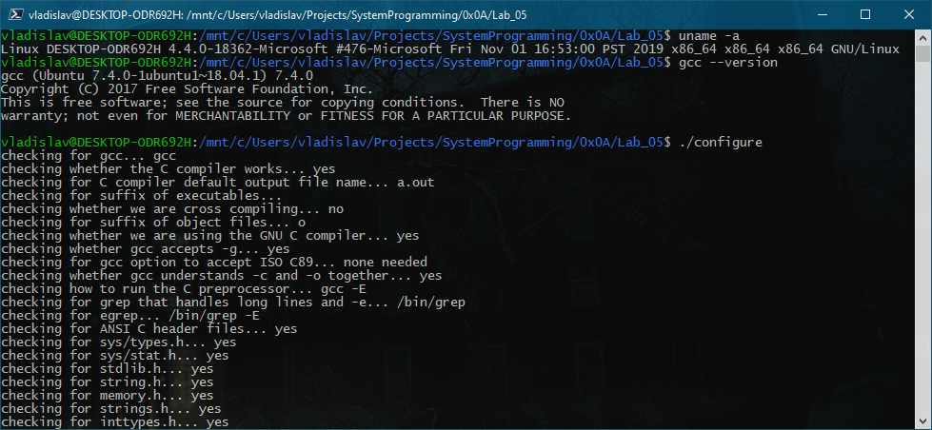

1. Запуск ./configure

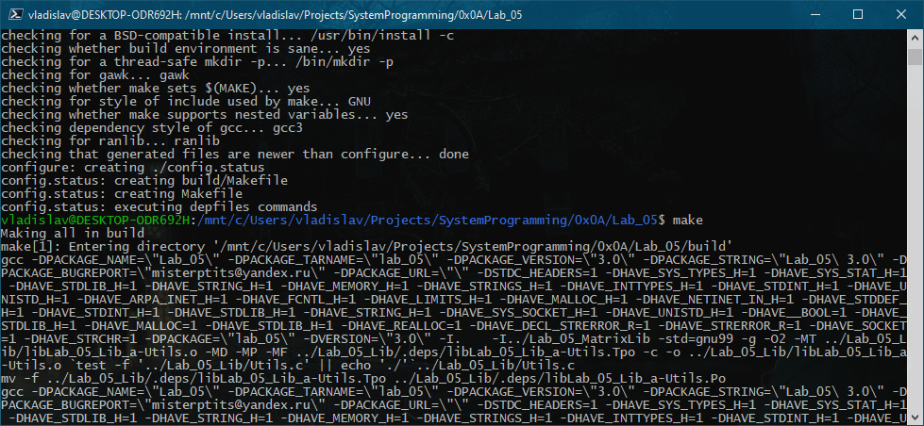

1. Конец работы ./configure, запуск make

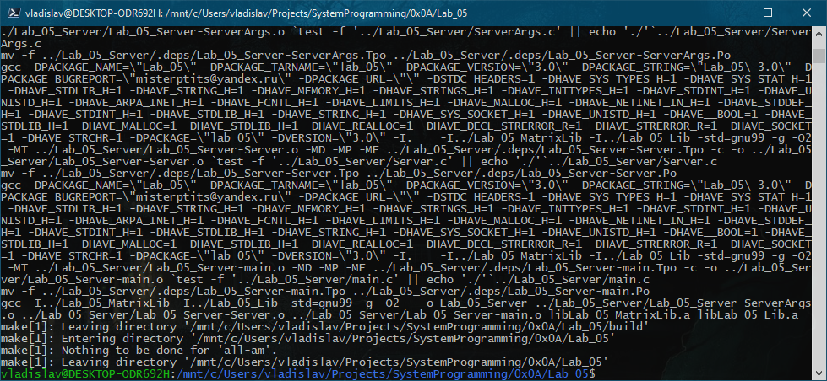

1. Результат работы make

### Сборка с помощью CMake и MSBuild на клиенте

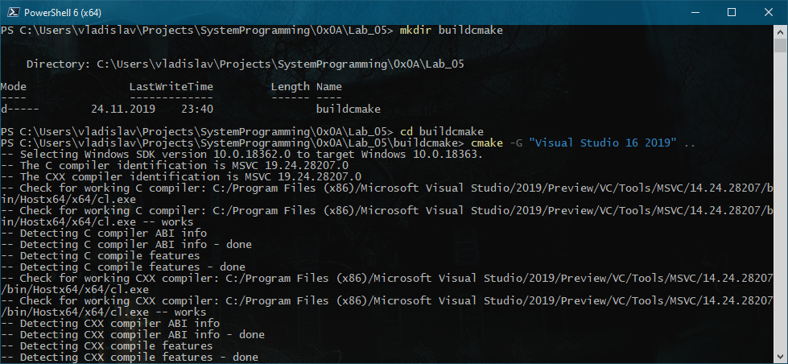

1. Запуск cmake

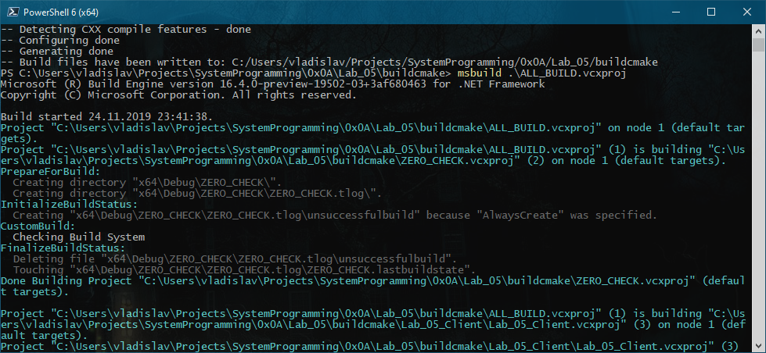

1. Запуск msbuild

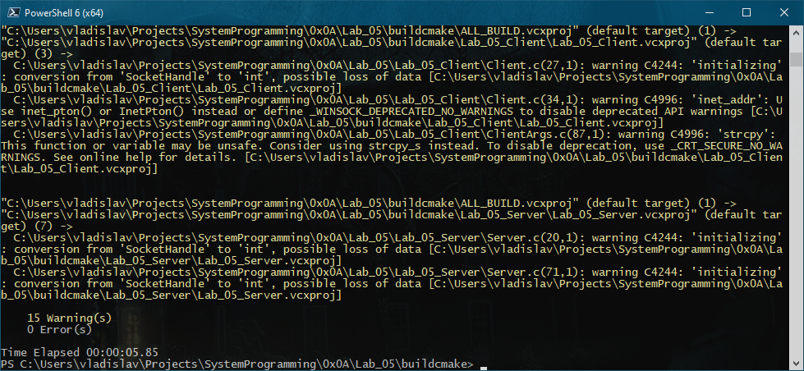

1. Конец работы msbuild

### Запуск сервера

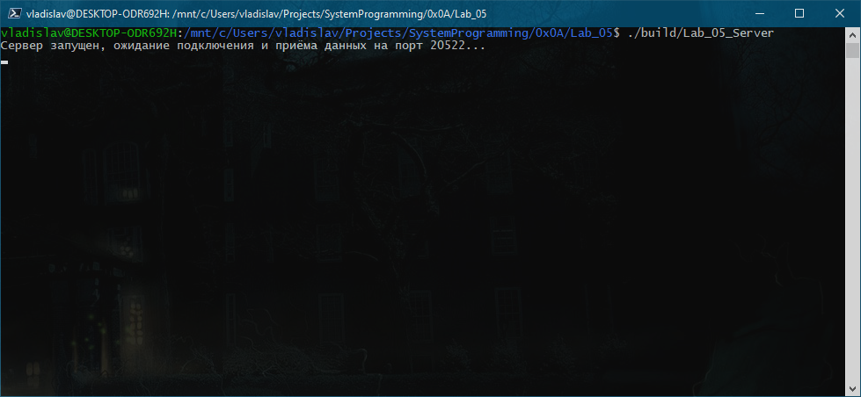

1. Сервер ожидает подключения от клиента

### Запуск клиента

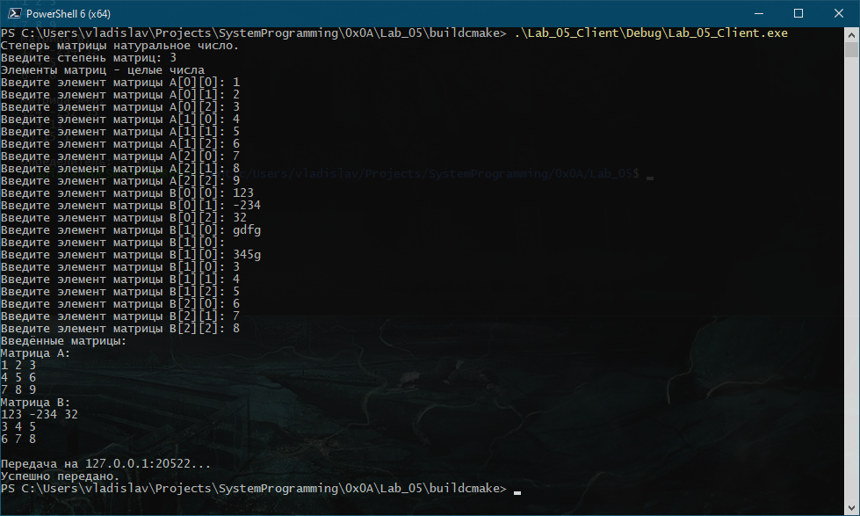

1. Клиент считал данные, передал и успешно завершился

### Результат работы сервера

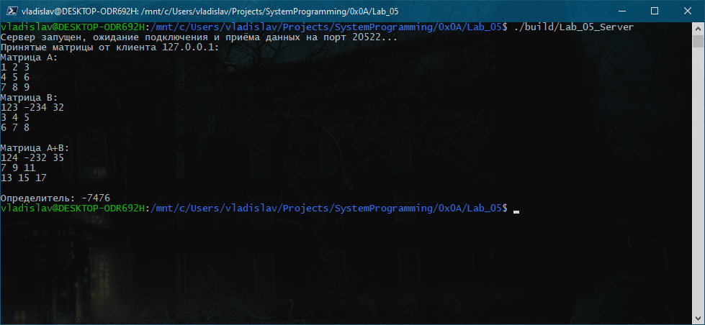

1. Сервер принял, вычислил, вывел результат и успешно завершился

## Запуск №2 (по локальной сети; сервер – Ubuntu 19.10, GCC; клиент – Windows 10, Clang)

### Сборка на сервере с помощью autotools

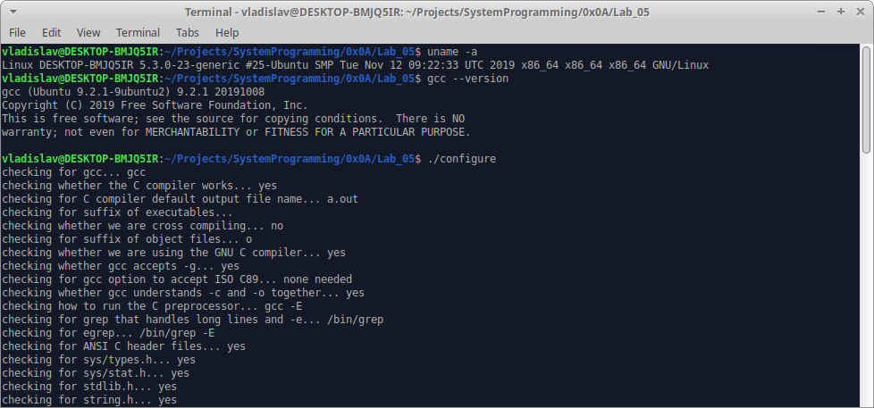

1. Запуск ./configure

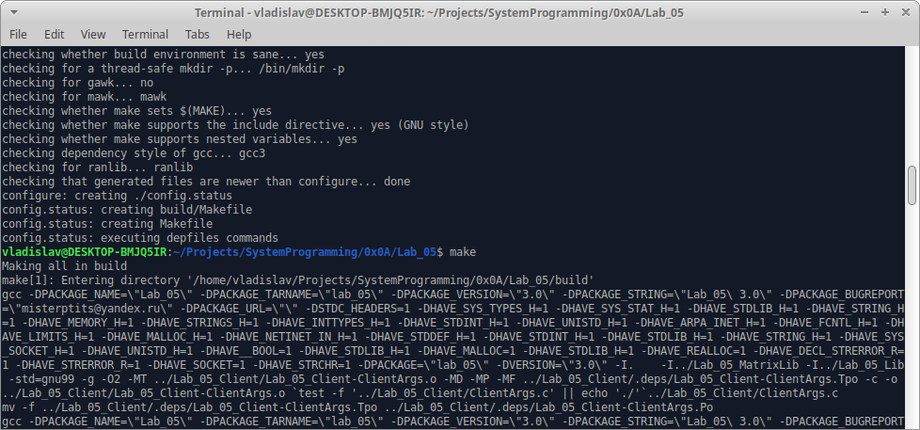

1. Конец работы ./configure и запуск make

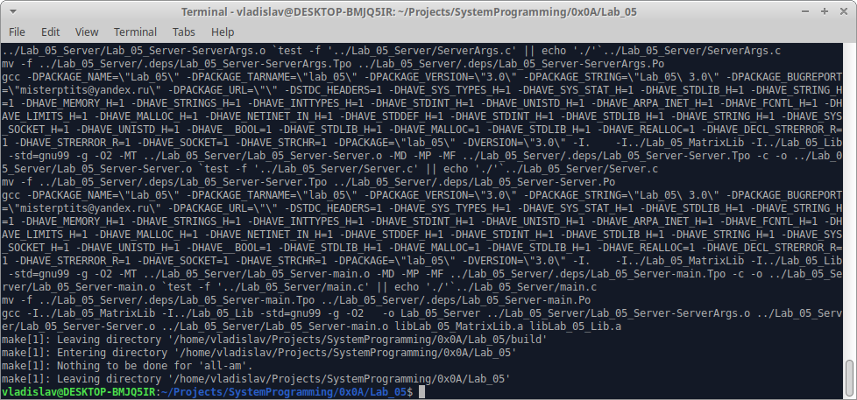

1. Конец работы make

### Сборка на клиенте с помощью CMake и Ninja

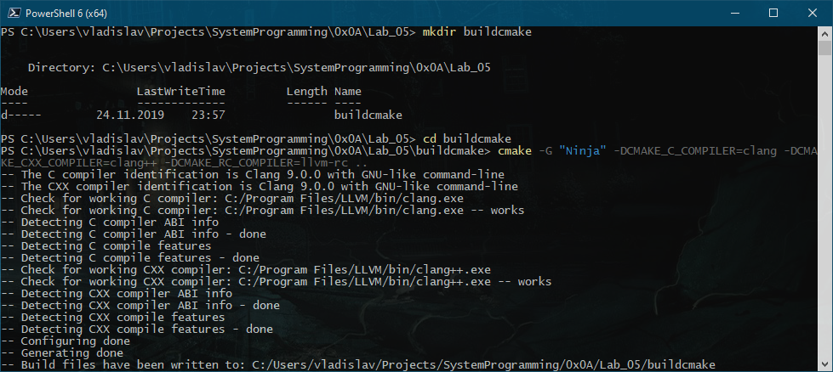

1. Запуск cmake

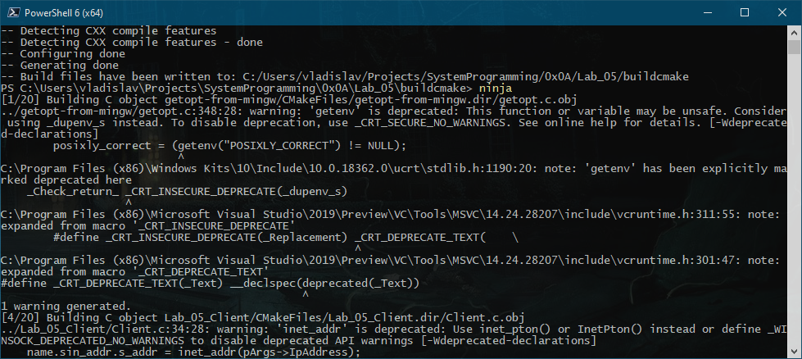

1. Запуск ninja

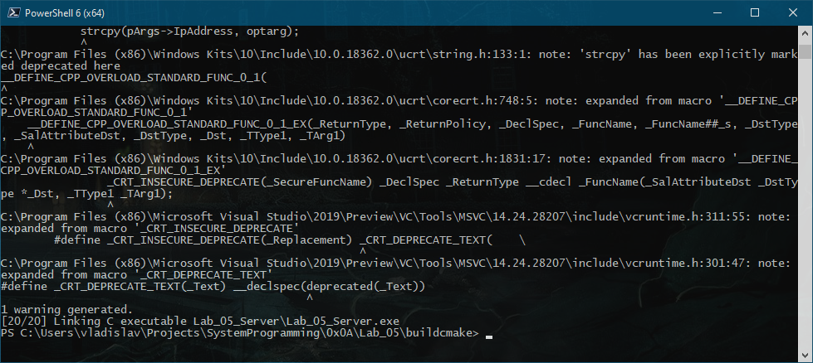

1. Конец работы ninja

### Запуск сервера

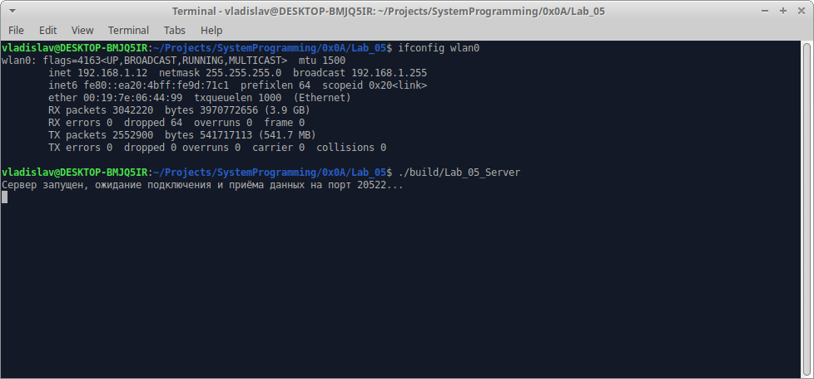

1. Запуск ifconfig для получения IP-адреса сервера в локальной сети и запуск сервера

### Запуск клиента

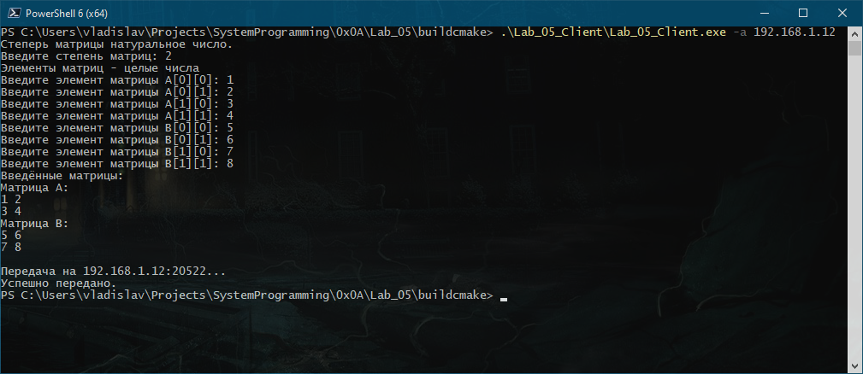

1. Запуск клиента

### Результат работы сервера

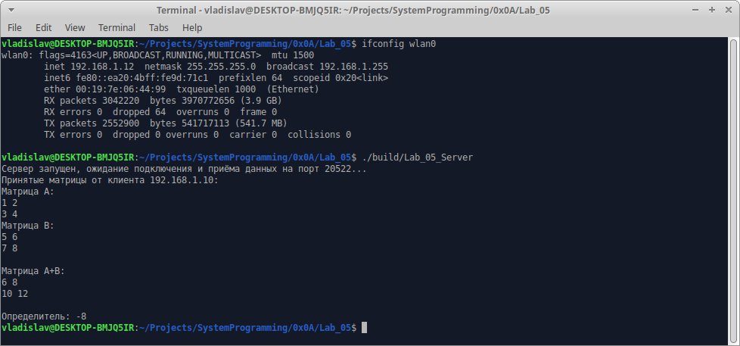

1. Результат работы сервера

## Запуск №3 (по виртуальной сети; сервер – Android (Termix), Clang; клиент – Ubuntu 19.10, Clang)

### Сборка с помощью CMake и Ninja на клиенте

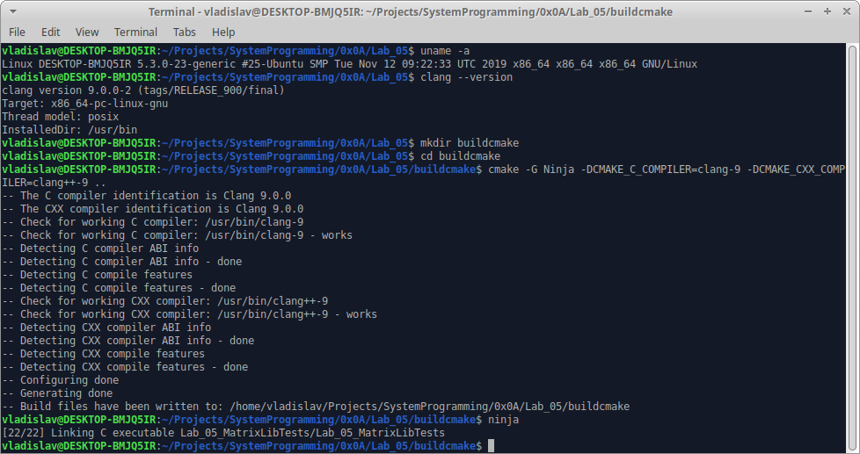

1. Запуск cmake и ninja

### Сборка с помощью autotools на сервере

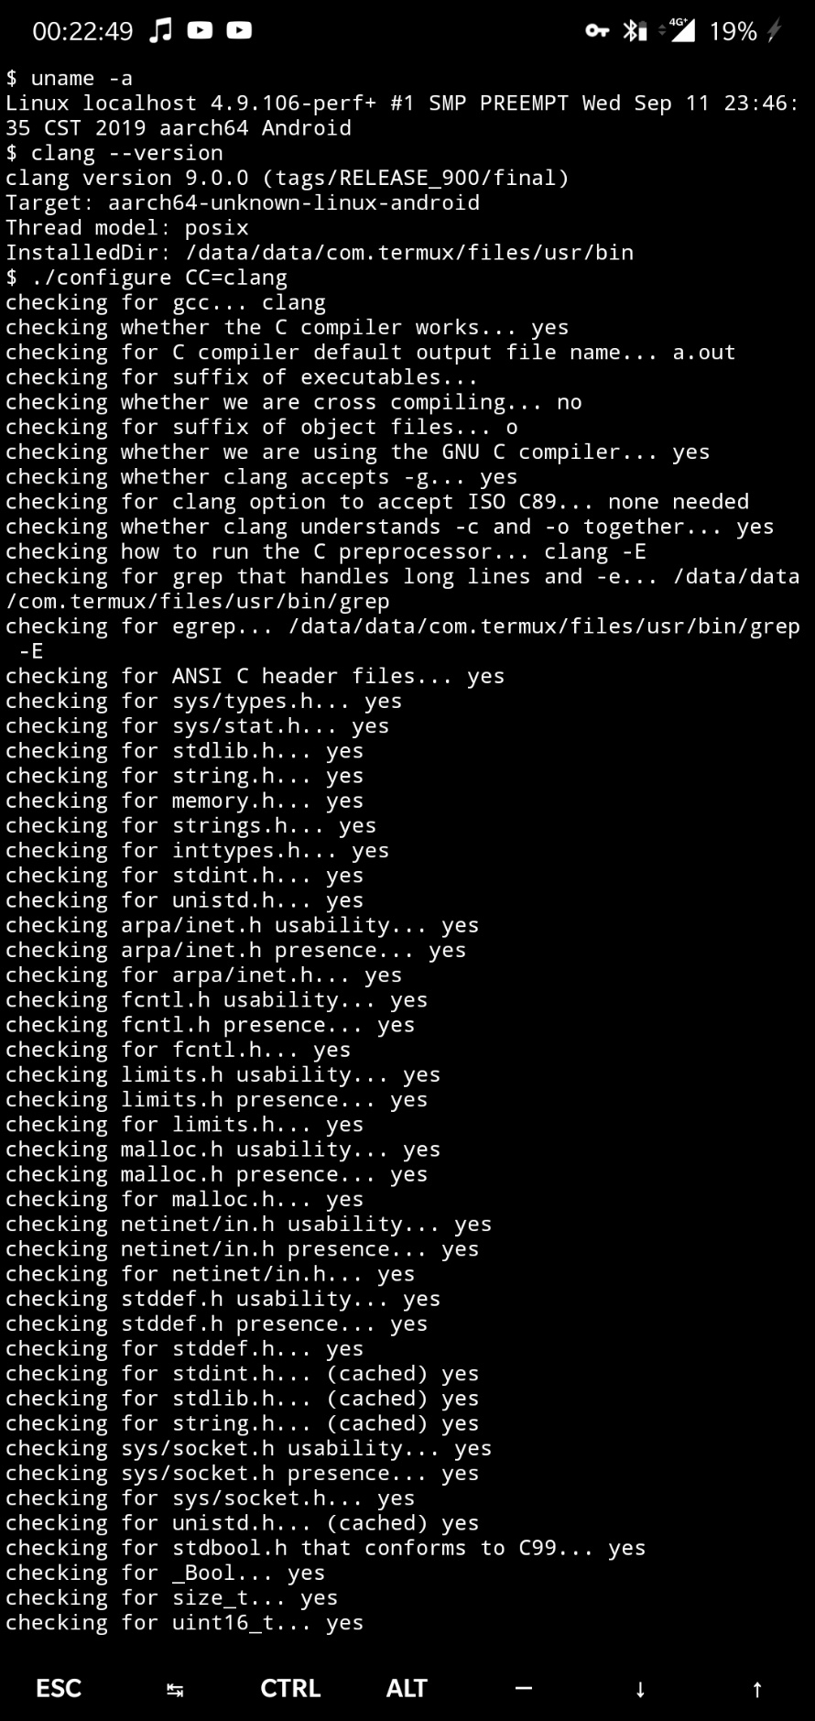

1. Запуск ./configure

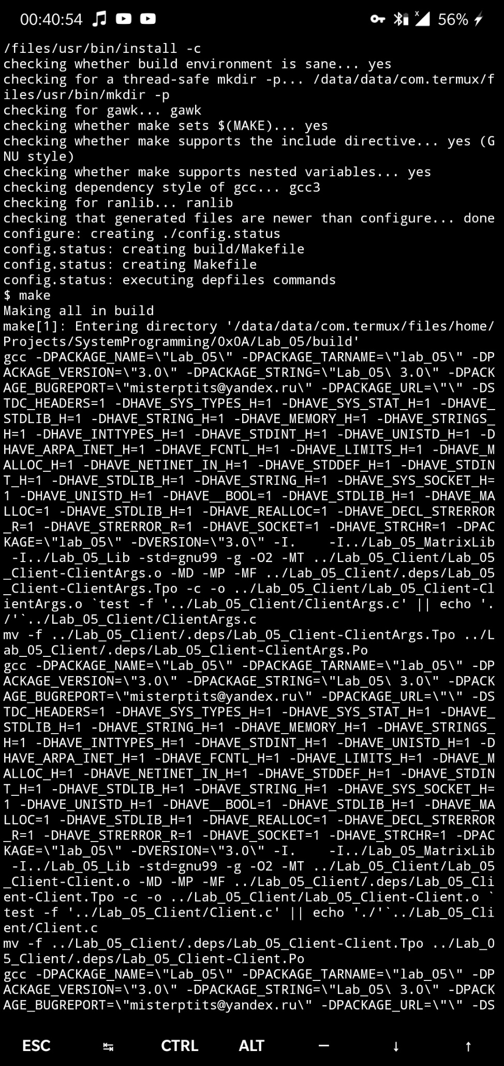

1. Запуск make

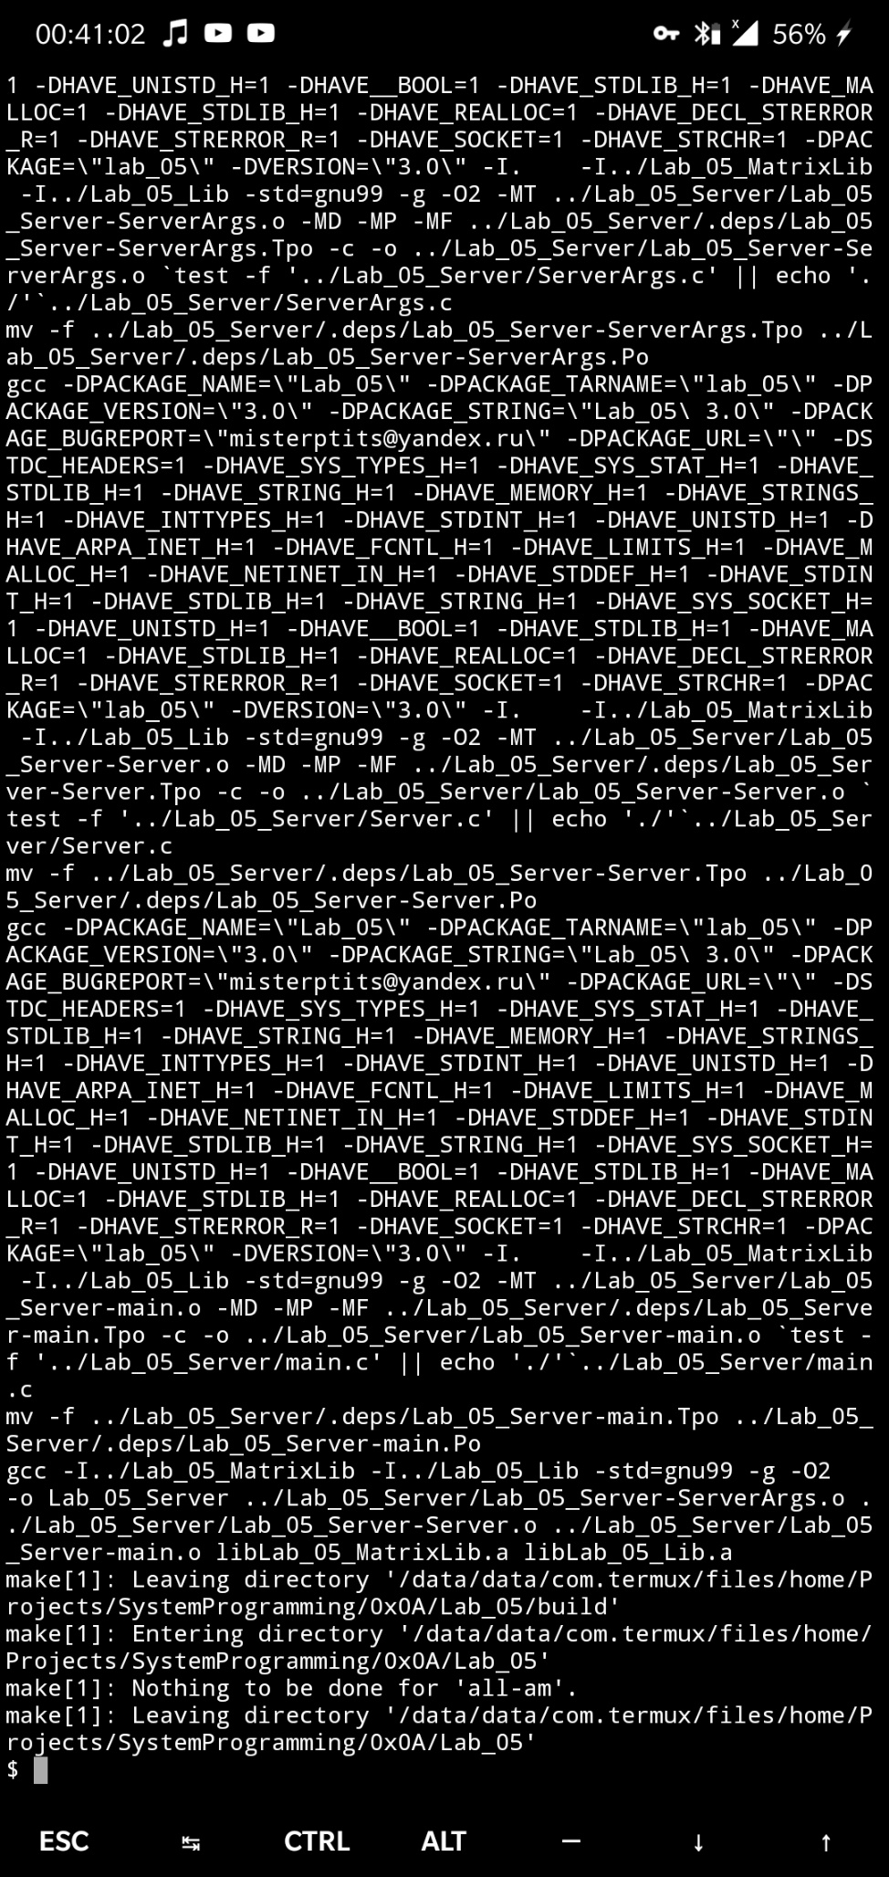

1. Конец работы make

### Запуск сервера

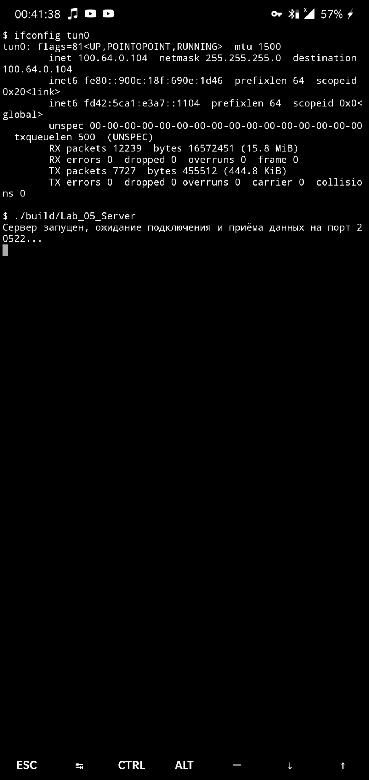

1. Запуск ifconfig для получения IP-адреса сервера в виртуальной сети и запуск сервера

### Запуск клиента

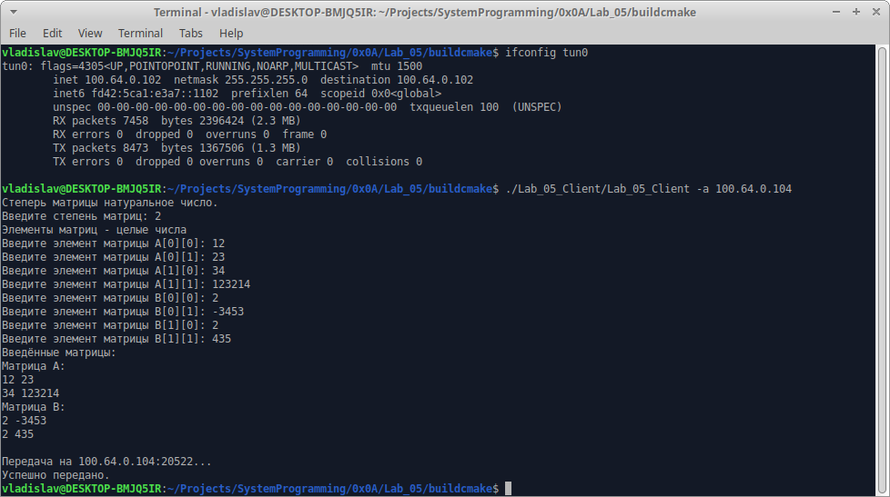

1. Клиент считал данные, передал и успешно завершился

### Результат работы сервера

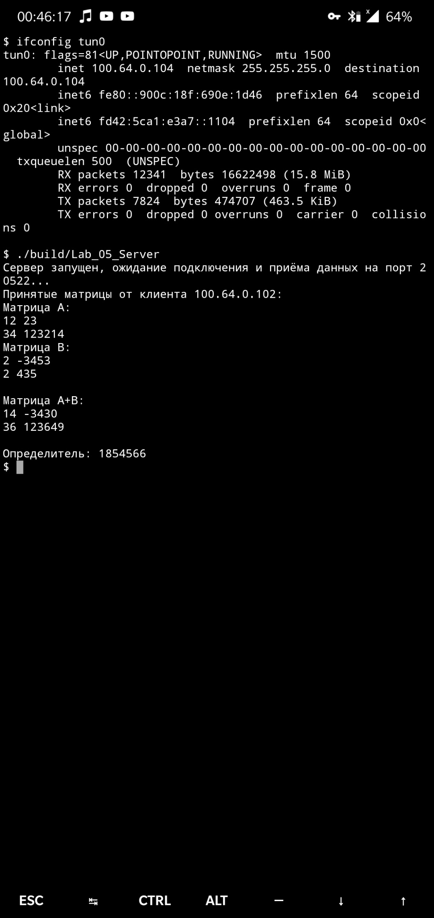

1. Сервер принял, вычислил, вывел результат и успешно завершился

## Запуск №4 (по глобальной сети; сервер – Ubuntu 16.04, GCC; клиент – Windows 10, MinGW)

### Сборка на клиенте с помощью CMake и mingw32-make

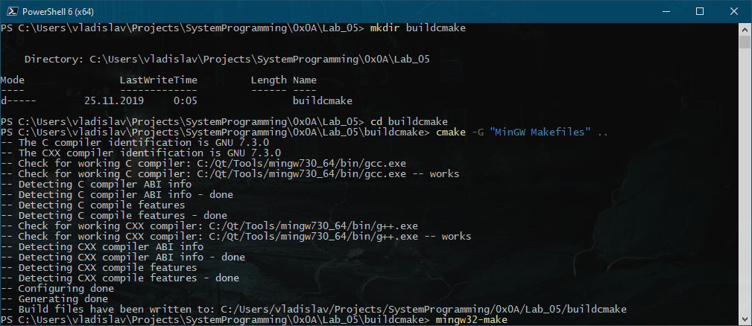

1. Запуск cmake

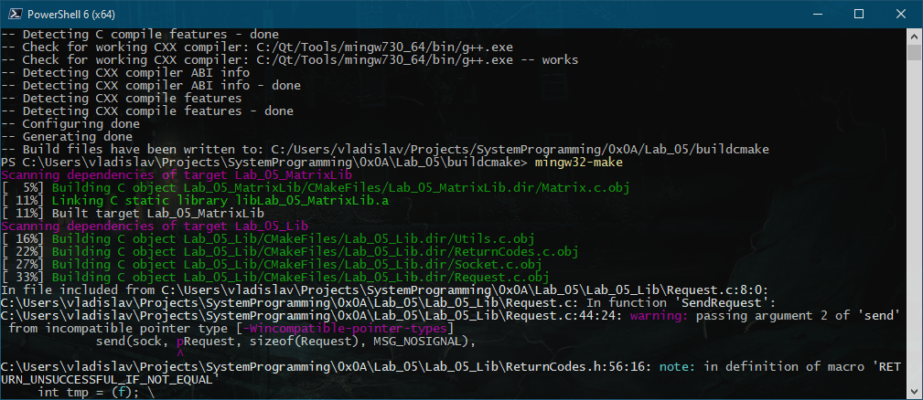

1. Запуск mingw32-make

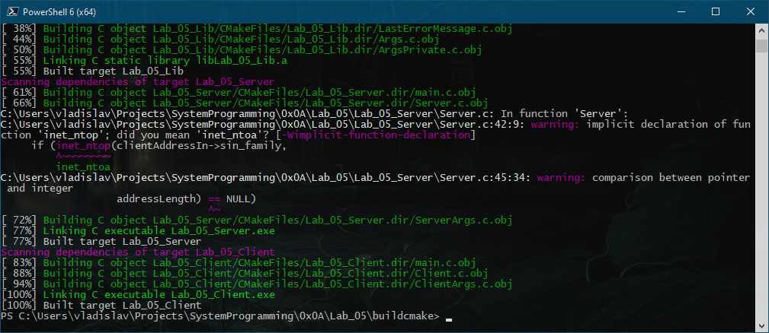

1. Конец работы mingw32-make

### Сборка на сервере с помощью autotools

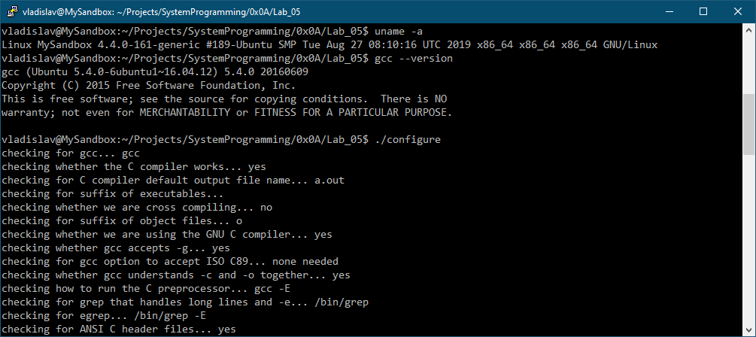

1. Запуск ./configure

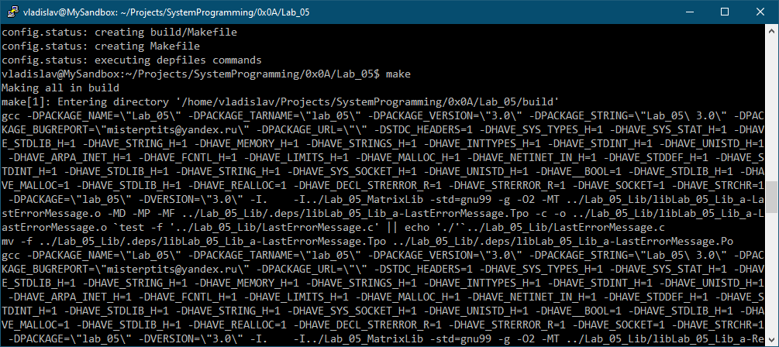

1. Запуск make

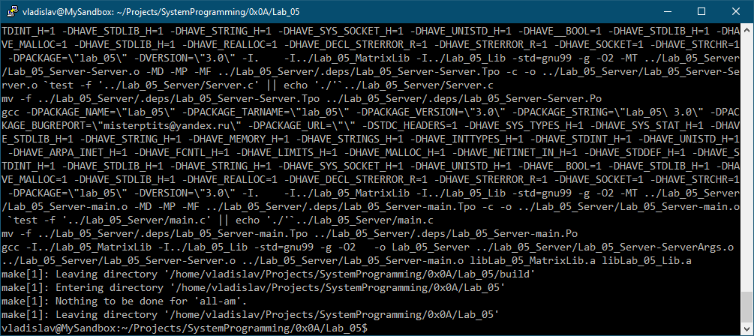

1. Конец работы make

### Запуск сервера

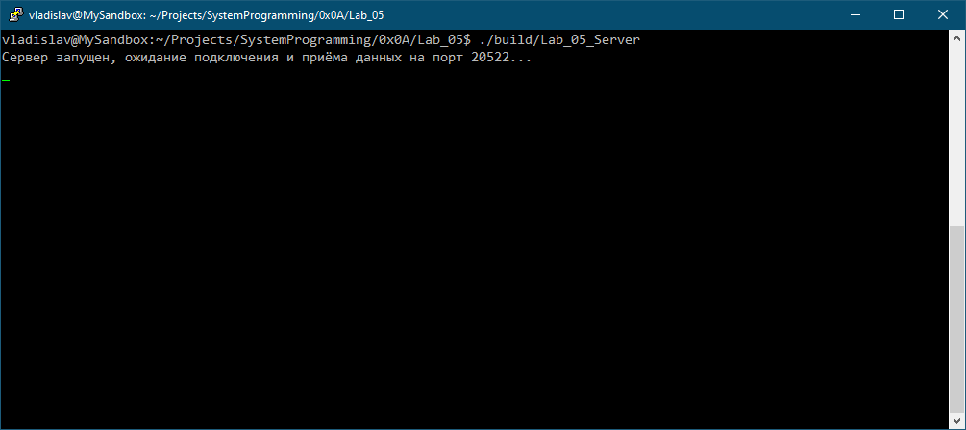

1. Запуск сервера

### Запуск клиента

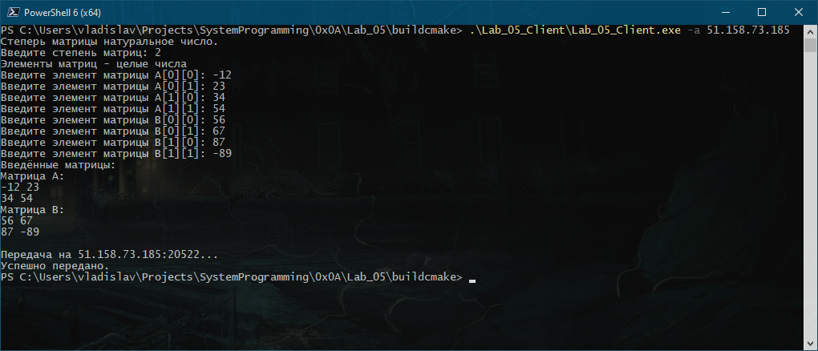

1. Запуск клиента

### Результат работы сервера

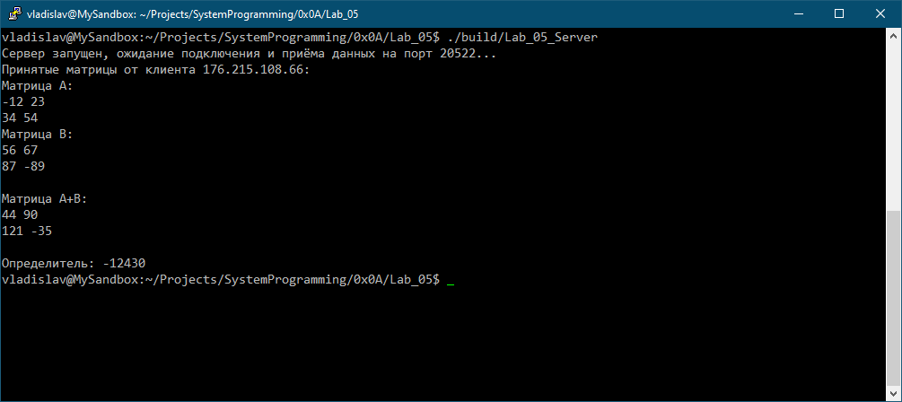

1. Результат работы сервера